Year 3 & 4 Homework – Week 3

**Homework is due in on every Tuesday, please complete it in your red homework books and hand it in on time. **

YEAR 3 MATHS:
In Maths this week, Year 3 have been learning to order numbers, find more or less. Please complete the questions in the pages below. Feel free to challenge yourself and attempt the more tricker questions
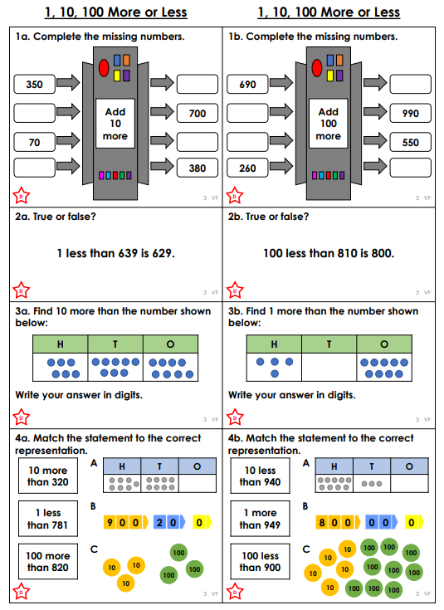
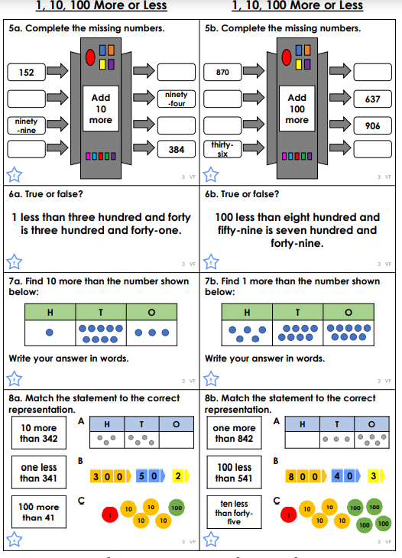
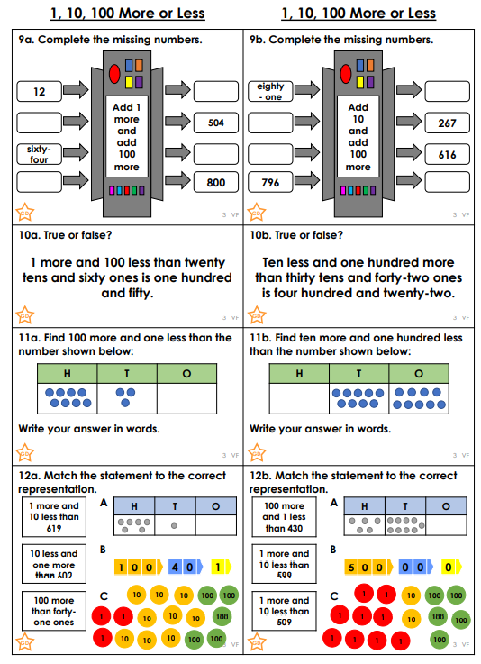

GREATER DEPTH:

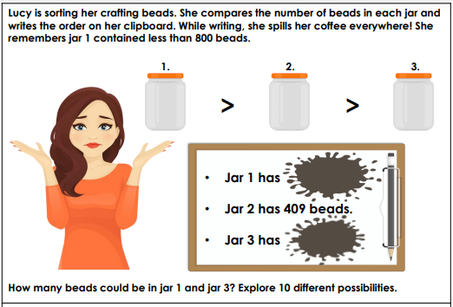

Year 4 Maths
Year 4 have been learning about ordering, comparing numbers, More or Less. Complete the worksheet below to consolidate your learning. Please feel free to challenge yourself with the more tricker questions!

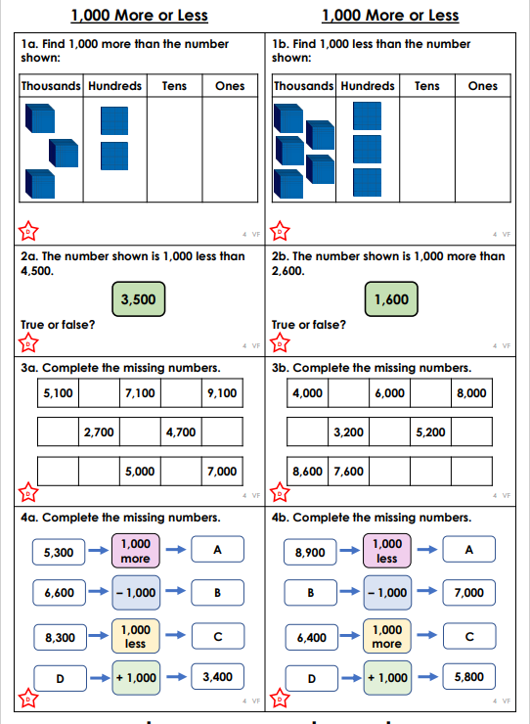
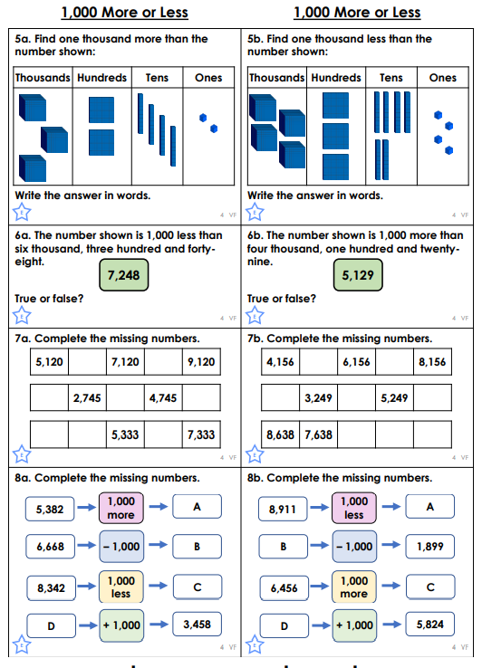
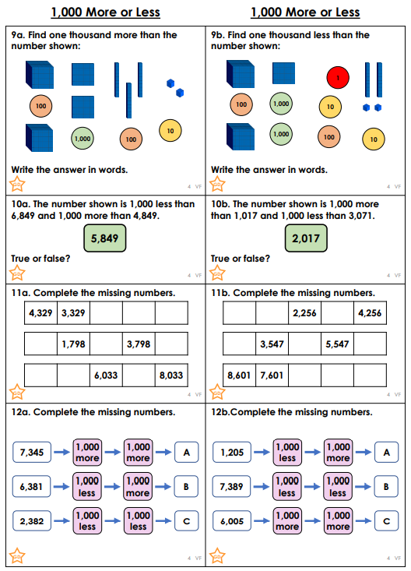

GREATER DEPTH:
