Year 2 Homework

We would like you to try spelling these words, repeat the word four times and write them out, practise makes perfect!
Example:
Word: from
from
from
from
from
I have a cousin from Egypt.
Spelling | X1 | X2 | X3 | X4
Towel
Tinsel
Metal
Pedal
Drenched

Once you have completed these words, please practice spelling out the word of the week. Our word of the week is drenched.
We would like you to find out what drenched means and write down the definition.
After you have done this, please write out two different sentences using our
word of the week
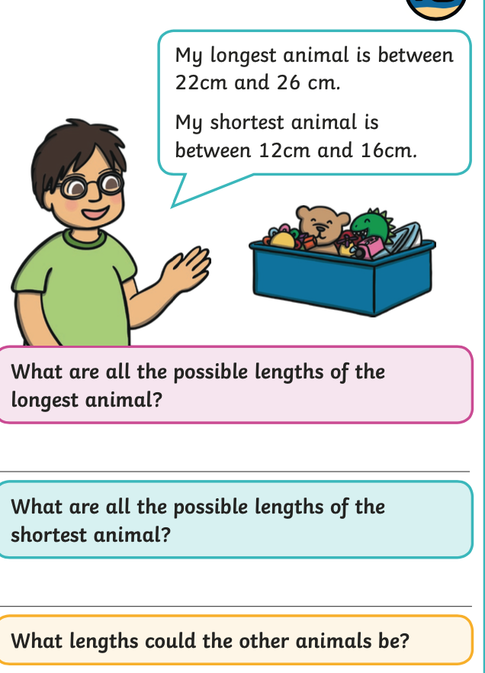
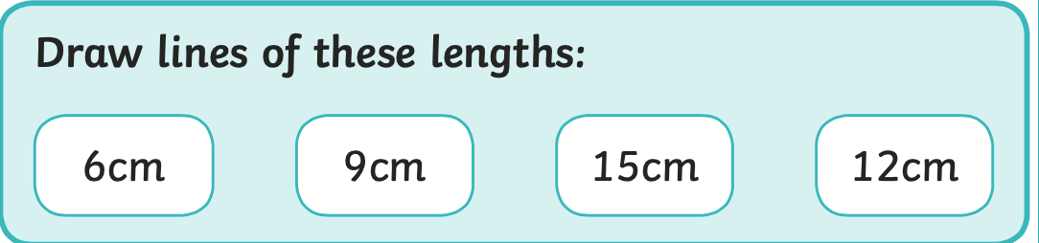
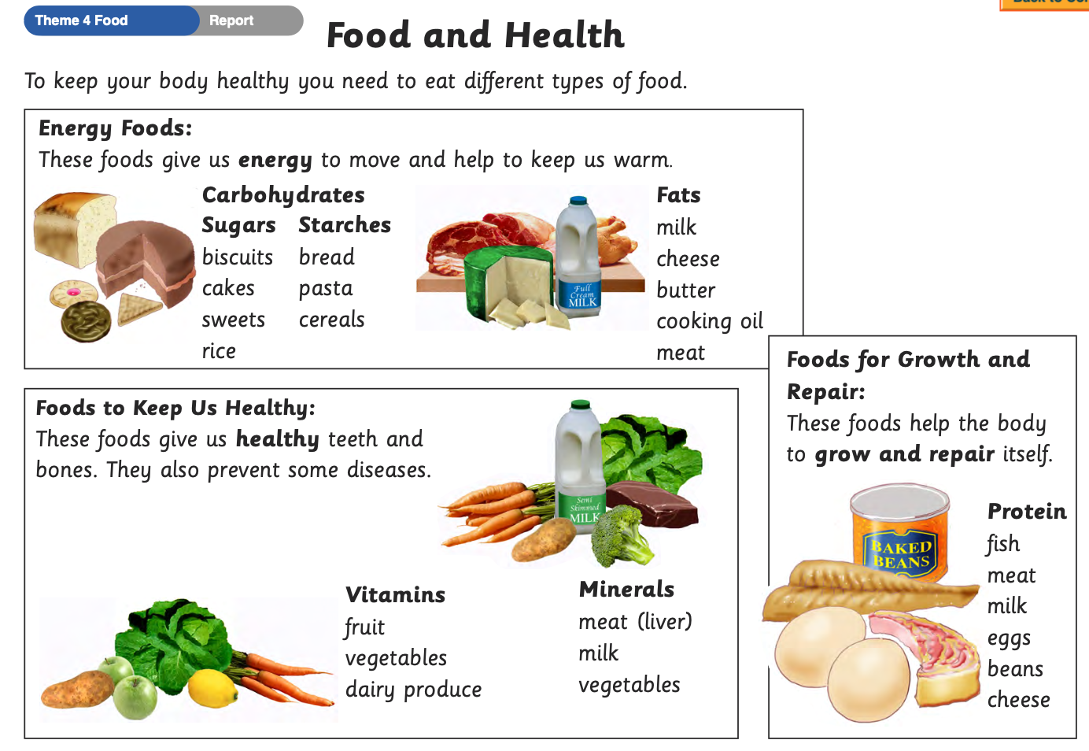
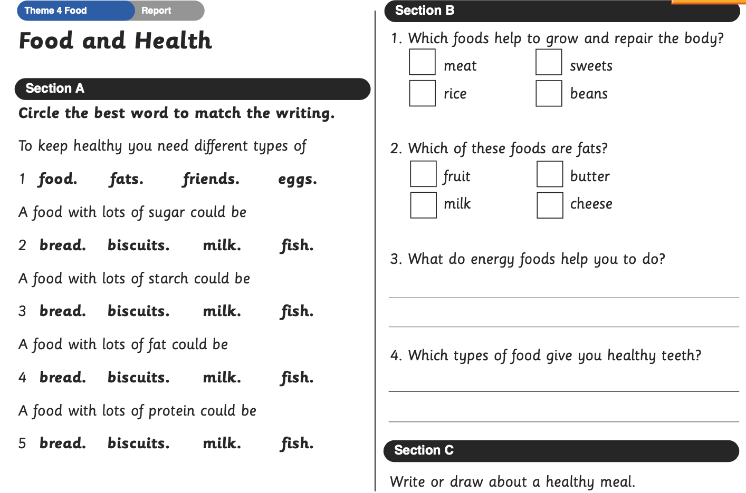

PLEASE REMEMBER TO HAND IN YOUR HOMEWORK BY NEXT TUESDAY

