Buttercup Primary School

Risk Assessment Policy

This policy applies to the whole school including EYFS

This policy should be read in conjunction with the schools COVID-19 Policy. Due to the ongoing pandemic, there may be some aspects of this policy which may suddenly change or be placed on hold.

At Buttercup Primary school we aim to make children, parents and staff aware of health and safety issues and to minimize any hazards so that children can thrive in a healthy and safe environment.

The Headteacher and staff team are fully committed to promoting the safety and welfare for all in the school community so that effective education can take place. Their highest priority lies in assessing and ensuring all the operations within the school environment are safe and comply with not just the law but also best practice.

This policy should be read alongside the following policies which can be found on the school’s website;
- Health and Safety Policy (This includes supervision)
- Fire Safety Policy
- First Aid Policy (This includes medical needs)
- Safeguarding Policy
- COVID-19 Policy and Risk Assessment

Guidance relating to Health and Safety is also in the 2019-20 Handbook and Code of Conduct for Teachers, Assistants, Administrators and Peripatetic Staff which is updated and disseminated to all staff.

Aims of the Policy

The aim of this policy is to:

- protect both the School and individuals (including pupils and employees) from unnecessary risks by ensuring risks are identified and managed
- ensure consistency of approach and management across the wide range of activities that the School is involved in

Risk Assessments

A risk assessment is a tool for conducting a formal examination of the harm or hazard to people (or an organisation) that could result from a particular activity or situation.

Risk assessments make good sense – focusing on prevention, rather than reacting when things go wrong.

Risk assessments can be used to identify the potential hazards to people (slipping, falling), property (fire), strategic (reputation, loss of pupils, impact on development), compliance (child protection issues) and environmental (asbestos, legionella).

Risk assessments are reviewed and updated regularly. A “library” of risk assessments is maintained by the Office.

Our risk assessment process includes:

- Rigorous polices, which include Health and Safety, Fire Safety Policy, First Aid Policy, Safeguarding Policy, should be read alongside this Risk Assessment Policy.
- Keeping Children Safe in Education September 2020 informs our policies and practice.
- Written risk assessments checking for potential hazards and risks indoors and outdoors are compiled each term and reviewed.
- We maintain a checklist of Health and Safety issues which are checked regularly.

Training

The Headteacher has appointed a Health and Safety Officer to ensure that its practice reflects the high standards required of schools and for any developments and changes to be cascaded to the staff team.

The staff team has had a Health and Safety at Work training inset in July 2019 to highlight potential risks and responsibilities.

Staff members are encouraged to take responsibility for their classrooms and school grounds in risk assessing and to be diligent, raising awareness where necessary.

Health and Safety issues are included within inductions as well as staff meetings.

Fire Safety

The fire safety system is serviced by Island Fire service and an annual audit is carried out by Response fire safety
The Fire alarm system is tested weekly.
The school ensures that the whole school has a fire drill practice termly. Termly risk assessments are compiled to identify any potential hazards.
The school has a Fire Safety Policy which should be read in line with this Risk Assessment Policy.

Gas and Electrical Appliances

Electrical appliances are PAT tested annually. An electrical circuit check is completed every 5 years.
Gas boiler checks are completed annually. Carbon monoxide alarm is tested monthly.
Our boiler, fuse boxes and gas meter cupboard are not accessible to the children. Heaters, electrical sockets, wires and leads are guarded.
There are sufficient sockets to prevent overloading.
Safety covers protect all sockets accessible to the children when they are not in use. Lighting and ventilation is adequate in all areas.

Water

A legionella audit is completed annually.
TMV’s are checked annually. A thermometer is run under the tap for a period of 2 minutes and the temperature is recorded.
Temperature checks are checked weekly and recorded. The temperature for each mixed TMV tap must be below 43c (ideally 38-43c).
Little Used Outlets as well as indoor taps are flushed at the beginning of the week in line with legionella recommendations and recorded as well as flushing upon returning from a holiday period.

Asbestos

The Control of Asbestos Regulations 2012 places specific duties on those who manage non- domestic premises to identify the presence of asbestos-containing materials and manage the risks they present. Buttercup Primary school follows these regulations carefully it is has been confirmed that no asbestos was used to build the property due to building regulations. The School site was built during 2001.

COSHH

Hazardous substances are kept in containers in secure, designated cupboards. A risk assessment is completed termly to access the safety of such substances.

COVID-19

The COVID-19 outbreak is dynamic and changing daily, if not hourly, and there are now many agencies providing information. The school takes guidance from Department for Education (DfE) and Independent schools Association (ISA).

The schools COVID-19 Risk Assessment identifies and assesses risks and describes methods of controlling those risks. We recognise that this risk assessment must be a fluid process, updated whenever advice, circumstances, or any of the assessed risk factors are seen to have changed.

Responsibilities

The member of staff responsible for Health and Safety is Sulthana Begum. The management of Health and Safety is the responsibility of Zahina Faruque Written risk assessments where necessary are carried out by Zahina Faruque.

Risk Assessments are conducted when and where necessary. Where appropriate risk assessments ae recorded in writing (e.g. Pro-forma -Appendix A). An annual plan is used to help track and monitor evaluating effectiveness (Appendix B).

The staff team is responsible for taking reasonable care of their own safety, together with that of pupils and visitors. They are responsible for cooperating with the Head to comply with their legal health and safety responsibilities.

All members of staff are responsible for reporting any concerns relating to risks or defects to Zahina Faruque or Sulthana Begum.

When conducting a risk assessment in any area consideration should be given to the likelihood any hazard could potentially cause harm. This will determine whether action needs to be taken to reduce the risk. Even after all precautions have been taken some risk usually remains.

All visitors to the school sign in and receive a visitor’s pass with guidance stating the following: “Safeguarding statement and fire safety is provided and all visitors are requested to cooperate in this duty of care”.

Classroom Management

It is the responsibility of staff to risk assess within the classroom in relation to planning and leading session in class including the outdoor classroom.

Building and Premises
Public pathways at the front of the building are risk assessed daily for hazards. The building indoors and outdoors is visually checked for hazards each morning.

Educational visits and trips

Venue risk assessments are requested prior to leaving.

A checklist of Health and Safety issues is maintained which are checked prior to an educational visit or trip (Appendix C).

RIDDOR

The Head is responsible for reporting and recording any notifiable accident that occurs on school premises to a pupil, member of staff, parent, visitor or contractor to the HSE in accordance with the Reporting of Injuries Diseases and Dangerous Occurrence Regulations (RIDDOR).

Safer Recruitment

The schools Safer Recruitment Policy outlines the necessary procedures relating to risk assessing when recruiting new staff.

Safeguarding

The schools Safeguarding Policy should be read in conjunction with this policy as it covers matters related to assessing risk in relation to child protection.

Date: January 2021
Review: January 2021

Appendix A
Risk Assessment Annual Plan
This is by no means an exhaustive list but it gives an indication of the many H&S checks.
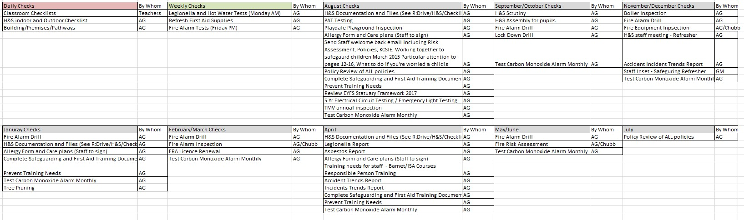

Appendix B
Trip Risk Assessment Pro-Forma
