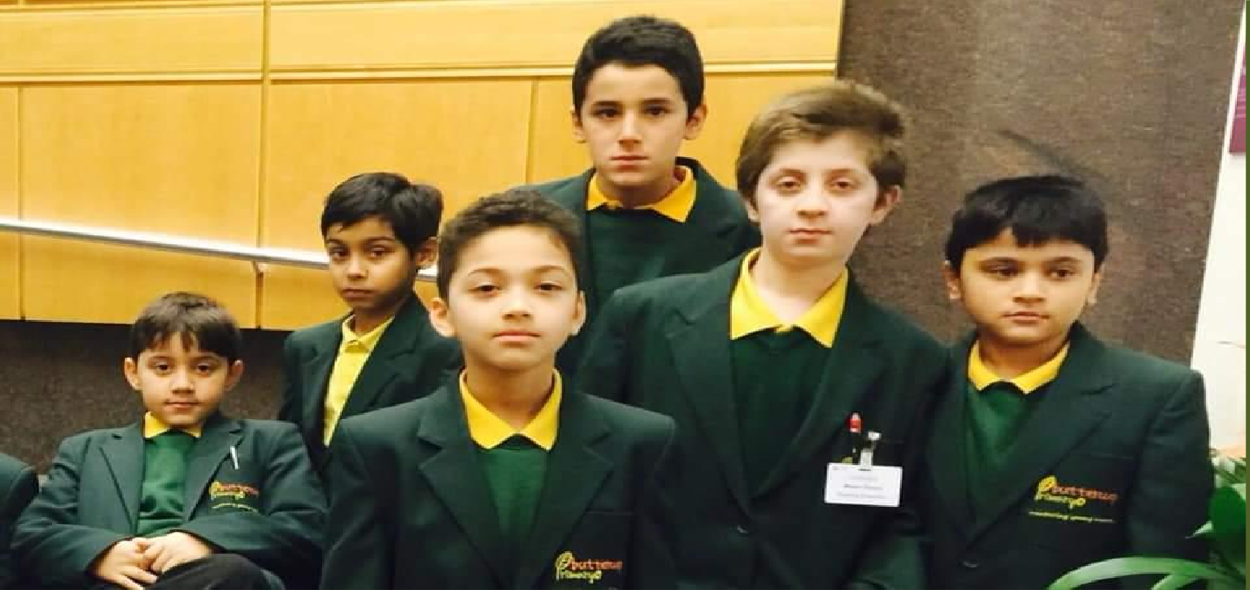
Buttercup Primary School

Your guide to returning to school

September 2020

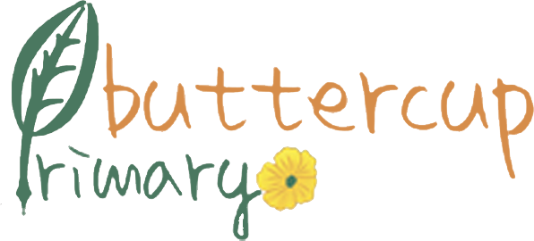

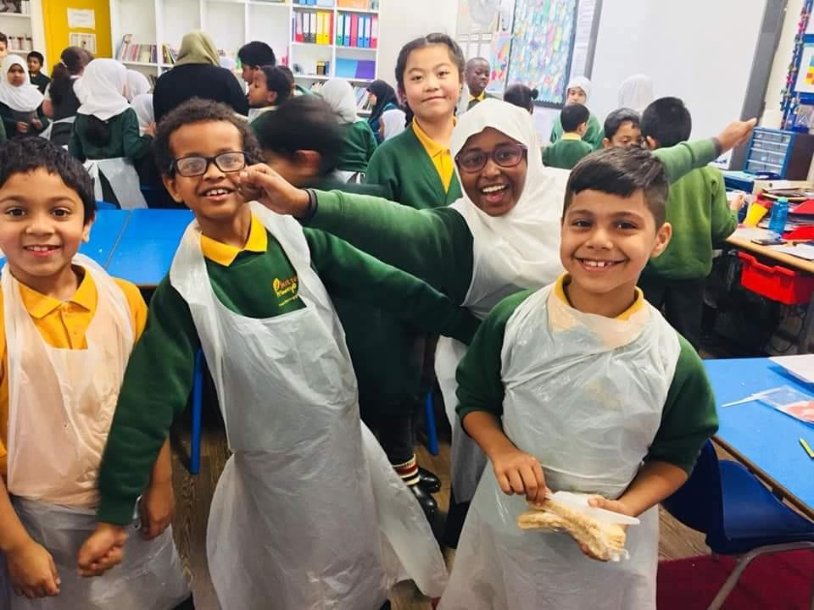

Contents

Introduction  Welcome to our guide for returning to school | 3
What is the purpose of this document? | 4
Our approach - Our key principles | 5
Preparing for opening | 6
Attendance | 7
Our Arrangement -Pupil well-being | 8
Our Arrangement -EYFS and Specialist Provision Transition | 8
Our Arrangement :The school day | 8
Our Arrangement : Beginning of the day – access and drop off | 9
Our Arrangement : Bubble and class organisation | 10
Our arrangements -Break arrangements | 10
Our arrangements- Lunch arrangements | 10
Our arrangements –  Salah and End of the day – exit /collection | 11
Extended provision | 12
Curriculum | 12-13
In the event of illness | 14-15
Social distancing | 16
Hygiene and cleaning | 17
Do’s and don’ts | 18
Useful information | 19

Introduction

Welcome to our guide for returning to school
While we are excited to get all our children back to school in September, safety remains our ultimate priority.
We have taken time to review all of the government, DfE and Public Health England guidance and are confident that our procedures and operational structures will minimise risk and provide everyone in our schools with as safe an environment as possible.
We are absolutely focused on ensuring all children return in September to continue with their learning and we have in place a clear strategy based on three principles: Re- open, Return and Recover.

We will re-open for all children.
We will expect all children to return.
We will implement a carefully planned curriculum to ensure children recover their lost learning.

Our core priorities
In September, we will be totally focused on three core priorities.
- Maintaining our rigorous procedures to minimise risk of infection.
- Supporting pupil’s well-being.
- Closing pupil’s gaps in learning and ensuring their progress is accelerated.

COVID-19 continues to pose a threat and we will need to introduce new operating procedures across our school to minimise the risk of infection and enable our trained practitioners to continue supporting the educational and general well-being of our children.
This means that school will look different upon our return and some of thestructures and experiences your child is used to in a normal school environment will have changed.

What is the purpose of this document?
This booklet sets out guidance for the full reopening of our school for the start of the Autumn Term 2020.
It is intended to give you an outline of what our new school environment will look and feel like and reassure you that we will do everything we can to ensure our school is as safe as it can be for pupils and staff.
This booklet will clarify a wide range of changes to the way we would normally operate and support you in preparing your child/ren for a successful to return to school. These changes have been informed by the DfE guidance issued to school on 2 July 2020.
The measures set out in the DfE guidance provide a framework for school leaders to put in place proportionate protective measures for children and staff, which also ensure that all pupils receive a high quality education that enables them to thrive and progress. We have been asked to minimise the number of contacts that a pupil has during the school day to reduce the risk of transmission.
It will provide you with a range of important information that clarifies how we will meet your expectations for supporting your child on their return to school as well as our expectations about how you can help us maintain a safe environment with minimal disruption to children’s learning.
We have appreciated your support throughout this process and familiarising yourself with the detail of this booklet will help us provide a positive start to your child’s return to full time education.

Our key principles
Drawing on guidance from the Department for Education and enhanced with our own additional measures, Buttercup Primary School COVID-19 protocols are designed to create ‘protective bubbles’, which separate our school from external factors and limit social interaction between groups of children and staff.
We are confident that the procedures outlined in this document offer the best possible levels of protection for our pupils, staff, and their families. We have undertaken a detailed evaluation of the level of risk across our site and this has provided a clear picture of the challenges and the measures we needed to put in place to ensure that all children, parents, and staff are entering an environment that is as safe as possible.
We were supported in our planning with input from teaching and support staff, colleagues and, importantly, an independent health and safety professional who has visited our site and will be returning regularly to see how we are operating during the Autumn Term.

Our key principles for opening in September are:
- We expect all pupils to attendschool.
- School uniform must be worn.
- We will teach a broad and balanced curriculum.
- We will implement a wide range of intervention support.
- We will reduce the risk of spreading the virus as far as possible.
- We will implement social distancing as far as possible.
- We will have in place a contingency plan for home learning.

The Department for Education have asked schools to prepare for all pupils to return full time from the start of the Autumn Term, including those in school-based nurseries. Schools must comply with health and safety law, which requires us to assess risks and put in place proportionate control measures. As you would expect, we have sought independent advice and carried out detailed risk assessments, which we will continue to monitor as the term gets underway.
The information in this section has been taken from the Department for Education guidance to schools issued on 2 July 2020. We are following their prevention and response to infection guidance. More detailed information can be found in the guidance – click here to access the full document.
Prevention - Essential measures include:
- A requirement that people who areill stay at home
  - ensuring that pupils, staff and other adults do not come into the school if they have coronavirus (COVID-19) symptoms, or have tested positive in the last 7days.
  - ensuring anyone developing thosesymptoms during the school day is sent home.
- Robust hand and respiratory hygiene
  - ensuring that pupils clean their hands regularly, including when they arrive at school, when they return from breaks, when they change rooms and before and after eating.
  - promoting the ‘catch it, bin it, kill it’ approach.
  - Public Health England does not (based on current evidence) recommend the use of face coverings in schools. This evidence will be kept under review.
- Enhanced cleaning arrangements including cleaning frequently touched surfaces often, using standard products such as detergents andbleach.
- Active engagement with NHS Test and Trace.
- Consideration of how to minimise contact between individuals and maintain social distancing wherever possible. This will include:
  - grouping children together.
  - avoiding contact between groups.
  - arranging classrooms with forwardfacing desks.
  - staff maintaining distance from pupils and other staff as much as possible. Response to any infection – Essential measures include:
- Engage with the NHS Test and Traceprocess.
- Manage confirmed cases of coronavirus (COVID-19) amongst the school community.
- Contain any outbreak by following local health protection team advice.

It is vital for all children to return to school to minimise the longer-term impact of the
pandemic on children’s education, well-being and wider development.
The Department for Education have advised us that school attendance will therefore be mandatory again from the beginning of the Autumn Term. This means from that point, the usual rules on school attendance will apply, including:
- parents’ duty to secure that their child attends regularly at school where the child is a registered pupil at school and they are of compulsory school age.
- schools’ responsibilities to record attendance and follow up absence.
- the availability to issue sanctions, including fixed penalty notices in line with local
authorities’ codes of conduct.
We understand that some students and parents may be anxious about returning to school. Please do get in touch with us if that is the case on info@buttercupprimary.co.uk
At BCP we expect all students to attend school, on time, every day, aiming for 100% attendance. Attendance below 97% is a concern. The table below clarifies our expectations and the impact of attendance on students’ learning.
Since September 2013 schools are not allowed to grant leave of absence for holidays and the Headteacher will grant leave of absence only in exceptional circumstances. Parents and carers should write to the Headteacher if they are requesting leave for this reason. If the absence is not agreed then Penalty Notices will be issued.
At BCP we are ambitious for our students and have high expectations. Students need to be in school to learn. Together, with excellent support, we will help our children and young people attend school every day so they are ready to succeed.

Attendance and punctuality matters.  Be smart – be here! |  | Research shows:
100% | Target – Excellent | Students makes good progress with their learning
97% | Very good | Students makes good progress with their learning
95% | 8 days missed each year. Concerning. | Learning is at risk of being negatively impacted
90% | 16 days missed each year. Very concerning. | Learning falls behind other students
85% | 24 days missed each year. Very concerning. | Learning significantly falls behind other students
80% | 32 days missed each year. Very concerning. | Learning significantly falls behind other students

Pupil wellbeing
We understand that children and their families may have some anxietieswith regards to returning to school after a long period of absence. At Buttercup we pride ourselves in the wealth of support, nurture and care that we provide not only for our children, but for our families too. An established Wellbeing Team can help with any anxieties or worries you or your child may have upon returning. If you would like to discuss any concerns or worries prior to your child returning to school, please email our welfare officer Ms Sulthana on: Sulthana.b@buttercupprimary.co.uk

EYFS & Specialist Provision Transition EYFS
Our aim at Buttercup is to make the induction into Nursery and Reception a pleasant and positive experience for both you and your child. All new parents have received an induction pack which outlines the specific arrangements. These include induction meetings and a phased start into school. Further information can be found on the settling in policy on the school website www.buttercupprimary.co.uk
Specialist Provision Years 1-6
We understand the difficulties our families and pupils within the Special Provision have faced during this time. Due to the duration that children have not been accessing school we are very aware that we need to ensure that the transition is carefully planned with the heart of the child first and foremost. We will continue to liaise with families and the SEND team with regards to your child’s transition and
successful return to full time education. All information regarding your child’s phased
return in September should have already been received.

The School Day
We want to ensure the measures we have put in place, for everyone’s safety, are strictly followed. Therefore, we have a phased start of the term over two days to enable us to settle smaller numbers of children quickly and ensure the starts and ends of the day run smoothly. Therefore:
Thursday 3rd September – We welcome back all the children

Beginning of the day
When parents are waiting to drop off their child, social distancing should be maintained at all times. Only parents who are symptom free and/or have completed the required isolation periods will be able to drop off or collect their child.
Entry into school will be via both entrances. only Early years parents will be allowed to enter in to the school building. they will be required to help settle their child/ren.

Please ensure social distancing is adhered to at all times upon arrival and collection of children. The school requests that at all times parents wear a mask.
Children in Years 5 and 6 will be expected to enter school via the yellow gate and walk in unaccompanied.
We request that drop off and collection is limited to one parent per family to limit the number of people congregating on the site.
Arrival times

Year group | Gate open from | Start time | Morning Club
Nursery/Reception | 8:30am | 8:45am | -
Years 1 & 2 | 8:25am | 8:45am | 8am
Years 3 & 4 | 8:30am | 9:00am | 8am
Years 5 & 6 | 8:25am | 9:00am | 8am

We strongly advise that parents walk or cycle to school to avoid a build-up of cars and movement of people on the roads surrounding school.
PLEASE ENSURE YOU ARRIVE AT SCHOOL NO EARLIER OR LATER THAN YOUR CHILDS ENTRY TIME ABOVE.

For children attending afternoon nursery only
The gate will open at 12.30pm. Entry into school will be via the front reception where parents will follow the one-way system to the Early Years unit.

Arrival into school
On arrival into school, if your child is wearing a face covering, they must be removed before entering the classrooms in line with DfE guidance. Reusable masks need to
be placed in a plastic bag and put into the child’s school bag. Parents need to provide the plastic bag. Protocols around hand washing will be followed once face coverings have been removed.

Bubble and class organisation
The overarching principle we are applying is to reduce the number of contacts between children and staff. This will be achieved by keeping groups in separate bubbles. Due to the l number of children at Buttercup we have elected to bubble our children by year group. This will mean:
- For the majority of their time in school, children will be grouped by class.
- Children will come into contact with children from other classes in their year group during activities such as outside break and lunch times, interventions, phonics lessons etc.
- The year group bubble can be taught by the same group of teachers and support staff every day – these adults will also supervise all break and lunch times.

Lunch Break arrangements
Children will have outdoor break times as normal each class will have their own box of specific equipment which only they will use. Children will be supervised in their year group bubbles only by members of staff working in those bubbles. Children may bring in a piece of fruit and water from home for break time.

Lunch arrangements
Lunch times will be staggered to allow children to safely eat their lunch with their bubble. Children’s lunch time will be split so they will be inside eating for half an hour and outside playing for half an hour. Zones will be set up in both the school halls to ensure that bubbles of children do not come into contact with each other. Children will be escorted to and from the halls and to the playground by adults from their bubbles to ensure bubbles do not come into contact with each other.
Please be aware that normal arrangements for booking lunches are now in place however, we require all lunches to be booked by Friday 4th of September with the school business manager lunch must be paid and ordered a week before the lunch is required. Please note the school has a healthy eating policy for those choosing a packed lunch for their child. The policy can be found on the school website. the school remains a nut free environment
Salah arrangements
Children in the year 5and 6 class will only be provided prayer space. Years 3 and 4 will be encouraged to perform dhikr and make up their prayer at home.
End of the day – exit and collection arrangements For children attending morning nursery only
Collection of children attending morning nursery will commence between 11:30am and 12:30am. For all parents collecting children at the end of the school day
We request that collection is limited to one parent per family to limit the number of people congregating on the school site. Please ensure social distancing is adhered to at all times on the one way system.
If you would like your child to walk home on their own, we will require confirmation of this from you prior to school re-opening in September even if your child walked home alone in their previous school year.
Please email info@buttercupprimary.co.uk stating your child’s name and class.

Year group | Collection time | After school club
Nursery/ Reception | 3:25pm | -
Years 1 & 2 | Year 1- 3:30pm  Year 2- 3.35pm | 4:30
Years 3 & 4 | 3:40pm | 4:30
Years 5 & 6 | 3:45pm | 4:30

Extended provision
On Monday 7th September, we plan to re-open our extended provision.
This will operate from our KS2 hall to allow us to keep the children in their year group bubbles. In order to maintain enhanced cleaning regimes, breakfast club will resume at 8 am and after school club will continue to run until 4:30pm.
In line with DfE guidance we will initially be offering a certain limited number of places to our current users only.
The cost for the Breakfast club /Afterschool clubs will be £2.50 per session
All communication and requests regarding our extended provision must go through Ms zahina

Curriculum

Specific curriculum adjustments
We plan to offer a broad and balanced curriculum in September covering all subjects of the National Curriculum however there will be some changes to how that curriculum has been designed from previous years.
The vast majority of lessons will be taught in the usual way. Sadly, we have had to remove some elements from the school day until further notice.
No large gatherings are permitted including:
- whole school assemblies
- Singing practice e.g. Nasheeds
We will also not be able to hold assemblies in our usual way, but we will be conducting single class assemblies across the school.
Children must attend school in their P.E. kit on days when they have P.E. to minimise spread of infection which may be caused by changing and the need for some children to be assisted with changing. Teachers will let you know which day this is at the start of term.
We will be sending details of how we will be operating parents’ evenings later in the Autumn Term.

Recovery curriculum
Very detailed plans are in place to identify and close gaps in children’s learning. This includes all aspects of the learning missed due to many children’s absence from school from March 2020. The focus of the Autumn Term will be to ensure
these gaps are closed and to ensure children move on to their current year groups curriculum as soon as possible. The key focus will be on addressing issues in reading, writing and mathematics as well as supporting their resilience and well- being.
Interventions
We will be implementing a wider programme of in school interventions. These will be additional to those we would be running during a ‘normal academic year’. We have created capacity with the recruitment of additional teachers who will work alongside an experienced member of the Senior Leadership Team to focus on small group support. This will run throughout the academic year and will be targeted to maximise pupil progress.
Extra-curricular learning
We will be implementing a wide range of extra-curricular interventions. These will take place either before or after school and will run throughout the year for children in Years 2 – 6. These sessions will focus on targeted groups of children who will benefit from additional support to close their gaps in learning or to help them secure greater depth based on previous performance. If your child is invited to attend some of these sessions, please support us by ensuring they attend regularly.
Contingency plans for extended home learning
In the unfortunate event of a full or partial closure we will revert to our well established preexisting offer based on the home learning portal on our website. Information regarding this will be posted on the school’s website under the Parent Info Home Learning tab.

A person with symptoms
If a person becomes unwell with a new, continuous cough or a high temperature, or has a loss of, or change in, their normal sense of taste or smell then they must be sent home, arrange a test and self-isolate for 10 days.
7 days

If a person becomes unwell with a new, continuous cough or a high temperature, or has a loss of, or change in, their normal sense of taste or smell then other members of their household should self-isolate for 14 days from when the symptomatic person first had symptoms.
14 days

Positive Test Result | Negative Test Result
If a person with symptoms tests positive, then other members of their household should self- isolate for 14 days from when the symptomatic person first had symptoms. | If a person with symptoms tests negative and they no longer have symptoms similar to COVID- 19 then they and other members of their household can stop self-isolating.

Response to a confirmed case in school
We have been advised we should contact the local health protection team.
The health protection team will work with us in this situation to guide us through the actions we need to take. Based on the advice from the health protection team, we must send home those people who have been in close contact with the person who has tested positive, advising them to self-isolate for 14 days since they were last in close contact with that person when they were infectious.
Close contact means:
  - face-to-face contact of any duration (less than 1 metre away) with the case.
  - were coughed or sneezed on by thecase.
  - had unprotected physical contact (skin to skin) with case.
  - Spent more than 1 minute within 1 metre of the case.
  - spent more than 15 minutes within 2 metres of the case.
  - travelled in a car or other small vehicle (even on a short journey).

A person who is sent home because they have been in contact with someone with who has tested positive

After seeking advice from the health protection team, if a person has been in contact with someone who has tested positive for COVID-19, they will be sent home and asked to self-isolate for 14 days.

14 days

If a person has been in contact with someone who has tested positive and has been asked to self- isolate for 14 days, then other members of their household do not need to self-isolate, unless the person who is self-isolating displays symptoms.
Not required to self-isolate

If a person has been in contact with someone who has tested positive and subsequently develops symptoms themselves within their 14 day isolation period, then they should stay at home and arrange a test.

Get tested

 | Positive Test Result | Negative Test Result
 | If a person with symptoms tests positive then they should inform their school immediately, and must self-isolate for at least 10 days from the onset of their symptoms. | If a person with symptoms tests negative, they must remain in isolation for the remainder of the 14-day isolation period as they could still get symptoms after being tested.
 | If the test is positive, then their household should self-isolate for at least 14 days from when the symptomatic person first has symptoms | If the test is negative, then their household does not need to self-isolate if they do not have symptoms

Protective Bubbles
- All children will be placed in groups known as bubbles. The aim of these protective bubbles is to minimise contact with other children and reduce the risk of spreading the COVID-19.
- Each bubble will be isolated from all other bubbles as much as possible.
- The bubble will be taught and cared for by the same staff every day where possible and will contain the same children every day.
- The bubble will be taught together and will have playtime and lunchtime together to avoid mixing between different bubbles.
In the classroom
- When working in their bases, children will be discouraged from having any physical contact with each other.
- Children will be allocated their own set of equipment to use, such as pencils, ruler, pens. However, other classroom equipment such as scissors, glue, reading books, can be shared amongst the children in the bubble. Specialist resources, such as science equipment, will be thoroughly cleaned after use and left for 48 hours before being used by another Yeargroup bubble.
- Children cannot bring in anything from home except a bag, water bottle and lunch. Children cannot access books from the school library. They may however have access to their class books.
- Staff will be limited in their ability to have physical contact with children. If your child soils themselves in school, we will be unable to help with personal care and you will be contacted to collect your child from school.
- We would also discourage children from wearing shoes with laces as staff will not be able to tie the
children’s laces for them.
Breaks
- Each bubble will have separate playtimes andlunchtimes.
- Children will be allowed to use the toilet as required during the day. Staff will be monitoring the flow of children to the toilet to ensure no crossing ofbubbles.
- The children will eat their lunch in their year groupbubble. Parents
- All Parents must NOT approach staff during arrival and dismissal, they will not be allowed into school, including reception areas. All contact will be via email or telephone, and any messages for specific staff must be telephoned through to the school office to be passed on.

While COVID-19 continues to pose a threat, it is very important that we keep the school environment as clean as possible. We will be introducing a range of measures to help keep our school clean and ask that you support us in our efforts by carrying out several measures too.

- Cleaners will be in school continually clean classrooms, toilets, and corridors.
- Cleaning materials will be available in each classroom so that staff can maintain standards of hygiene throughout theday.
- All children and colleagues must thoroughly wash their hands upon arrival and frequently throughout the day, particularly before and after going to the toilet, eating, and handling of resources.
- All waste will be disposed of in a hygienic and safe manner.
- On their desk, each child will have their own equipment (pencils, crayons, pencil)
- The classroom will be cleaned at regular intervals during the day.
- All new activities will be risk assessed, and our usual ways of doing things will be continually reviewed and adapted to optimise safety.
- Uniforms do not need to be cleaned any more often than usual, nor do they need to be cleaned using methods which are different from normal.
- Children must attend school in their P.E. kit on days when they have P.E. to minimize spread of infection which may be caused by changing and the need for some children to be assisted with changing.
By the end of the summer term, Public Health England will publish revised guidance for cleaning non-healthcare settings to advise on general cleaning required in addition to the current advice on COVID-19: cleaning of non-healthcare settings guidance. We will of course review this advice and amend our procedures as necessary.
Personal Care
At this stage, we need to advise you we cannot commit to providing a full range of personal care for children in nursery. Should your child soil themselves, we will be in touch if necessary.
First aid
General first aid will be unaffected in school but staff administering first aid may wear some personal protective equipment, depending on the treatment necessary.

Parent dos and don’ts
  - Parents must not send their child to school if their child or any other household members are displaying Covid-19 symptoms. This includes any siblings that attend the school.
  - Parents must keep school informed if anyone in their household displays symptoms and must inform school of Covid-19 test results.
  - Parents will not be able to speak to their child’s class teacher at drop off and pick up. Parents need
to use the school email address info@buttercupprimary.co.uk or make contact via telephone if
they wish to communicate with a member of school staff including your child’steacher.
  - Parents are not permitted to enter the main reception area unless they have an appointment.
  - Parents must enter the school using the front gate. Signage will support entry and exit points to maintain a one-way system.
  - Parents need to adhere to social distancing on the school’s site at all times including on the designated one-way systems in school.
  - Parents must drop off and collect promptly and must not stop to chat to otherparents.
  - Parents will not be allowed on any undesignated area of school grounds.

Pupil dos and don’ts (including behaviour expectations)
  - Children will be required to wear uniform, and wear PE kit all day only on their designated PE day.
  - Children can bring in a lunchbox and a bookbag.
  - Children must have their own labelled water bottle to be taken home and cleaned every evening.
  - Children must not leave bubble without permission to do so.
  - Children must not enter toilets if more than one child is in each bay.
  - Children must sanitise and wash hands as outlined by class teacher.
  - Children must not play contact games at play andlunch times.
  - Children must not wrestle and spit.
  - Children must be prompt in the cloakrooms.
  - Children must follow the instructions of all adults in the school including midday supervisors at all times.

Emergency contact details
Telephone: 0203 759 7408
Mobile : 07429112217
Email: info@buttercupprimary.co.uk

COVID-19
NHS.UK has the latest advice and general information about COVID-19. For more information visit: https://www.nhs.uk/conditions/coronavirus-covid-19/

NHS 111
To check your symptoms, please visit: https://111.nhs.uk/service/COVID-19/ or call 111 to speak to an operator.

