

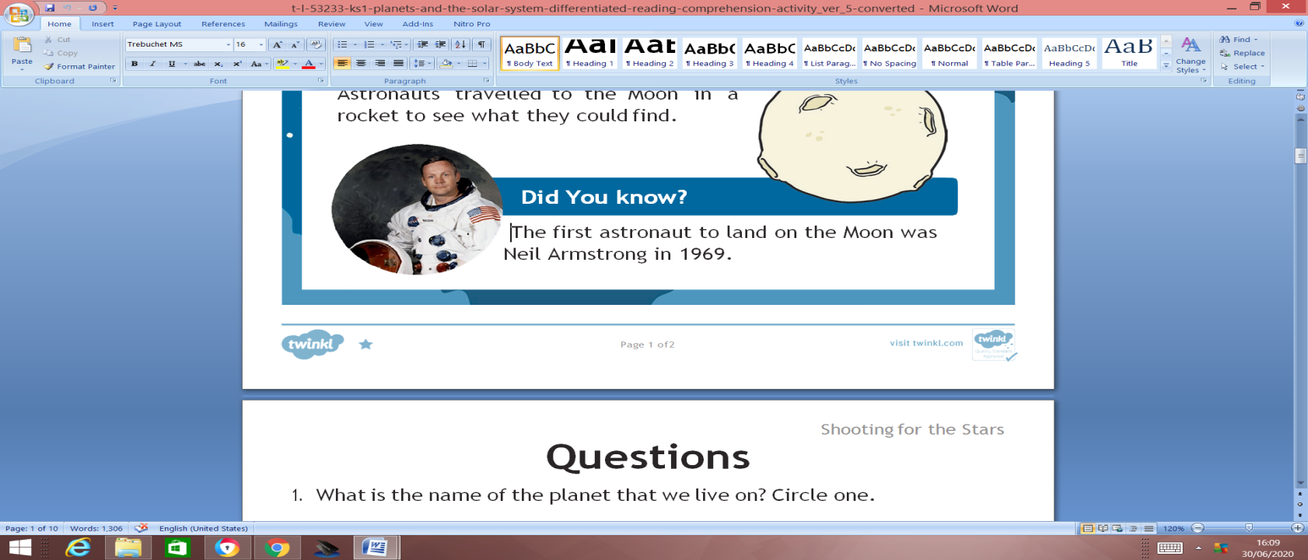

Questions

Write the answers in full sentences.

1. What is the name of the planet that we live on?

Jupiter Earth Mars

2. Where do fish live? Circle one.

in water on land in trees

3.What is in the middle of our solar system?

Mars on the moon the Sun

4. Who has travelled to the surface of the Moon?

doctors astronauts firefighters

