Week 7
Reading comprehension
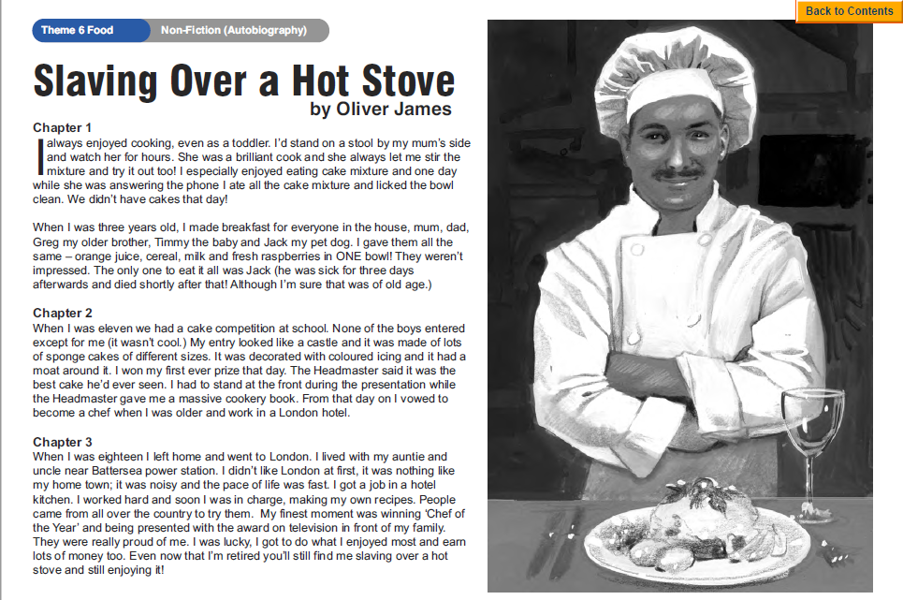
Questions
Year 5- Answer questions 1-6
Year 6- Answer questions 1-8
