Week 5
Reading comprehension- Yr 5 and 6
Comprehension-The Himalayas
Read the following passage and answer the questions.
Remember to write a whole sentence for your answers.

The Himalayas are the highest range of mountains in the world. The name ‘Himalaya’ means ‘land of snow’ and this is a good description as these mountains are always covered in snow. The Himalayas run from Pakistan to Tibet. The highest mountain in the world, Mount Everest, is in the Himalayan range. It is 8,863 metres (29,079 feet) high.
The summit of Mount Everest was not conquered until 1953. It was climbed by
Edmund Hillary from New Zealand and Tenzing Norgay, a Sherpa tribesman. They reached the summit and were the first people to stand on the ‘roof of the world’. News of their success reached Britain on the day of Queen Elizabeth’s coronation, 2 June 1953.
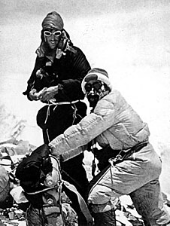

Questions

Yr 5- Answer questions 1-7
Yr 6- Answer questions 1-10

1. What are the Himalayas?
2. What does the name Himalaya mean?
3. What is the name of the highest mountain in the world?
4. How high is the mountain?
5. Who were the first people to climb Mount Everest?
6. What does ‘summit’ mean?
7. What happened on June 2nd, 1953?

Now read this passage to answer the following questions

Sherpas are the mountain guides from India and Nepal who have led mountain climbers to the top of the Everest. Without them, not many would have made it to the top of the world. Of the 1500 Everest summiteers, more than 500 are Sherpas. Sherpa Appa holds the record of 12 Everest ascents.
8. Who are Sherpas?
9. Who has climbed Everest the most times?
10. Leyland made a van called the Sherpa. Here is a picture used to advertise the original Sherpa van. Why do you think they put elephants in the van? What does it show the person who’s thinking of buying it?

