Week 5
English comprehension – Year 1 & 2
A New Pet 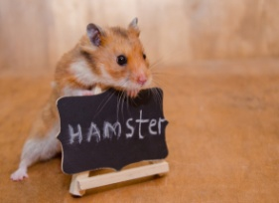
Tom was six. He lived in a flat with his Mum. The flat was on the top floor. It was very high up!
One day, Tom said to his Mum, “Mum, can I have a dog?”
But Mum shook her head and said, “No Tom, you can’t have a dog. There are no dogs allowed in a flat.”
Tom wanted to cry. Then he said, “Mum, can I have a cat?”
But Mum shook her head and said “No Tom, you can’t have a cat. There are no cats allowed in a flat.”
Now Tom did start to cry, “I want my own pet!” he shouted.
Mum patted Tom on the back and gave him a kiss, “Don’t cry Tom, I will see what I can do.”
The next day, when Tom got home from school, there was a small cage on the table. Tom was excited! He ran to look in the cage. In the cage was an orange hamster! Mum put the hamster in Tom’s hands.
Tom smiled and said, “I will call it Rusty. Thank you, Mum!”

Questions
Please answer the questions in full sentences.
Year 1- Answer questions 1-7
Year 2- Answer questions 1-10

- How old is Tom?

- Where does Tom live?

- What pets did Tom want?

- How does Tom feel when Mum says “No?” How do you know this?

- How does Mum try to make Tom feel better?

- Why was Tom excited when he saw a cage on the table?

- What was in the cage?

- Why did Tom call his pet, ‘Rusty?’

- How do you know Tom is happy about his new pet?

- Do you have a pet or would you like one? What kind of pet?

