Thursday 17th December 2020
Year 3 &4 Homework
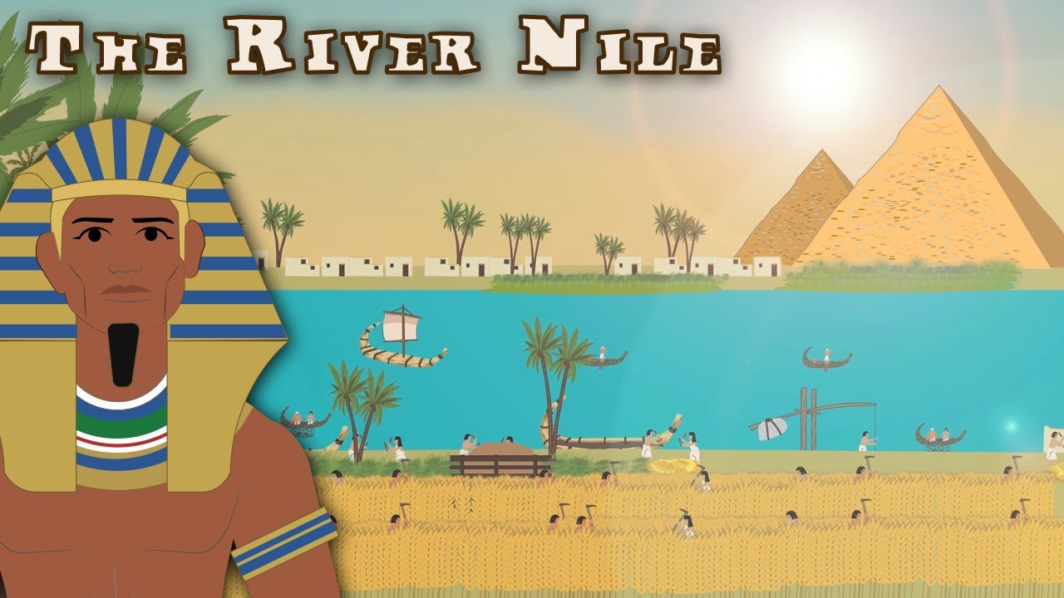

Year 3 & 4 students will be learning about ‘The River Nile’. You will learn everything you need to know about the River Nile and its impact on Egypt. You will learn to locate the River Nile on a world map and identify the countries it runs through. You will be able to identify the source and mouth of the river and to investigate its main physical and human features.
During the holiday, I would like you to research interesting and fun facts on the River Nile and why the River Nile is important to modern Egypt?
Create
- Posters
- Fact sheets
- Drawing and paintings

Please ensure that your work is neat, tidy and fabulous so you can have fun and the class can also have a good time learning about what you have researched.
Have a wonderful holiday Insha Allah!
Mrs Zainab and Miss Sultana

