Thursday 1st October 2020
Year 3 Homework

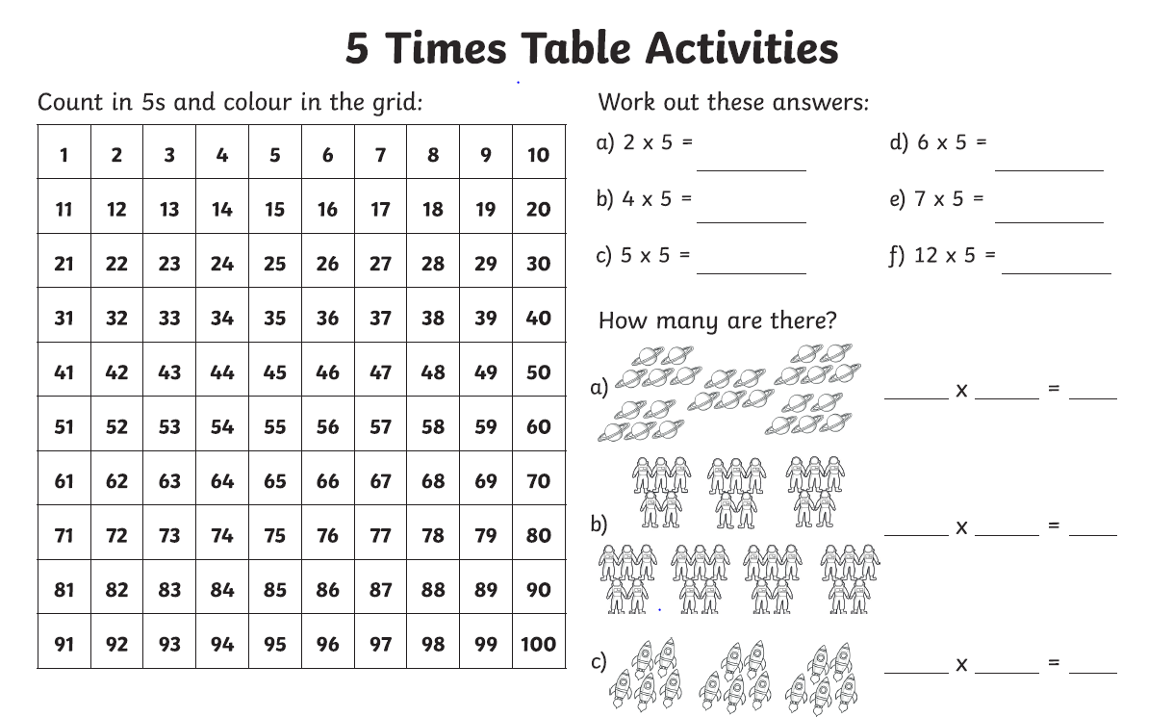

Week 4 - Year 3 Spelling
