KS1 – Flip Learning for W6 – 19th – 22nd October 2020
Dear year 1 & 2 - We are going to write poems next week in sha Allah so I think it will be a good idea to look at the videos of Joseph Coelho talk about it.

How to write fun poetry | BBC Teach
https://www.youtube.com/watch?v=2BSG2QRj_4M

How to write poetry about feelings | BBC Teach
https://www.youtube.com/watch?v=FcTdjH_vugk

How to perform poetry | English - Nothing Rhymes with Orange
https://www.youtube.com/watch?v=wFCcbFtd6Zo

This week we have started learning to add and subtract:
- Year 1 – Numbers within 20 (including money)
- Year 2 - Numbers within 100 (including money)

Please look at the following examples and try to practice your maths skills in sha Allah.

Year 1:
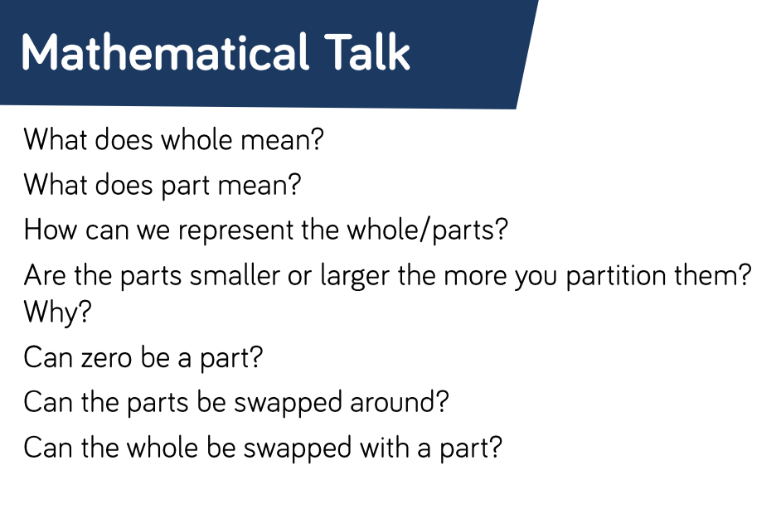
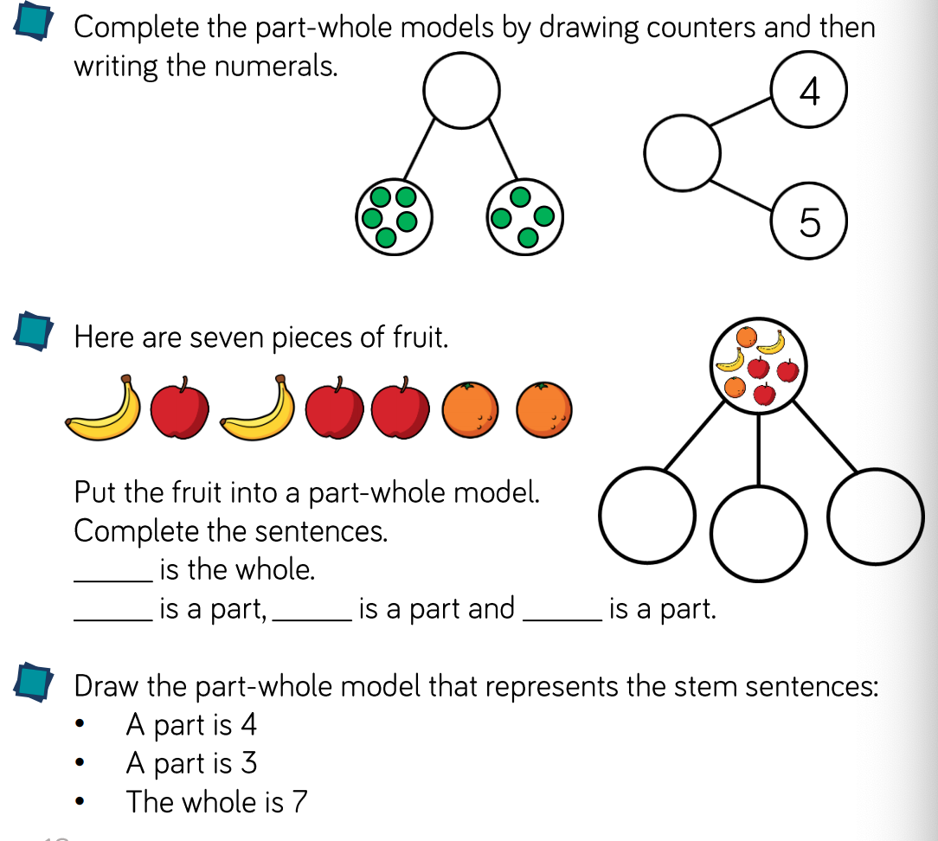
Year 2
