Nursery Homework
English  Watch the following video with your child:  https://www.youtube.com/watch?v=ls6wTeT2cKA&t=3s  After watching the video, ask your child the following questions:  - Can they remember what seasons were mentioned in the story?  - What was happening to the tiny seed in each season?  Challenge:  Can they draw 4 different pictures to show what was happening to the seed in each season? | Maths  Recap numbers 1 and 2 with your child.  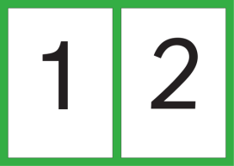  Can they write them down correctly?  Now get your child to practise writing number 3.  As they write it say-  