Year 1 Homework
Spelling
Year one to write out each word four times and then make a sentence including the word.
Example:
Word: by
by
by
by
by
i went to school by taking the bus.

Spelling  words | X1 | X2 | X3 | X4
off
well
miss
buzz
back

Once you have completed these words, please practice spelling out the word of the week. Our word of the week is grating.
Definition of grating: harsh and annoying
Please write out two different sentences using our word of the week.

Timetables

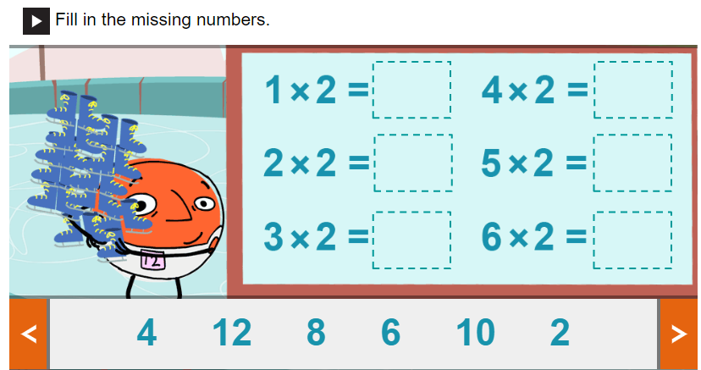

PLEASE REMEMBER TO HAND IN YOUR HOMEWORK BY MONDAY 2ND NOVEMBER 2020.

