Year 4 - Week 2 – Homework

Thursday 17th September 2020
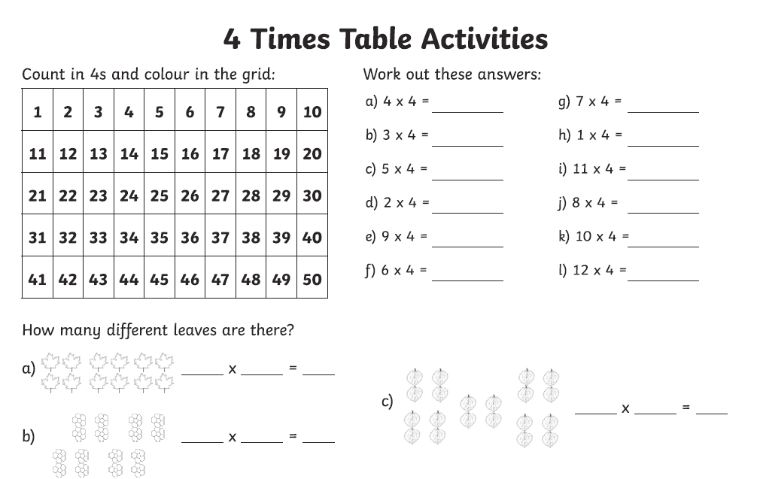

Week 2 – Year 4 Spelling
