Thursday 17th September 2020
Year 3 Homework
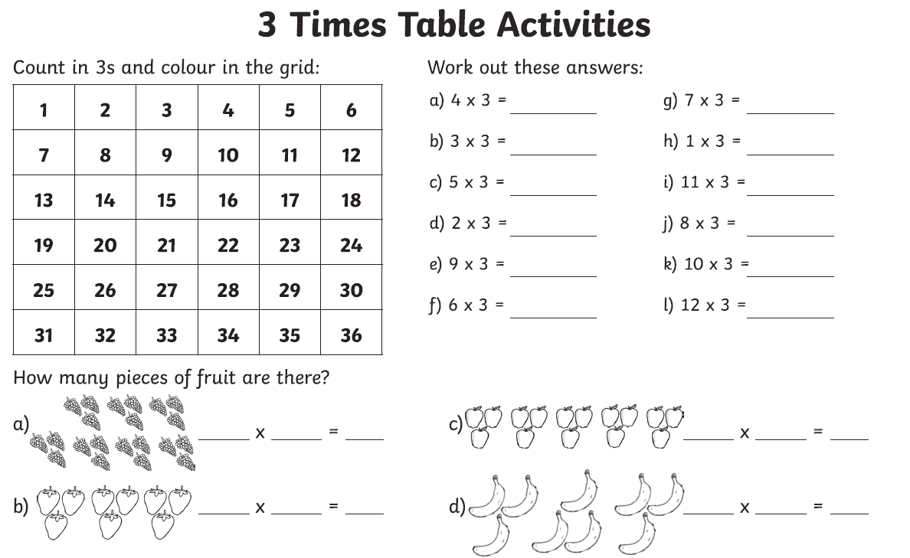

Week 2 - Year 3 Spelling 