W2: Literacy Flip Learning

Task:
This is the book we will be reading for this term. Look at the picture and answer the following questions in your homework book.
Due: Tuesday 22nd September 2020

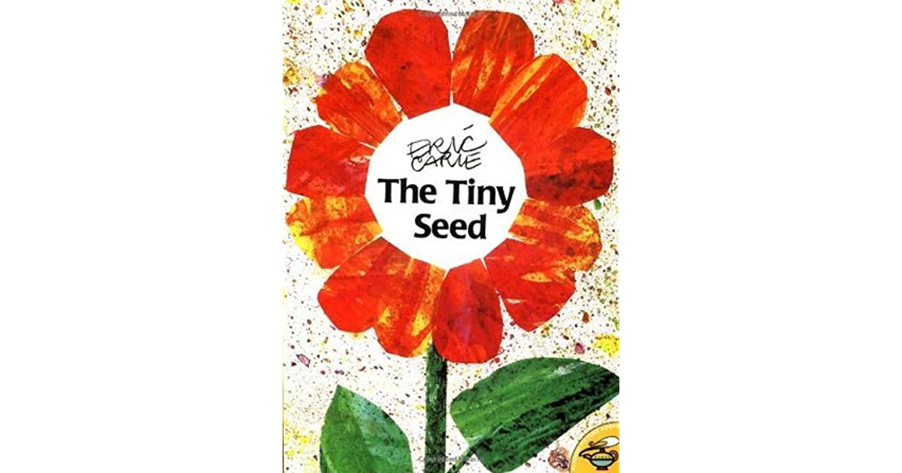

Where is the title?

Where is the name of the author?

Have a guess at what you think this book is about by looking at the picture on the front.

