Year 2 Homework
SPELLING
Year 2 students to practise and write out each word x4 and then form a sentence including the word. Please make sure you write it out in your homework books.
Example, word: came
came
came
came
came
He came to the party.
Year 2 spelling words:
- climb 6. cold
- most
- only
- both
- old
TIMETABLES
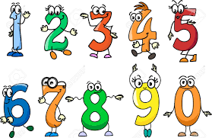
Year two to write out and practise their 4 and 5 timetables.
Please make sure you write this out on your homework books, write it out twice or three times. Practise makes perfect! Try to say it out loud so you can remember and memorise. Try to write up to 40 for your 4 timetable and up to 80 for your 5 timetables.

Example, 5 timetables.
5,10,15,20,25,30,35,40,45,50,55,60,65,70,75,80…

HOMEWORK TO BE HANDED IN BY WEDNESDAY MORNING!!! (30/09/20)

