Week 18
Monday 20th July 2020
Reading comprehension
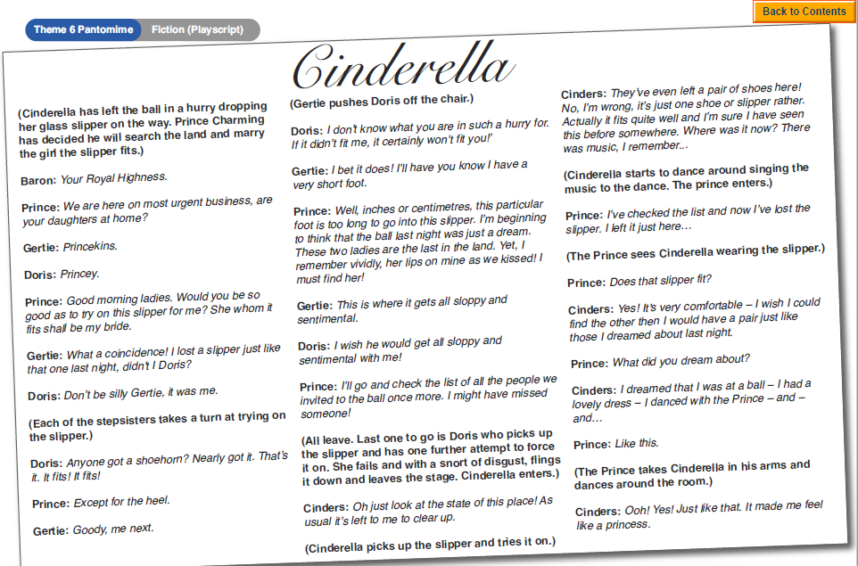
Answers
Year 5- Answer questions 1-6
Year 6- Answer questions 1-8
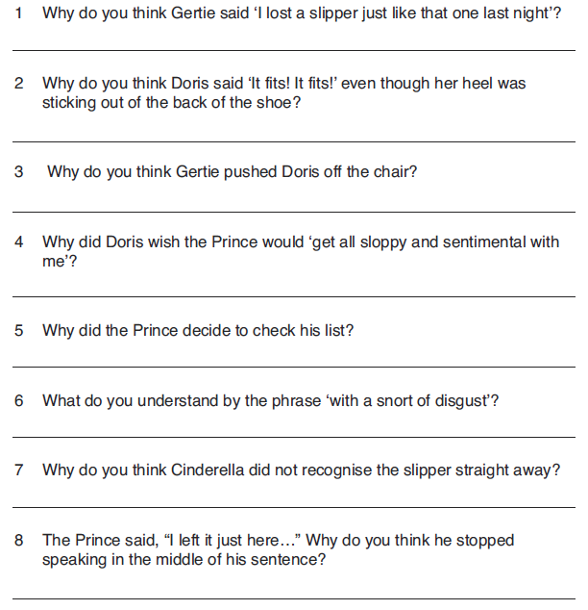

Tuesday 21st July 2020
English SPAG
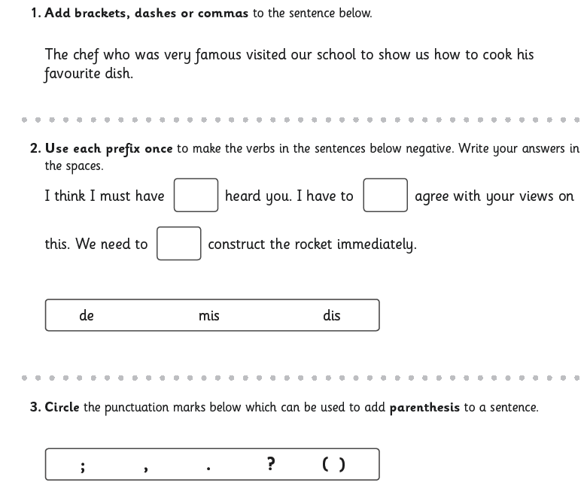
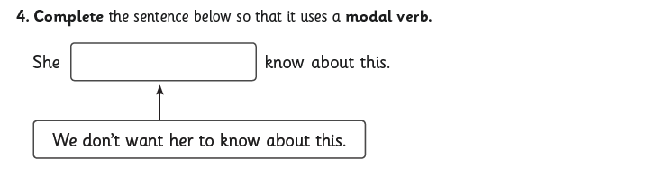

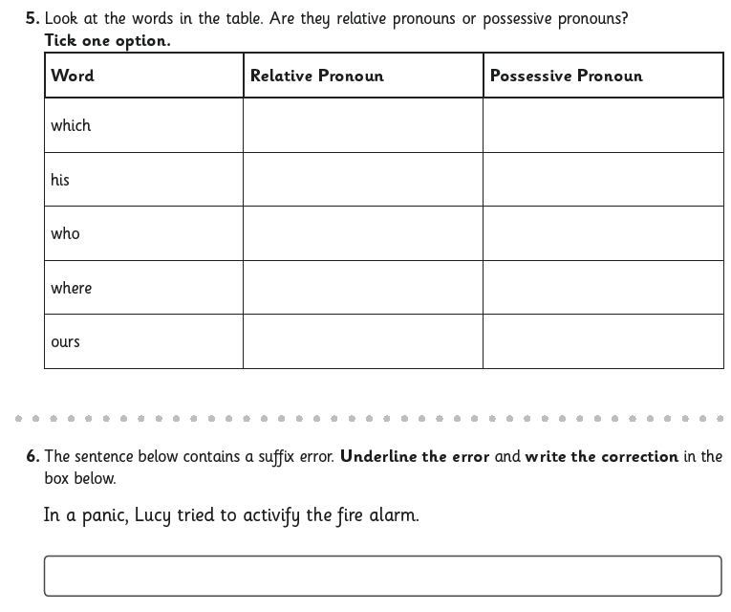
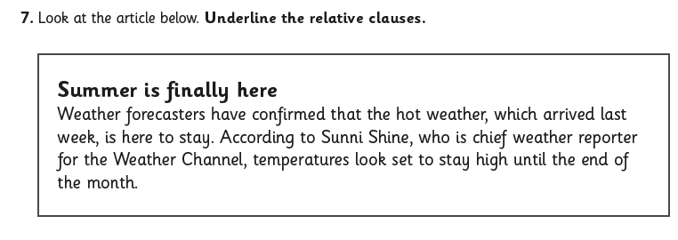

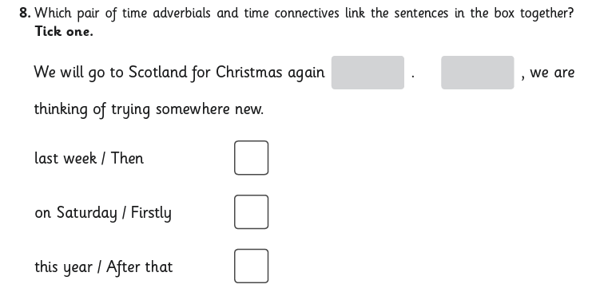
Wednesday 22nd July 2020
English writing
The Time Capsule
Without a doubt, the year 2020 will be written in history! The COVID – 19 pandemic affected our daily lives drastically! All around the world people faced challenges to adapt to this new way of life. What will you remember? What can you share with the people of the future? Think of how people in the future might learn about this time that we are living through right now. What will they learn about it?
Task: Your task is to present a time capsule of what you would like to share with the future generation – you can collect snapshots of most memorable objects, events, or experiences and write a summary of it, why it was so memorable. You can also write a letter to yourself as a memory of this time to open later in the future. All these can be a part of a time capsule to be opened in the future by you or someone else in the future. Imagine it as an artefact to help explain to others this historical event.
Here are some examples of what others have recorded:

Life in Lock Down on Lear Drive

Introduction
Coronavirus, Coronavirus, Coronavirus. The only word said at the moment is Coronavirus. But soon, it will be gone. This is an article to tell you what it was like living in lockdown to keep safe from Coronavirus.

The bad things
The bad things about lockdown might be you are stuck at home and you can only go to a certain number of places like Wybunbury walk. Or it could be you cannot see any family or friends unless you might bump into them somewhere, like I did at the park. This may sound awful. You might have missed school even the hot dinners. Luckily there are some good things about Coronavirus.

Good things
If you are a gamer like me, you will get lots of time on computer games like Fortnite, Overwatch and iPad games such as Zooba! It is also good that every day you might go down to the park to play football with your Dad or have music practise with your Mum. Do you like staying at home? Or do you like going to school?

Keeping in touch
Different ways you may keep in touch might be talking to people on zoom or on a computer game Like Fortnite. I sometimes do a video call to my Grandma and Grandad and sometimes my cousins. You might also get a phone call from your teacher. There are lots of different ways to keep in touch with people. Have you been keeping in touch with people?

Typical Day
7.30am I get up
10.00am we start school maths (White Rose Maths plus my teacher’s extension)
11.00am break time football with Elodie my sister.
11.30am to 12.30 pm English (BBC bitesize watch a few videos then do a task.)
12.30 to 1.30 lunch relax on iPad.
1.30 to2.00 wash up (I get paid!)
2.00 to 2.30 sax practice.
3.00 to 4.00 end of day. Sometimes we go for a walk eg. Duck pond with baby swans and ducklings.
6.00 tea
8.00 bed

Conclusion
When I look back on lockdown, I will remember this time for staying with my house hold every day but not seeing any friends. I did like getting lots of time on computers, but I really missed playing with my friends at football and cuddling my little cousins. I hope lockdown never happens again!
Me and my sister doing a spooky story 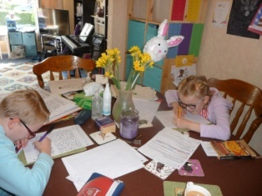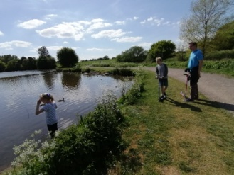 Us at the duck pond seeing ducklings
Monday 4th May 2020
Dear me,
It is now been almost 3 months since the Coronavirus broke out across the world. Covid – 19 pandemic they call it. It’s plastered across the media and I can’t help but feel anxious. Due to this so called Covid – 19 pandemic, we had to lock ourselves away from our normal daily routine of school, work, friends and other activities as we call ‘normal’.
We are at home everyday trying to find different ways to keep busy. Mum and dad are trying to stay positive by teaching us all kinds of new things that we wouldn’t have normally done if we were back in school all day. I enjoy learning to bake all sorts of delicious treats, like raspberry and white chocolate cupcakes. Dad has taught me to sew and I actually sewed my own cushion for my bed! I still have to do school work every day, which is a bummer! But I actually feel that it helps me feel like my life is somewhat ‘normal’! Even that word ‘normal’ has become a strange to me. I am not sure anymore what is ‘normal’, maybe this new way of life is ‘normal’ now. I often play a game with my brother when I find myself feeling a bit lost and bored with everything else.
The ‘outside world’ is strangely calm, almost like a ghost town! The streets in my neighbourhood are most of the time deserted, with one person or two passing by. We line up for almost everything now: the local grocery store, the pharmacy and that’s about it. I mean there isn’t anything else to line up for since there isn’t anything else open! Frightening - libraries, shops, parks, schools, theatres, restaurants, everything that you could possibly imagine that was a part of our lives, has been shut down indefinitely, for now! Even public transport has slowed down and everyone is to ‘remain at home unless travel is absolutely necessary!’ We are bombarded by the government’s quote: Stay home. Save the NHS. Save lives. The doctors and nurses are our heroes at the moment. The eerie silence of outside is broken on Thursday nights, when we hear clapping and the clanging of pots and pans in our neighbourhoods. I usually like to peek through the curtains to have a look, neighbours hanging from their windows with their utensils and pots and others frantically clapping outside their front doors. Mum and dad are usually too busy rushing us to bed for any of us to participate, although at times, I have noticed mum also glaring out the window watching the applauses for our ‘NHS heroes’.
The news is constantly updating us on how many people have now been infected and how many have passed away. It scares me to think what we would do if any of us were to fall ill. Some say it’s like the flu and it passes, while others have warned of the possibility of long term damages to our organs like our lungs or kidneys. I don’t really understand it all, but I do know that I don’t want any of us to catch it! Even the GP offices are only taking phone consultations. One of the days, I was feeling very unwell and my mum had to ring the surgery. Despite her calm appearance, I could see she was quivering inside. I could almost read her mind: ‘what if she’s caught it?’ After the meeting over the phone with the GP (which involved a lot of ‘ummings’ and ‘awwings’) I could see she was somewhat satisfied and relieved. That also put my fears at ease (for that time anyway!). I mean, how could I possibly catch it being locked away most of the days with very little contact with others? Mum and dad even take it in turns to go out to the grocery store without taking us. Our daily exercise and means of getting fresh air and natural vitamin D from the sunlight, is either running around our garden or taking a walk around our neighbourhood. It’s almost like a treat now to get to go to the shops!
Well, there you have it: our lives living with COVID – 19. I can only advice to the future me, who is reading this (or anyone else!) to always remember that we got to know each other during these past few months. I don’t know how much longer we will spend living like this, but I do know that our lives and who we are have been changed forever. How? You may wonder. Well, I now know more family members than I ever have in a short span of time, and I think we will all make that joint effort now to make those once ‘tedious phone calls’, now they are ‘a need, a must’ in our daily routines. We actually listen to each other and have become more creative as a family in many ways. I don’t think we have had this much time together and I’m not sure if we ever will, but I think everyone will agree, it was much needed. Thank you COVID – 19 pandemic for making us better people!

Yours truly,
Emily

Thursday 23rd July 2020
English spellings
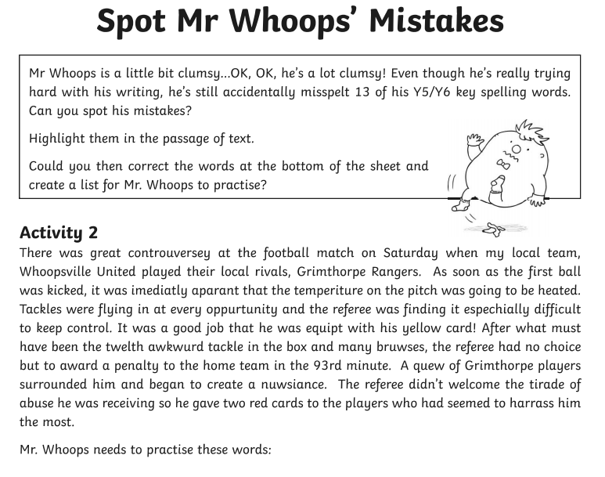
Please make a list
Friday 24th July 2020
Reading comprehension
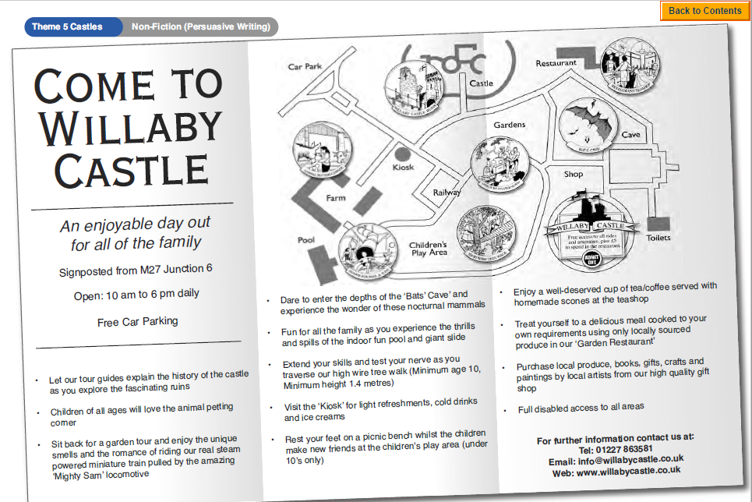

Questions
Year 5- Questions 1-6
Year 6- Questions 1-8
