Week 16
Monday 6th July 2020
Reading comprehension
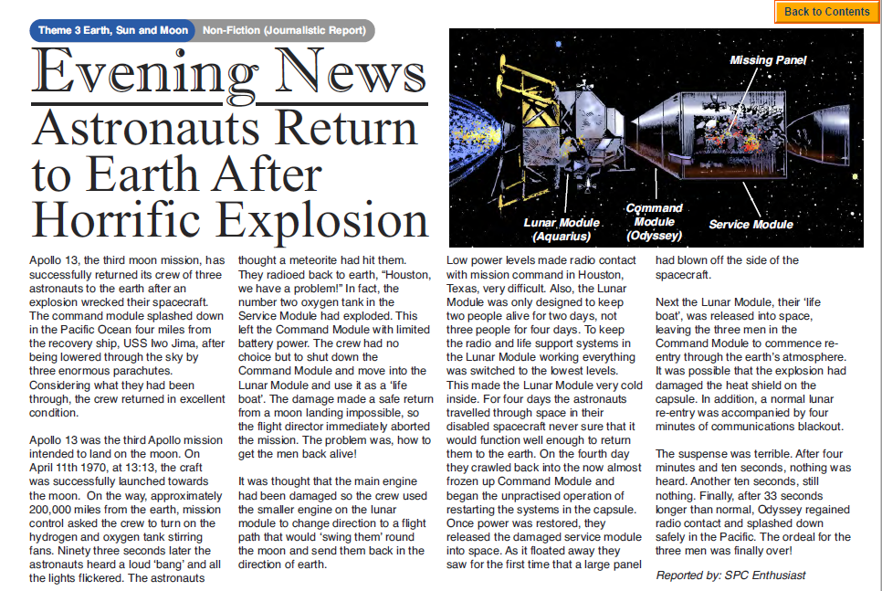
Questions
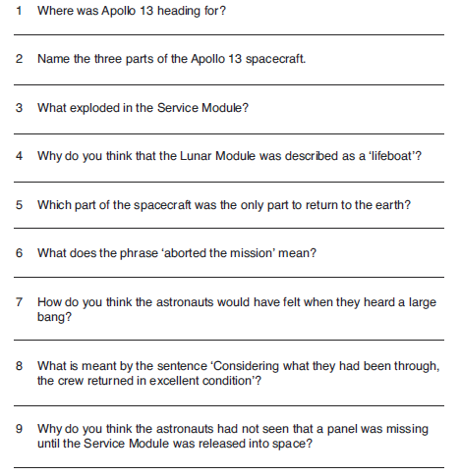
Challenge: Imagine you are on a space mission and something goes wrong. Write a short newspaper account telling what happened.

Tuesday 7th July 2020
English SPAG
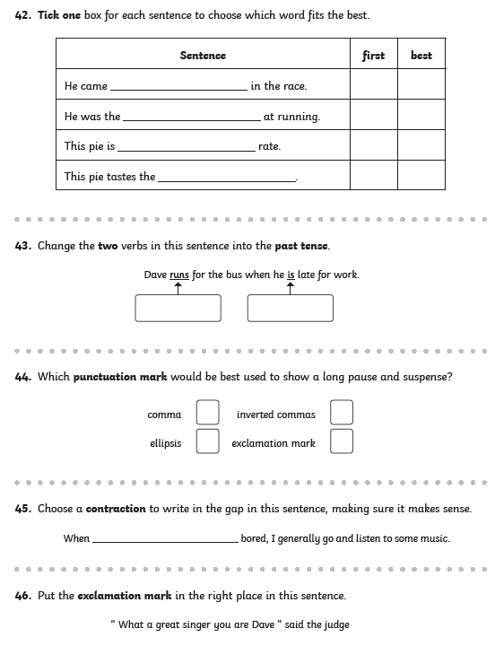
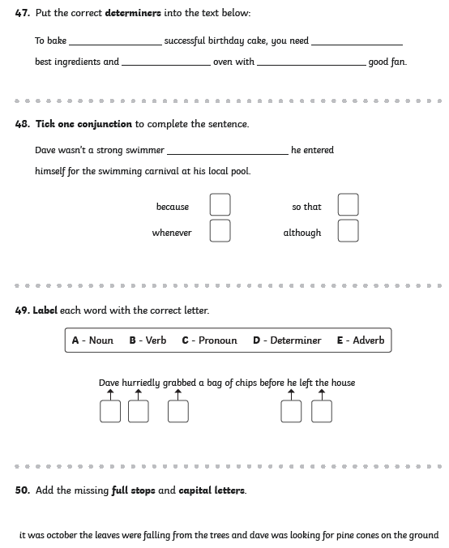
Wednesday 8th July 2020
English Writing
Lockdown Creative Writing
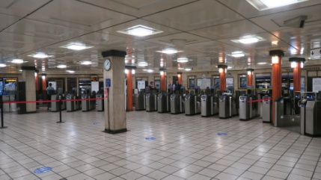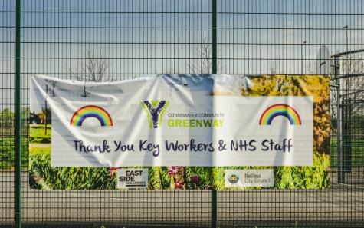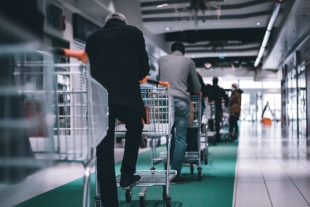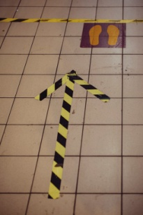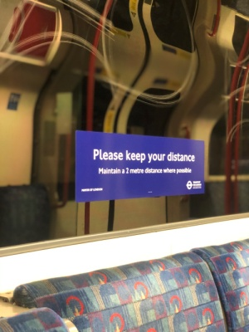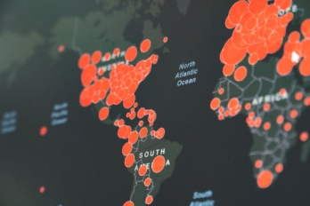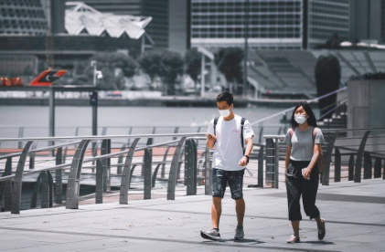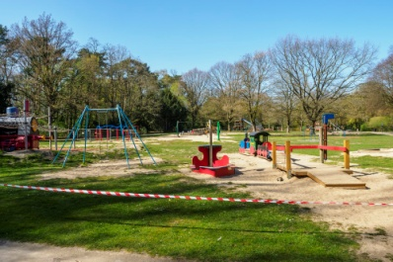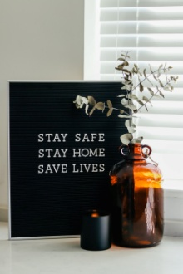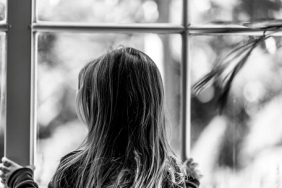
These are some of many images captured during the lockdown around the world...

How do they make you feel? What emotions, thoughts and ideas do they inspire?
Think about your experience during the lockdown – what impact has it had on you? How did it change you or your life? Do you think your life can ever be same again?

Put your thoughts and emotions into a piece of writing. It can be a poem, a short story, or even a creative story. Here are some examples of students’ writing around the world: https://www.bbc.co.uk/newsround/52984345

Maya, 14, from Za’atari refugee camp, Jordan

“Where’s the school? Where are the classes?
And my friends, and the teacher asking us about our homework.
Empty and sad streets.
And the playgrounds are as if they’re asking about us.
Corona, tomorrow you will see.
Our dreams, our awareness and our will, shall bring us victory over you.”
Lincoln, 11, from the United Kingdom
"When it is safe, I’ll hold my arms open wide,
and shout to the world we can all go outside!
Don’t give up hope the end is in sight,
if we all stick together, we’ll all win this fight!”

Molly's poem
Home is now where school is,
Our lives in a mess.
More and more challenges every day,
Education has changed; everything on the internet.
Sitting in the sun; writing and reading,
Computer always on, providing me lessons.
Open-minded, trying new things.
Obeying the law, social distancing.
Longing to see my friends again,
Improvising and being creative.
Negative vibes are not needed now,
Good and positivity will show us the way.
By Molly

Corona

It happened so sudden

It is still unclear

How you got here

You came down like a heavy burden

And instilled so much fear

To such an extent the bustling streets were cleared

Days, weeks and months hidden in our dens

But we are still told to stay clear

Will we ever see a day that we can cheer?

Our hearts and minds can see no end

Through window panes we stare

Unsure of how much more we can bare

Anonymous

Thursday 9th July 2020
Spellings
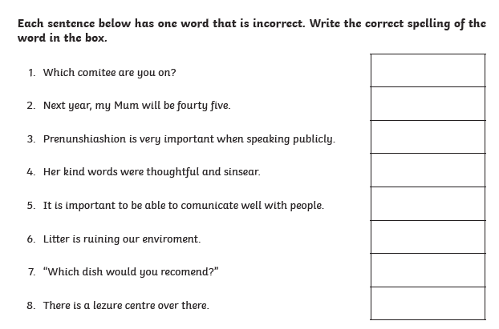
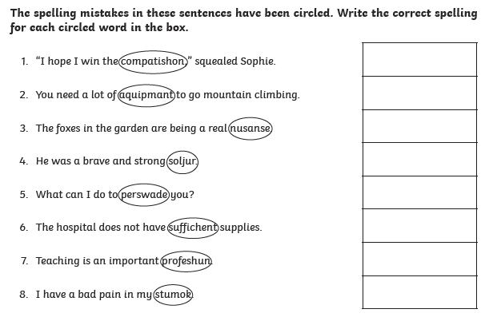
Now write a sentence using each word that you corrected. Make sure the word is written in the correct context
Friday 10th July 2020
Reading comprehension
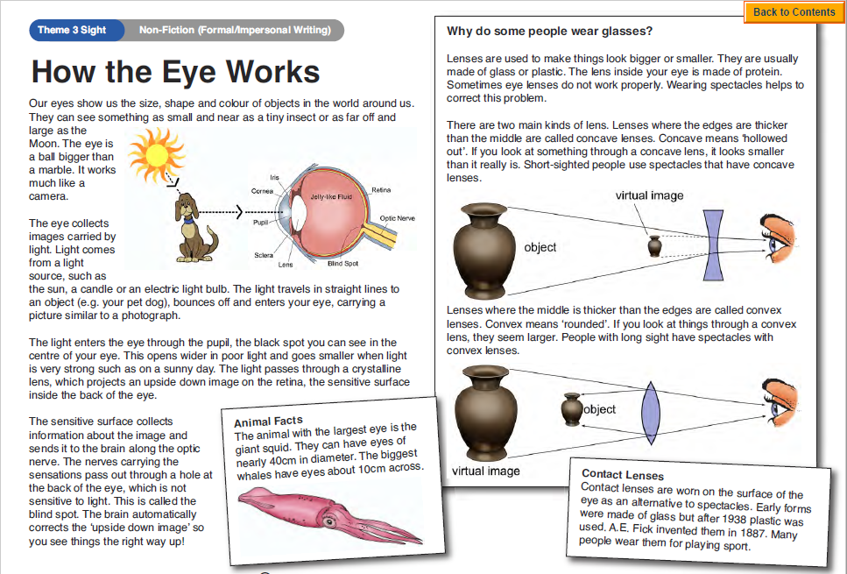
Questions
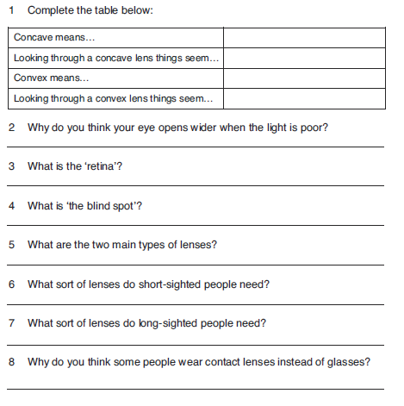
Challenge: Write a short story in which you meet a giant squid with an eye 50cm in diameter.

