Week 15 - Monday 6th July 2020
Year 3/4
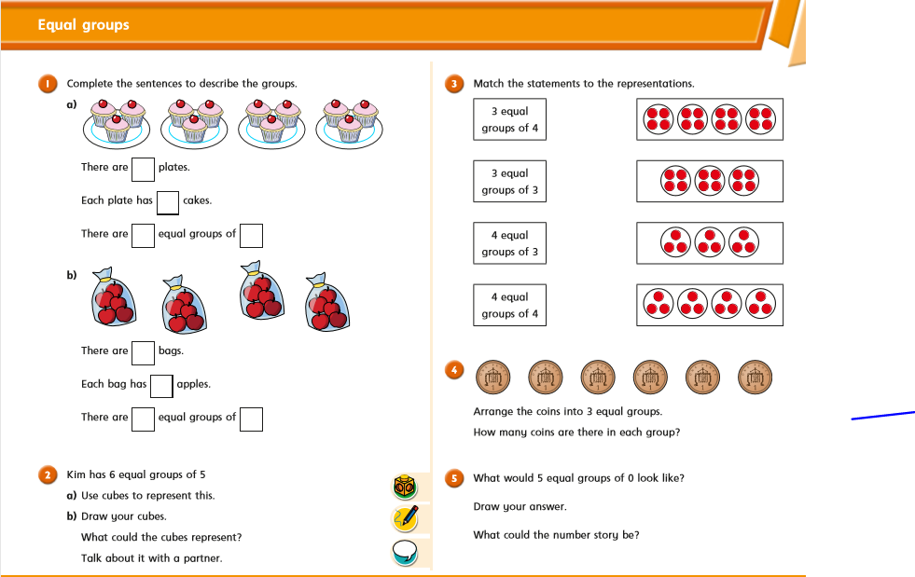
Year 4 Challenge
