Summer 2
Rec Maths

Notes for parents
(Remember gold prizes from me for neat outstanding work)

If you do not have access to a printer, provide your child with an exercise book to do their work in.

- Write the short date (today's date)
- Write the L.O:
- Miss a line
- Question numbers in the margin and write answers on the line.

(I will be asking your parents if your work looks neat and to send me a picture of your amazing work. I myself will check your work once you come back to school in sha Allah)

Monday 6th July 2020

Can you write the seven days of the week in order?

Sunday
Thursday
Monday
Friday
Tuesday
Saturday
Wednesday
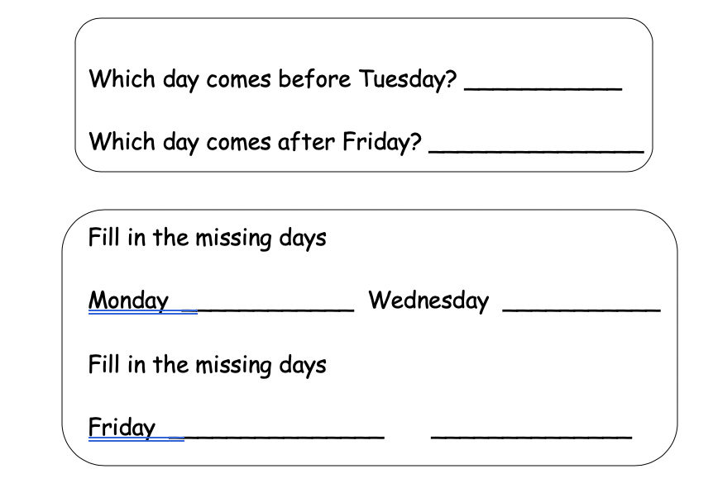

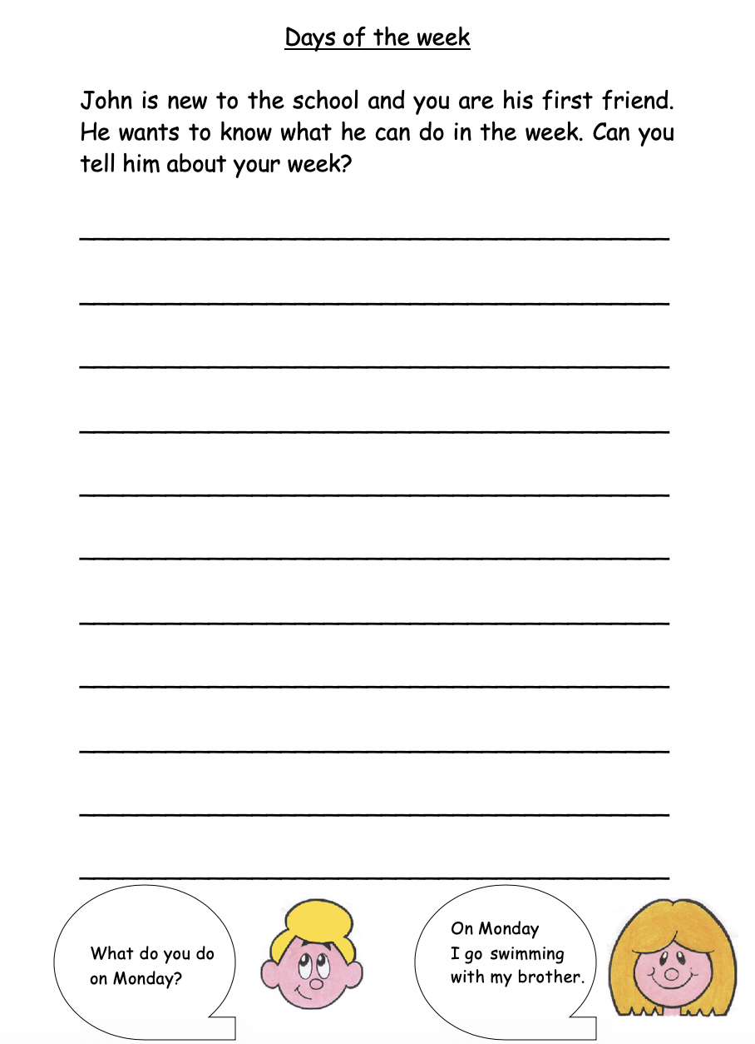
Tuesday 7th July 2020

Wednesday 8th July 2020

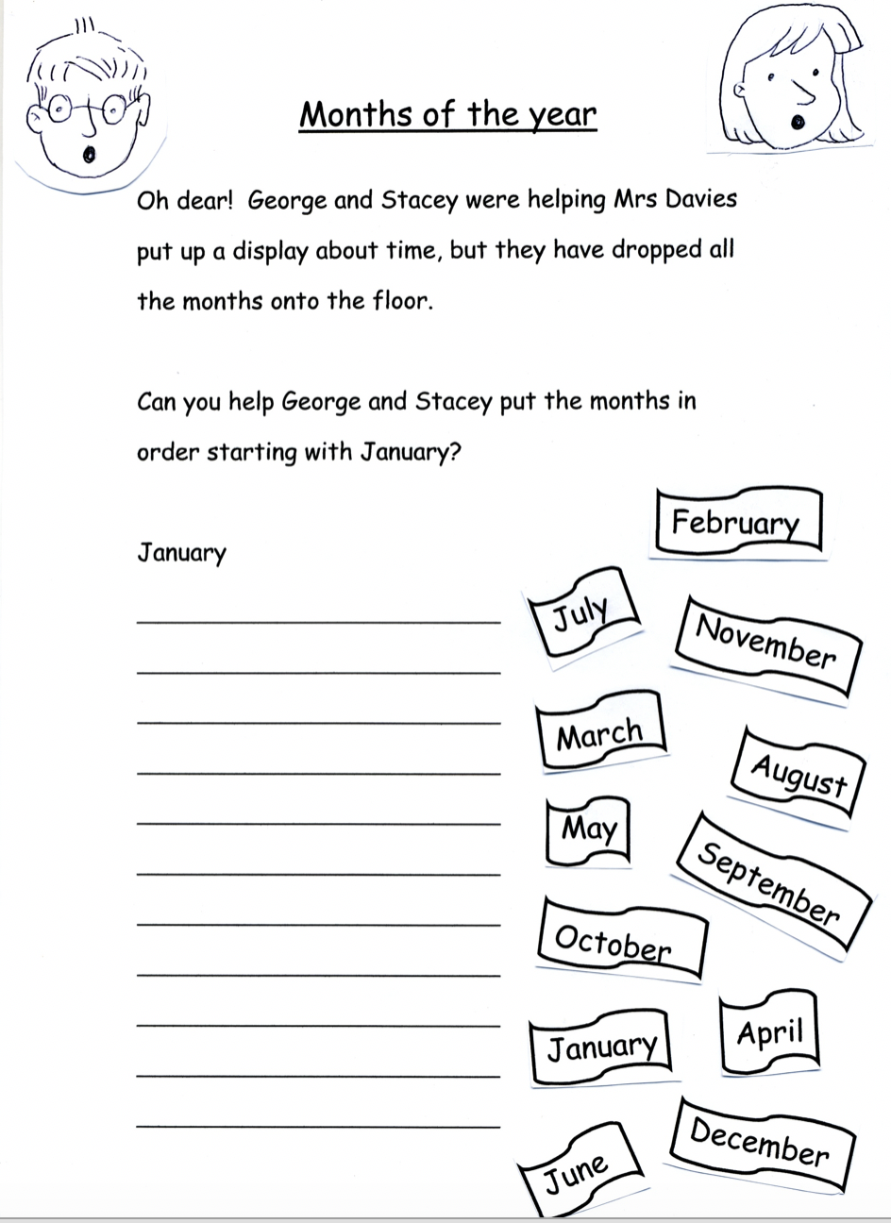

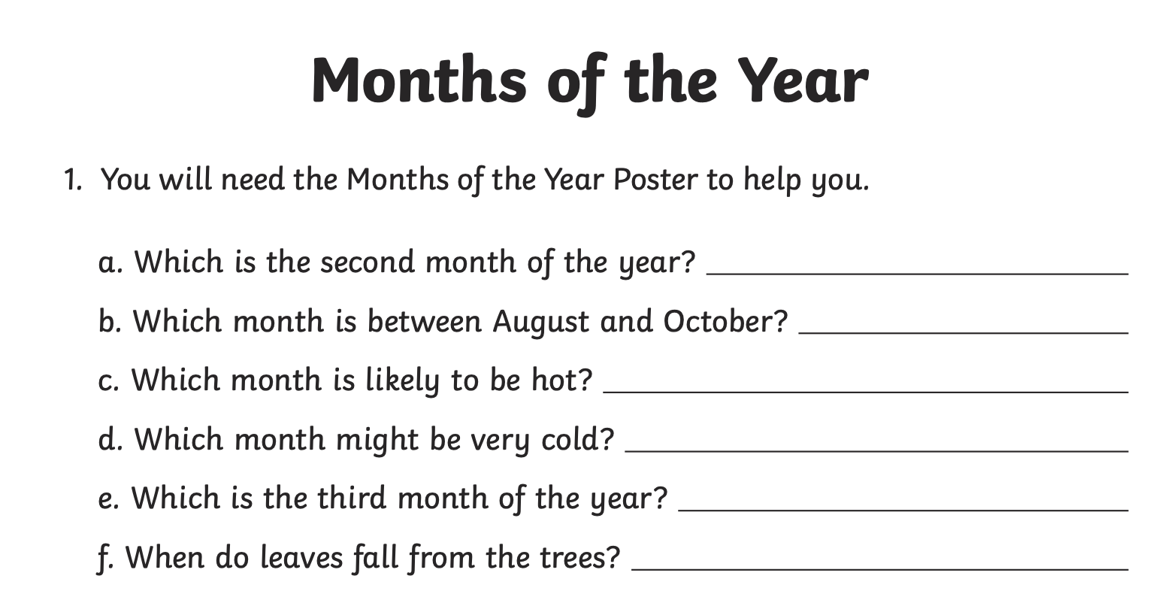
Thursday 9th July 2020

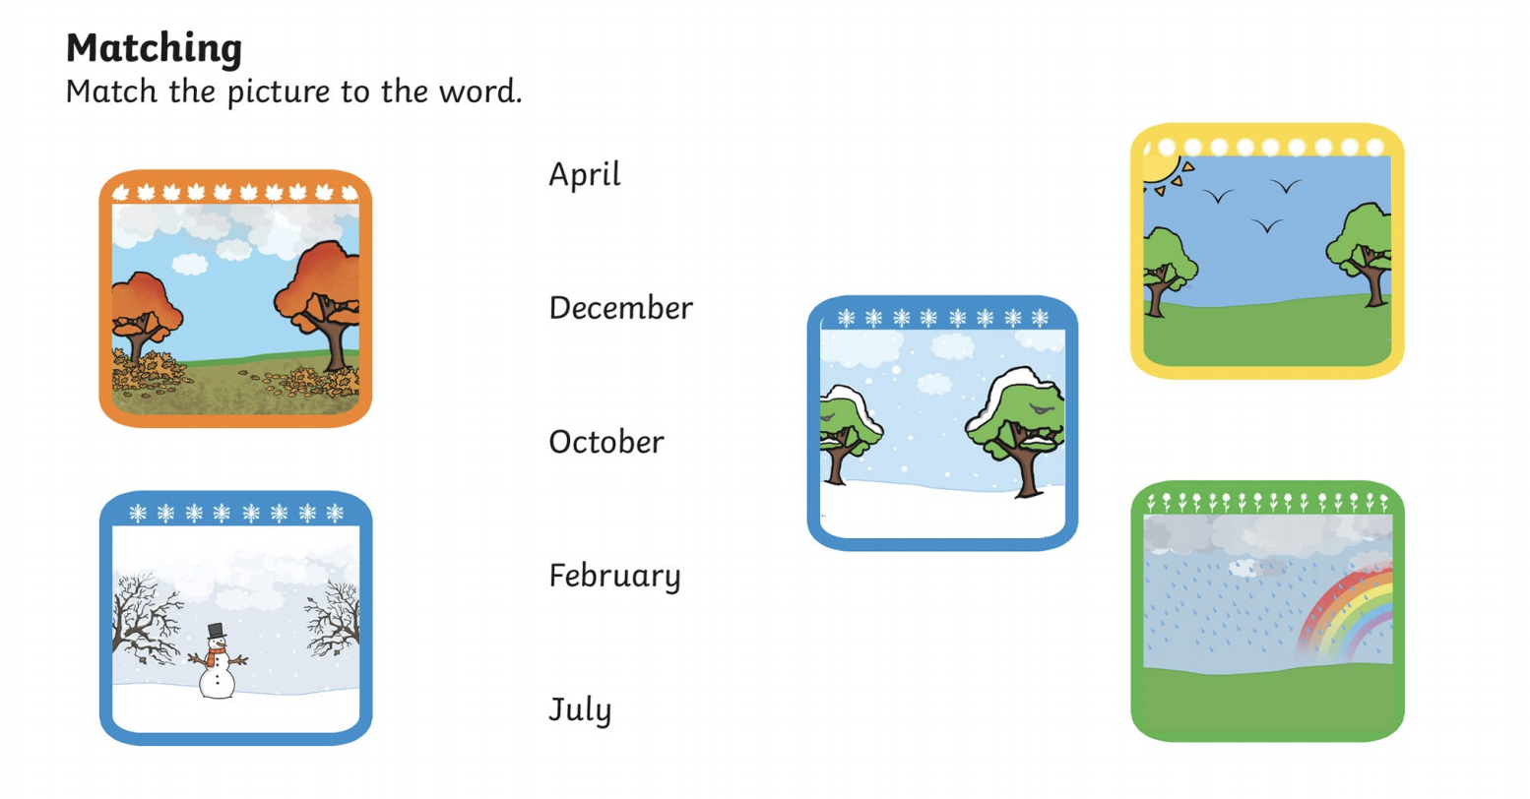

Friday 10th July 2020
