Week 15 Monday 29th June 2020 - English comprehension – Year 3 & 4 L.O: To answer reading comprehension questions by deducing and inferring information. Read the extract, then read the questions and find evidence from Usain Bolt biography to answer the questions.
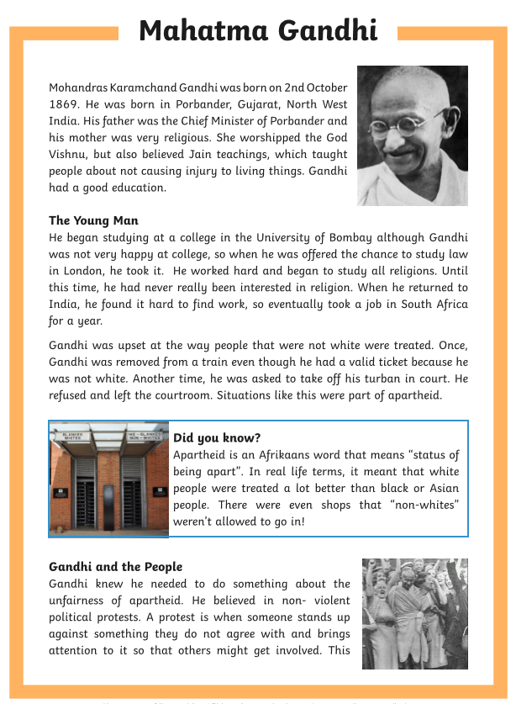 | 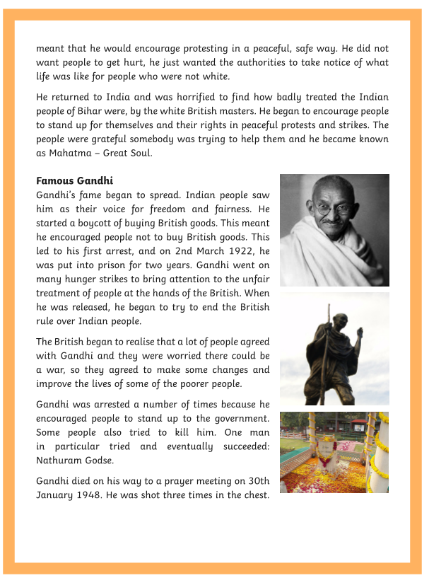

Questions- Year 3 answer questions 1 to 6
Year 4 should attempt to answer all the questions.
- Please answer in full sentences e.g. What area of India was Gandhi born?
- Answer- The area of India Gandhi was born is ______________

- What area of India was Gandhi born?

- Describe which two events made Gandhi realise that he was being treated differently in South Africa?

_________________________________________________________________________________________________________________

- What do you it was like for Non-white people living in South Africa?
________________________________________________________________________________________________________________

- What sort of protests did Gandhi believe in?
________________________________________________________________________________________________________________

- Why did the people call Gandhi ‘Mahatma’?
________________________________________________________________________________________________________________

- What were the British masters afraid of? Explain your reasons.
_________________________________________________________________________________________________________________

- What changes as a result of Gandhi’s protests?
_______________________________________________________________________________________________________________

- Who killed Gandhi?
_______________________________________________________________________________________________________________

Tuesday 30th June 2020
LO: I can add the suffix -ful to words to make adjectives.
Students MUST write the date and LO in their books.
TASK 1: Add -ful to these words to make an adjective.
Please complete ALL the suffixes.
Word Adjective  Example: Help Answer: Helpful  - Thought  - Mercy  - hope  - Success  - Care  - Hurt  - Colour  - Grate  - Wonder  10. Faith  11.Peace  12.Dread  13.Doubt  14.Respect  15.Power | TASK 2: Use the adjectives to form a sentence.  Year 3 should use 10 adjectives from the table above to form sentences.  Year 4 should use ALL 15 adjectives to form sentences.  Example: Help:  Sentence: The teacher was very helpful and kind as she answered all my questions.
Note from teacher:
Grammar lessons are very important as they will help you to improve and develop your English writing. Do not forget the basic grammars such as Capital letters, full stops, spelling, adjectives, adverbs and all other grammar rules we have been practicing until now! Please practise and implement what you are learning throughout your work and not just for that lesson! Thank you.
Tuesday 30th June 2020
Spellings
Write and learn the following words in your book.
Write the words 5 times.
Use each word in a sentence.
Do not forget to use a capital letter and full stop in your sentences.
Challenge- can you use at least 2 of the words from the list in a sentence?
Example- It is possible to ignore the pressure from your friends.
- position

- possess

- possession

- possible

- potatoes

- pressure

- purpose

Week 15
Wednesday 1st July 2020
English writing – Year 3 & 4: Task: LO: To write an information leaflet on how to look after a pet of your choice.

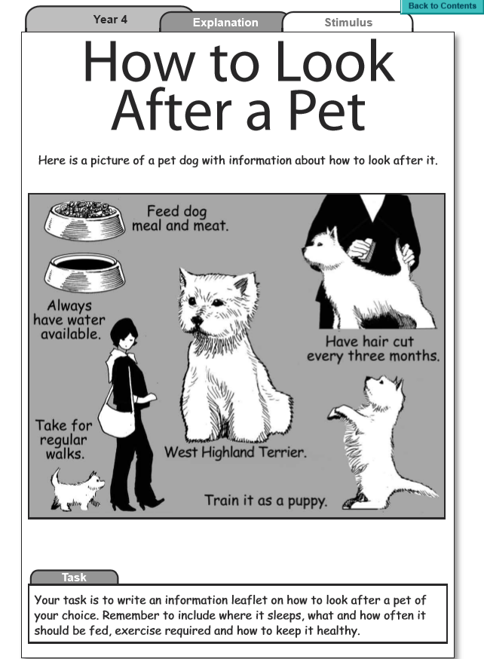 | 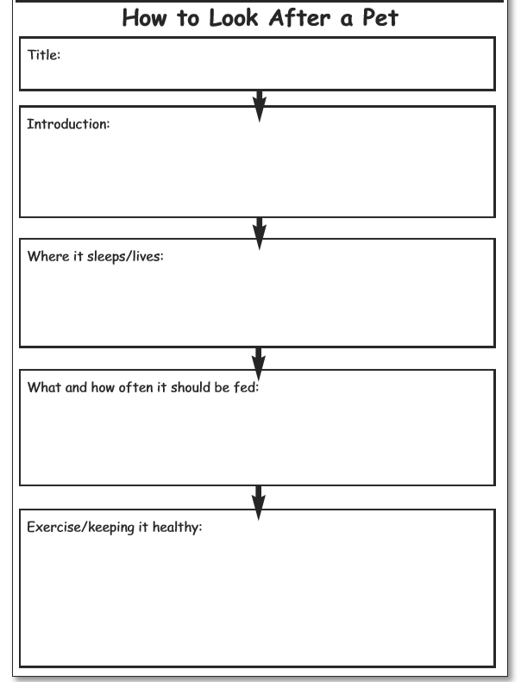

Your task: To write an information leaflet on how to look after a pet of your choice.  Remember to include:  Where it sleeps, what and how often it should be fed, exercise required and how to keep it healthy  Do not forget to:  - Use capital letters and full stops.  - Include lots of adjectives (describing words) and adverbs (to describe the verbs)  - Read each sentence to check if it makes sense.  - Use a wide range of punctuation including at least 3 of the following: full stop and capital, question mark, exclamation mark, apostrophe and comma.  - Use more sophisticated connectives, (e.g. although, however, nevertheless, despite, contrary to, as well as etc) | 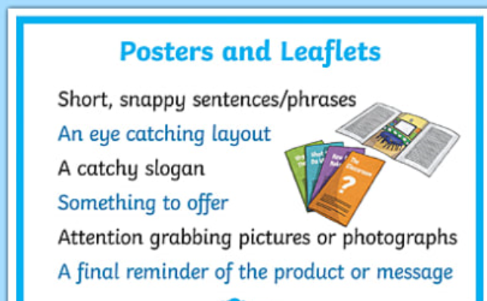

Week 15
Thursday 2nd July 2020
Reading and book review – Year 3 & 4
Click on the link and listen to the story of ‘Paddle-to-the-Sea’ Write A book review about the story.
https://stories.audible.com/pdp/B002V59ZLM?ref=adbl_ent_anon_ds_pdp_pc_pg-1-cntr-0-32
Book review by: ________________________________________________________
Title:_____________________________________________
Author: ___________________________________________
Non-fiction Fiction
What is the book about?
______________________________________________________________________________________
_____________________________________________________________________________________
Who would this book be suitable for? Age/interests

______________________________________________________________________________________
What was your favourite part? (Describe)
______________________________________________________________________________________
Year 4 challenge: Would you/would you not recommend the book to someone else? Why?

Week 15
Friday 3rd July 2020
Comprehension: Read the report and answer the questions in your home learning book. Make sure you date your work and write the title. Remember answers should be written in full sentences.

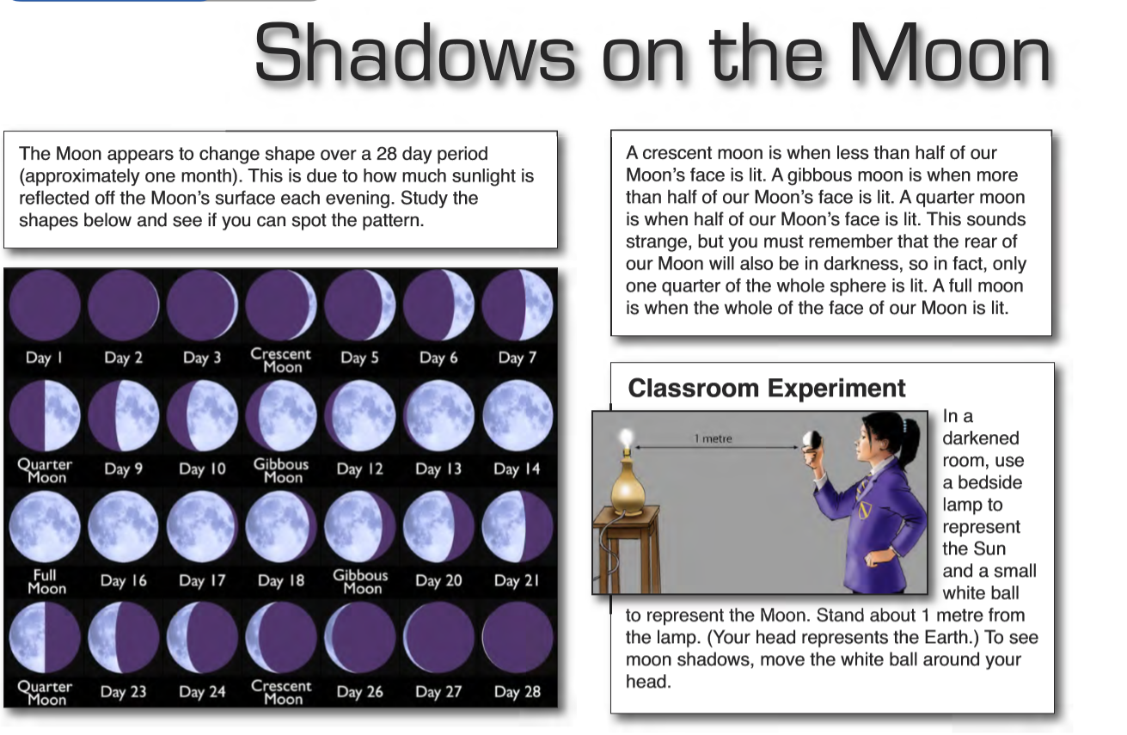
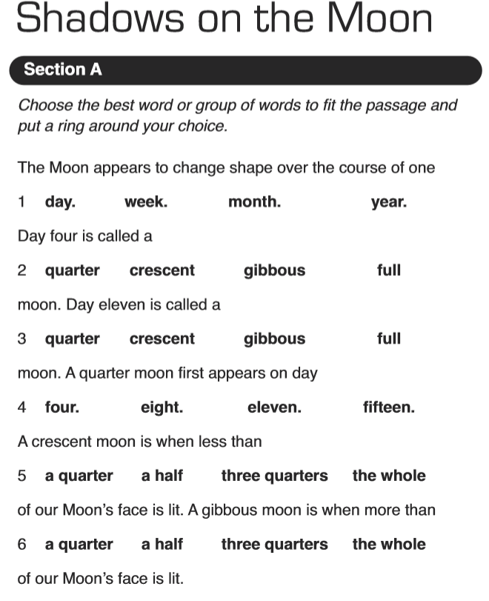 | Section B  - Does the moon change shape?  _________________________________________  - Over how many days does the change take place?  _______________________________________  - What is a full moon?  - What represents the sun in the classroom experiment? ____________________________________  - What does the ‘small white ball’ represent in the classroom experiment?  _________________________________________  - How can you see ‘moon shadows’ in the classroom experiments?  ____________________________________  - What makes our Moon appear to change shape?  ____________________________________  Challenge: write your own account telling how our Moon appears to change shape over the course of one month.

