Week 15
Monday 29th June 2020
English comprehension – Year 1 & 2
The Zoo Vet

On Monday, George the giraffe visited the vet. He had a sore throat. The vet gave George some medicine and a scarf to wrap around his neck.
Thanks to the vet, the patient soon began to feel much better. On Tuesday, Fatima the flamingo visited the vet. She had a broken wing. The vet bandaged Fatima’s wing and put it into a sling. Thanks to the vet, the patient soon began to feel much better. On Wednesday, Cam the chameleon visited the vet.

He had a temperature. The vet put a cool flannel on Cam’s head and gave him plenty of water to drink. Thanks to the vet, the patient soon began to feel much better. On Thursday, Eric the elephant visited the vet. He had a cold. The vet gave Eric a big hankie and a hot-water bottle. Thanks to the vet, the patient soon began to feel much better. On Friday, Tori the tiger visited the vet. She had a thorn stuck in her paw. The vet pulled the thorn out of Tori’s paw and wrapped it in a bandage. Thanks to the vet, the patient soon began to feel much better. Oh no! On Saturday, it was the vet who was feeling poorly! On Sunday, he put some cream on his spots and got plenty of rest......and soon began to feel much better!
Questions

- What job does the main character have in the story? Tick one.
He is a teacher.
He is a taxi driver.
He is a vet.

- Which animals appear in the story? Tick two.
an elephant
a giraffe
a polar bear

- What does the zoo vet do to help Fatima the flamingo? Tick one.
He gives her some medicine.
He builds her a new home.
He puts her wing in a sling.

- What did the vet give to Cam the chameleon? Tick one.
plenty of milk
plenty of juice
plenty of water

- What happens on Saturday and Sunday in the story? Tick one.
The zoo vet has a party.
The zoo vet is poorly.
The zoo vet goes to the cinema.

Tuesday 30th June 2020 English Spag – Year 1 & 2
Spag - Task

L.O: To put an exclaimation mark into sentences

Year 2 Challenge
Write sentences with an exclamation mark in your writing
For example: I can't believe what I just saw!
Vocabulary : won, gold cup, competition, 1st, 2nd, 3rd, everyone, excited, activities, friends

Week 15
Tuesday 30th June 2020
Spellings
Write and learn the following words in your book.
Write the words 5 times.
Use each word in a sentence.
Do not forget to use a capital letter and full stop in your sentences.
Challenge- Can you use at least 2 of the words from the list in a sentence?
Example- I ran across the sandy beach.
- must
- inside
- beach
- better
- through
- began
- across

Week 14
Wednesday 1st July 2020
English writing activity – Year 1 & 2

Comic story writing
You are going to draw and write your comic today on a comic page.
  - First create your very own comic page using Making a Simple Comic Page.
  - Then follow the instructions in Writing your own comic story to create a fantastic adventure of your own.

Reading aloud
Show off your finished comic to your family. Read it aloud to them. Say the speech bubbles with a different voice for each speaker.
  - How would each one speak – bravely, crossly, cheerfully?

Now try this Fun-Time Extra
- Copy and send your comic strip to relatives by post or email. You can write a message to go with your comic, explaining what you did.

Writing your own comic story

You are going to draw and write your comic today on a Comic Page.

Look at the instructions on Making a Simple Comic Page below and follow them to create your very own Comic Page.
Now you can get writing…

  - In the first empty panel, draw your superhero and your planet from Part 1 of your planner.
  - Add a speech bubble and write what the superhero is saying.
  - Use your best handwriting and word spacing. Remember to start your sentence with a capital letter and end it with a full stop.
  - Now do the same thing for the next two panels – one for each part of the remaining sections on your planner.
  - Use the empty panel to make up your own ending. Maybe you can have Mum saying, ‘Suppertime, everyone! It’s [whatever your vegetable is]!’ and the children groaning, ‘Oh, no!’
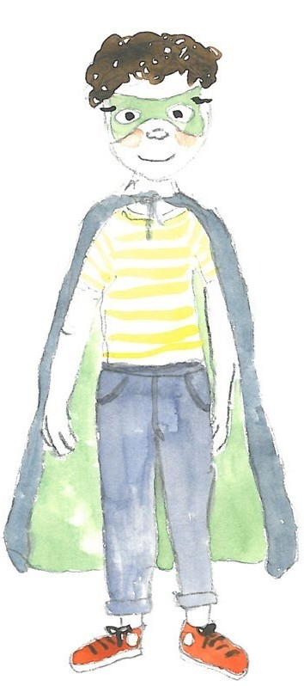

Making a Simple Comic Page

- Find a nice large piece of square or rectangular paper. A big piece of paper is important, as smaller pieces don’t allow enough space for drawings or writing in speech bubbles.

- Fold the paper in half and then in half again.

- Unfold the paper so that the creases make four panels or sections.

- You can use a marker pen to go round the edges of each panel so that they stand out clearly.
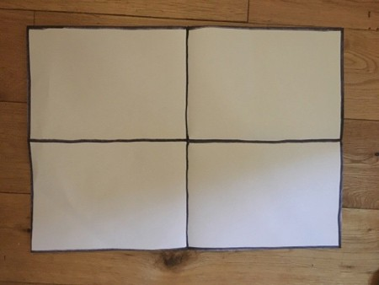

- If you want you can add text boxes in the top left hand corner of each panel for children to write in scene-setting story explanations. It was morning in Super Daisy’s house.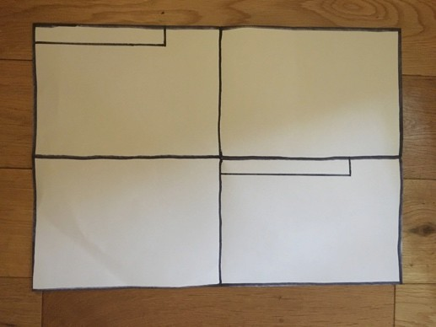
Thursday 2nd July 2020
Reading and book review – Year 1 & 2
Stone Soup by Heather Forest https://stories.audible.com/pdp/B002VA9UQM?ref=adbl_ent_anon_ds_pdp_pc_pg-1-cntr-0-7
Answer these questions below
What did you like about the book?

What was your favorite part? (Describe)

Who was your favorite character and why?

Draw a picture of your favorite scene.

Yr 2 challenge: What rating would you give out of 10 for this book and why?

Week 15
Friday 3rd July 2020
English spelling
Spelling
Write and learn the following words in your book.
Write the words 5 times.
Use each word in a sentence.
Do not forget to use a capital letter and full stop in your sentences.
Challenge- can you use a Speech mark in your sentences?
Example- "This is my pet fish called Floppy", Paul replied.
- these
- anyone
- find
- soon
- white
- floppy
- car

