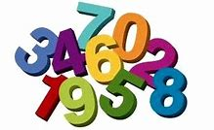
Numbers

Monday activity
Please practise writing numbers with your child.
Write the numbers big with a yellow colouring pencil and then place an arrow showing them where you want them to start from.
Repeat each number 10 times.
Here is an example what I mean…
1 1 1 1 1 1 1 1 1 1
2 2 2 2 2 2 2 2 2 2
3 3 3 3 3 3 3 3 3 3
4 4 4 4 4 4 4 4 4 4
Practise writing up to number 10

Count and match with correct number
Tuesday activity
1
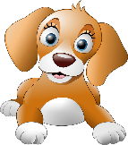
2

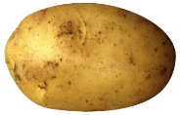
3
This Photo by Unknown Author is licensed under CC BY-NC
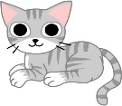
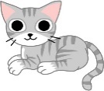
This Photo by Unknown Author is licensed under CC BY-ND
This Photo by Unknown Author is licensed under CC BY-ND
This Photo by Unknown Author is licensed under CC BY-ND
This Photo by Unknown Author is licensed under CC BY-ND
This Photo by Unknown Author is licensed under CC BY-ND
This Photo by Unknown Author is licensed under CC BY-ND
4

5
This Photo by Unknown Author is licensed under CC BY-SA
This Photo by Unknown Author is licensed under CC BY-SA
This Photo by Unknown Author is licensed under CC BY-SA
This Photo by Unknown Author is licensed under CC BY
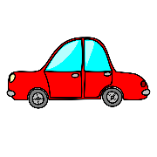
6

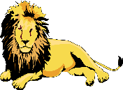
7
This Photo by Unknown Author is licensed under CC BY-SA
This Photo by Unknown Author is licensed under CC BY-SA
This Photo by Unknown Author is licensed under CC BY-SA
This Photo by Unknown Author is licensed under CC BY-SA
This Photo by Unknown Author is licensed under CC BY-SA
This Photo by Unknown Author is licensed under CC BY-SA
This Photo by Unknown Author is licensed under CC BY-SA

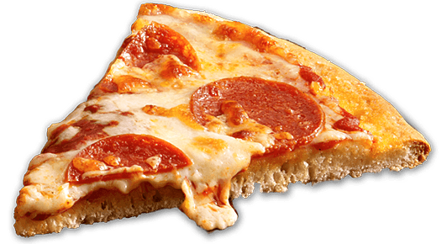
This Photo by Unknown Author is licensed under CC BY-NC
This Photo by Unknown Author is licensed under CC BY-NC
This Photo by Unknown Author is licensed under CC BY-NC
8
This Photo by Unknown Author is licensed under CC BY-NC
This Photo by Unknown Author is licensed under CC BY-NC
This Photo by Unknown Author is licensed under CC BY-NC

This Photo by Unknown Author is licensed under CC BY-SA
This Photo by Unknown Author is licensed under CC BY-SA
This Photo by Unknown Author is licensed under CC BY-SA
This Photo by Unknown Author is licensed under CC BY-SA
This Photo by Unknown Author is licensed under CC BY-SA
9
This Photo by Unknown Author is licensed under CC BY-SA
This Photo by Unknown Author is licensed under CC BY-SA
This Photo by Unknown Author is licensed under CC BY-SA
This Photo by Unknown Author is licensed under CC BY-SA
This Photo by Unknown Author is licensed under CC BY-SA

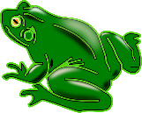
10
This Photo by Unknown Author is licensed under CC BY-NC

Wednesday activity
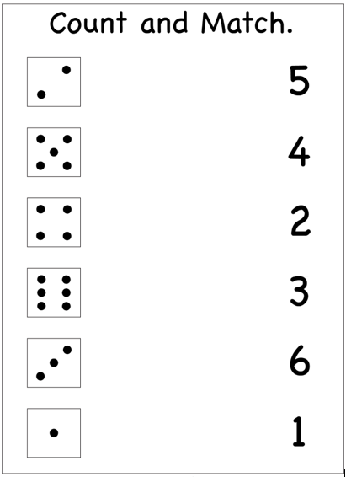

Thursday activity
Have a look in the kitchen
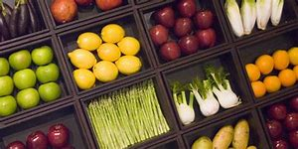
And see if you have any of the items below:
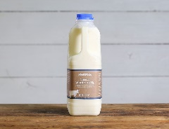
Banana Milk
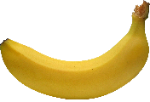
This Photo by Unknown Author is licensed under CC BY-NC

How many did you find? How many did you find?

Crisp packet Butter
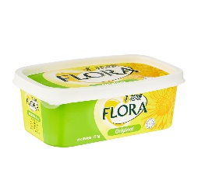
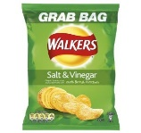
This Photo by Unknown Author is licensed under CC BY-SA-NC

How many did you find?
How many did you find?

Oranges Drink bottle
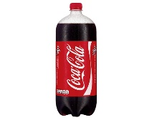
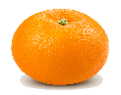
This Photo by Unknown Author is licensed under CC BY-SA
This Photo by Unknown Author is licensed under CC BY-NC

How many did you find? How many did you find?

Have a look around your house
Friday activity
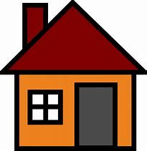

How many pillows do you have?
How many pans do you have?
Have many cups do you have?
Have many bowls do you have?
Have many telephones do you have?
Have many computers do you have?
Have many mobile phones do you have?
How many cookers do you have?

