**Week 14**

**Monday 22nd June 2020**

**English comprehension – Year 1 & 2**

My Dad, the Superhero

“Wake up!” said Sam to his dad.

On Father’s Day, Sam and his dad always spent the day together. Last year, they rode roller coasters. The year before that, they went to a football match.

“Okay,” said Dad as he got out of bed and into his wheelchair. “Mum made your favourite breakfast,” said Sam. Dad and Sam went to the kitchen. Mum was making pancakes. “What are you going to do today?” Mum asked with a smile.

“We can go see the new superhero movie!” said Sam. “Good idea,” said Dad. Just then, the phone rang. When Dad hung up the phone, he said, “I’m sorry, but I have to go to work.” Sam was so very sad. “I have an idea,” Dad said, “You can come to work with me.”

Sam smiled and ran to his room to get ready.

He had never seen his dad at work and hoped it would be fun. Sam was shocked when they arrived at the zoo. His dad had keys that opened every door. Inside was a room with a zookeeper and two nurses. They clapped when his dad came in and thanked him for coming so quickly. In the corner of the room was a black and white panda. The panda was upset. “This is my patient,” Dad said.

After an hour, Sam’s dad was holding four tiny panda cubs. Sam’s dad handed one to Sam. He was so proud of his dad. He thought his dad was just like a superhero. “This is the best Father’s Day,” said Sam to his dad. “I get to hold a panda cub, and I learned that you are a superhero!”

Questions

Read and copy each statement. Write ‘T’’ if you think the statement is true, or ‘F’ if you think it is false.

1. Sam’s dad wakes Sam up.
2. Sam and his dad rode roller coasters last year.
3. Dad’s favourite breakfast is pancakes.
4. Sam wants to go fishing for Father’s Day.
5. Mum answered the phone.
6. Dad has to go to work on Father’s Day.
7. The panda has black and brown fur.
8. Dad works at the supermarket.
9. The mumma panda had 6 cubs.
10. Sam thinks his dad is like a superhero.

**Tuesday 23rd June 2020 English Spag – Year 1 & 2**

Spelling, Grammar and Punctuation

Task 1 Fix the sentences below and re-write them correctly in your book.

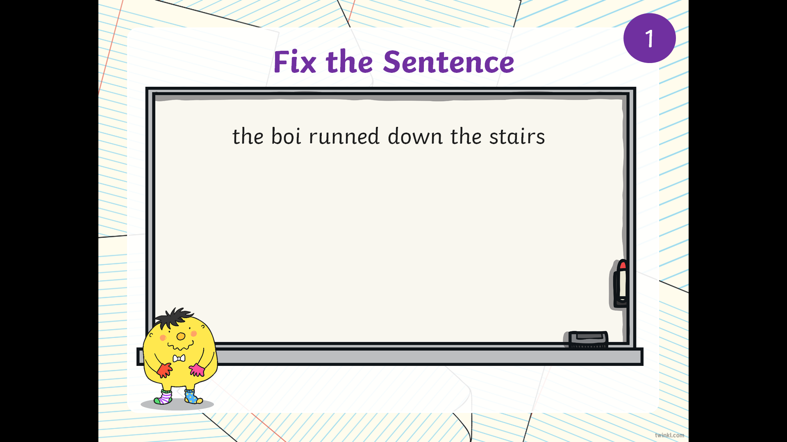

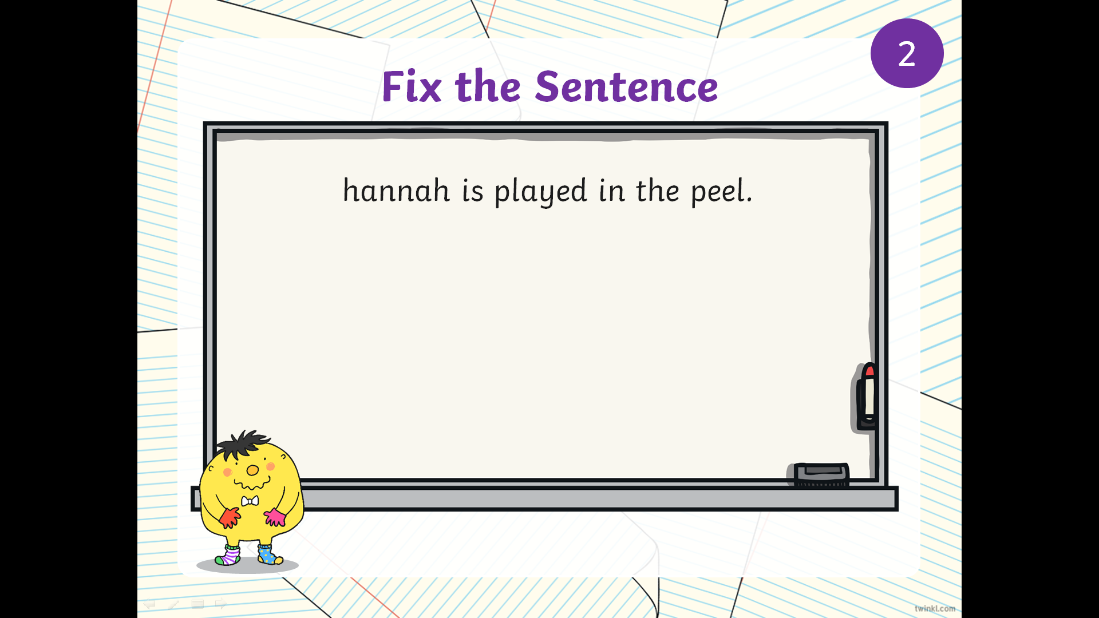

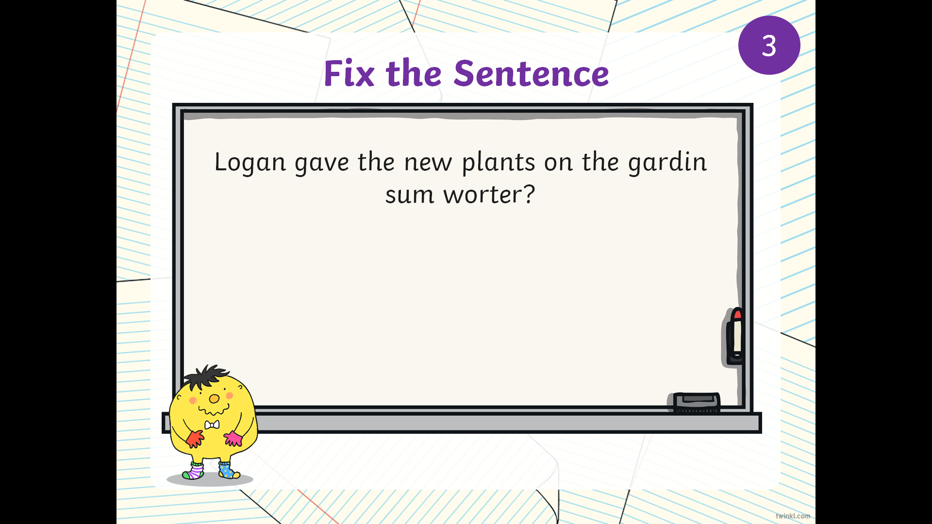

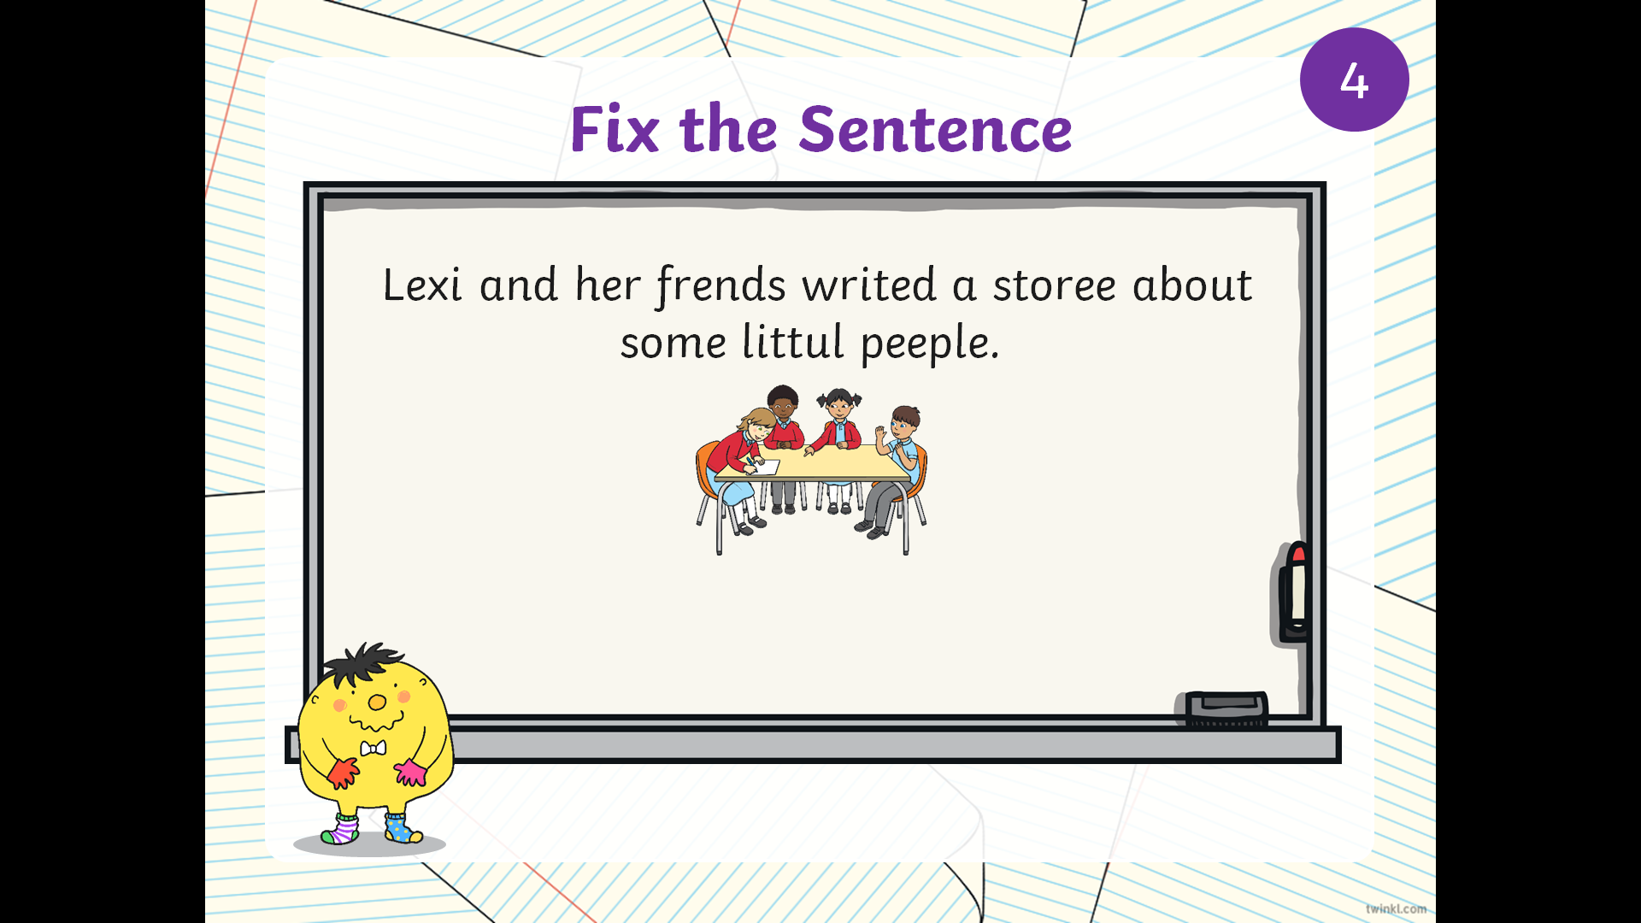

Task 2

Click on this link for more information: <https://www.bbc.co.uk/bitesize/topics/zqhpk2p/articles/z3cxrwx>

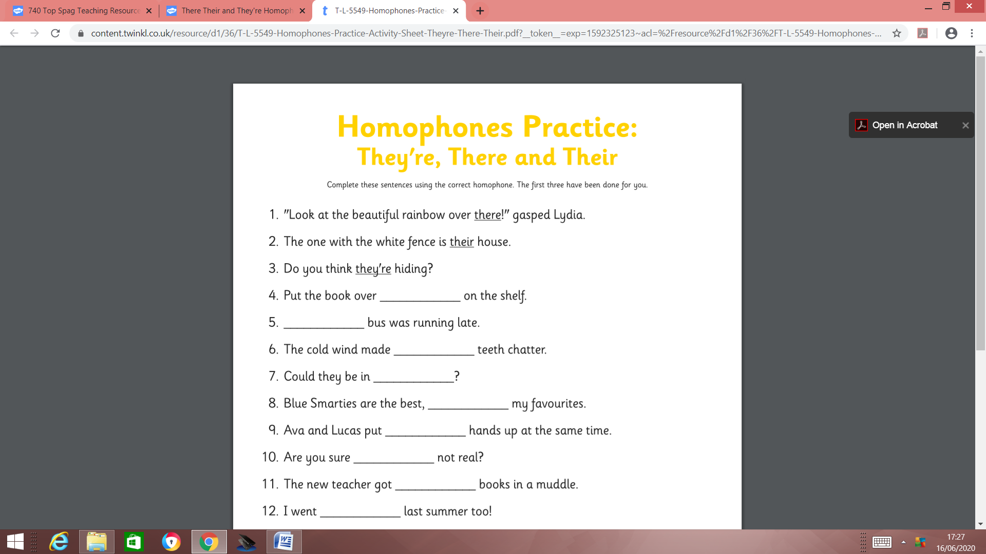

**Week 14**

**Tuesday 23rd June 2020**

**Spellings**

**Write and learn the following words in your book.**

**Write the words 5 times.**

**Use each word in a sentence.**

**Do not forget to use a capital letter and full stop in your sentences.**

**Challenge- Can you use at least 2 of the words from the list in a sentence?**

**Example- The squirrel won a badge in a race.**

* **badge**
* **fudge**
* **fog**
* **race**
* **gnaw**
* **tunnel**
* **squirrel**

**Week 14**

**Wednesday 23rd June 2020**

**English writing activity – Year 2**

# Carefully cut out all the *Animal Picture Cards* and *Food Picture Cards.*

* + Shuffle the sets of cards and lay them down face up on a table, animals on one side and foods on the other.
  + Match each animal to the strange, muddled-up food.

# Sequencing events

Lay out your matched pairs of cards.

* + On small pieces of paper, write each pair out under the pictures. *The giraffe and the fish, The pelican and the branch*, etc. Use all your spelling strategies to get the animal’s names right.
  + Draw pictures of Muna and Bobo.

# 3. Now try this Fun-Time Extra

* Draw a picture of what YOU love to eat on *My Favourite Food*. Write captions and describing words to tell everyone what is so good about your choice.

|  |  |
| --- | --- |
| **Animal Picture Cards** | giraffe |
| pelican | lion |
| bat | zebra |
| flamingo | snake |

|  |  |
| --- | --- |
| fish | leaves |
| hay | egg |
| meat | mango |
| worms | **Food Picture Cards** |

# My Favourite Food



**My Favourite Animal**







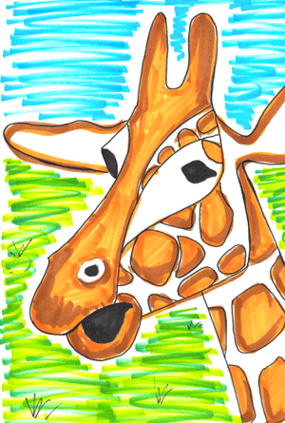

Lion Snake

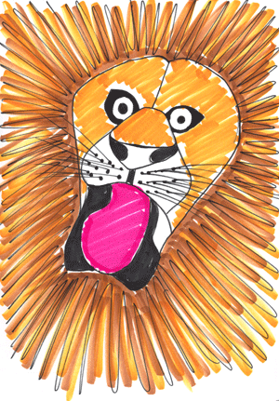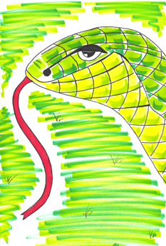

Zebra Flamingo

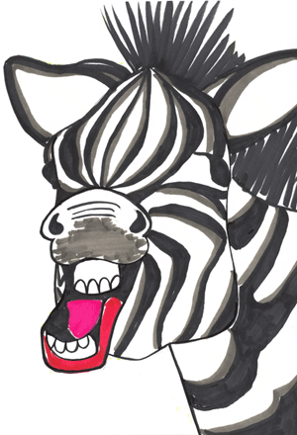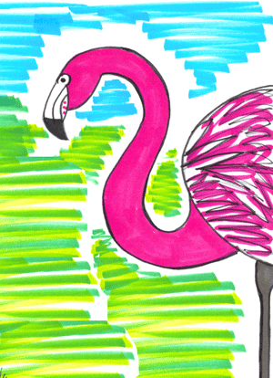

**Thursday 24th June 2020**

**Reading and book review – Year 1 & 2**

**The Foolish Crow written by Sheila Gandhi** **(click on the link below to listen to it)**

<https://stories.audible.com/pdp/B085KBC8ZL?ref=adbl_ent_anon_ds_pdp_pc_pg-1-cntr-0-31> **Answer these questions below**

**What did you like about the book?**

**What was your favorite part? (Describe)**

**Who was your favorite character and why?**

**Draw a picture of your favorite scene.**

**Yr 2 challenge: What rating would you give out of 10 for this book and why?**

**Week 14**

**Friday 25th June 2020**

**English spelling**

**Spelling**

**Write and learn the following words in your book.**

**Write the words 5 times.**

**Use each word in a sentence.**

**Do not forget to use a capital letter and full stop in your sentences.**

**Challenge- can you use a comma in your sentences?**

**Example- I fell on my knee, then my friend helped me get up.**

* **apple**
* **bottle**
* **gnat**
* **knee**
* **wrong**
* **join**
* **animal**