**Week 13 - Monday 15th June 2020**

**Year 3 & 4**

**4 Times Table Test**

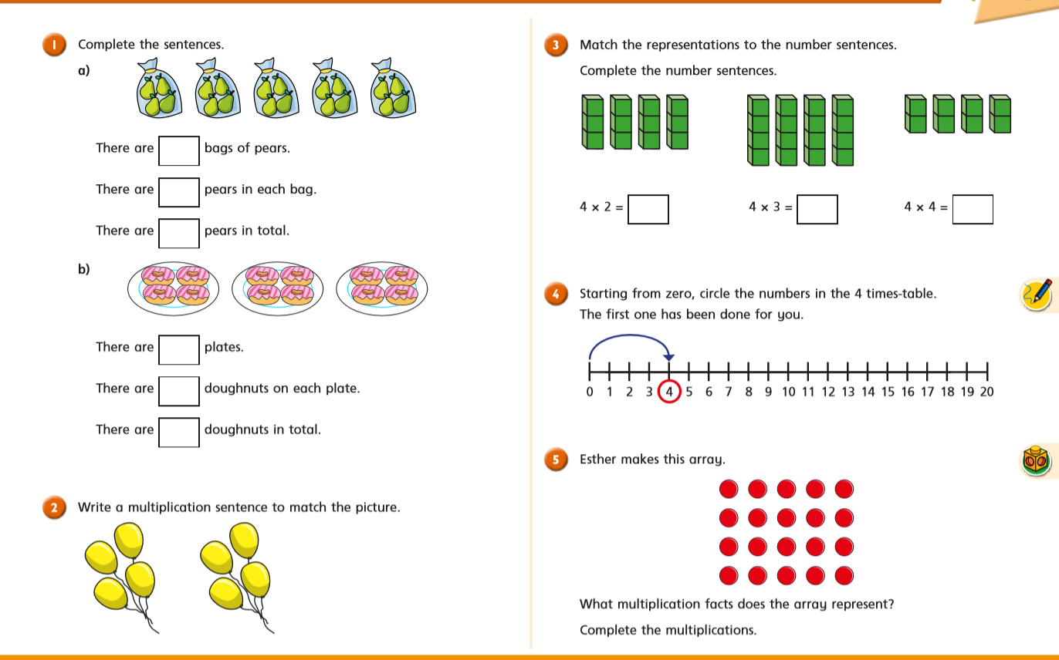

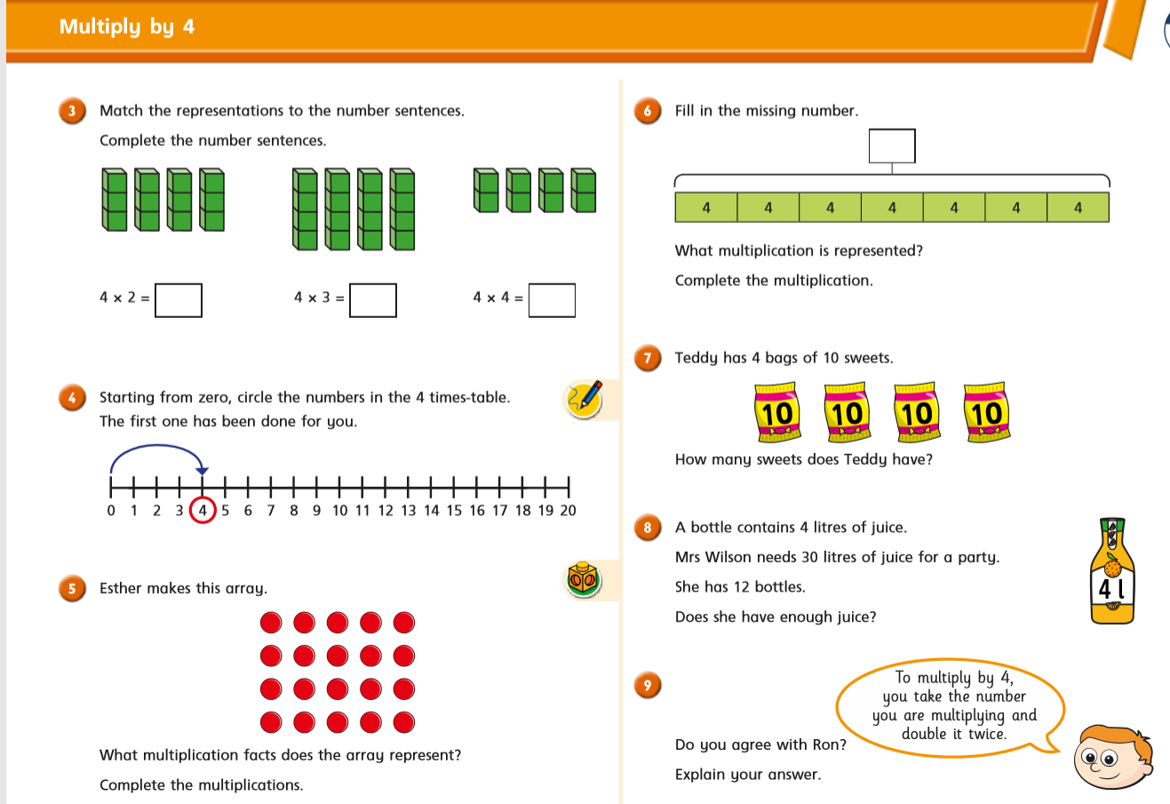

**Year 3 Challenge**

