|  |
| --- |
| **Buttercup/Evergreen Primary**  **Letters and Sounds phonics** |
| **Week 13 Phase 4** |
| **REMEMBER**  Your child will learn to read the words by -  **segmenting** – breaking the word into sounds  **blending** – putting the sounds together to hear the word. |
| [A picture containing drawing  Description automatically generated](http://images.google.co.uk/imgres?imgurl=http://www.otherlandtoys.co.uk/magletters2_800.jpg&imgrefurl=http://www.otherlandtoys.co.uk/mini-magnetic-letters-p-1590.html&usg=__CAYZgY-R7OAGBSGY_W4J3VnnOk4=&h=499&w=800&sz=110&hl=en&start=1&um=1&tbnid=VEjF-UTVwWsVDM:&tbnh=89&tbnw=143&prev=/images%3Fq%3Dmagnetic%2Bletters%26um%3D1%26hl%3Den%26rlz%3D1T4SUNA_enGB245GB246%26sa%3DN)**Activities** A picture containing meter  Description automatically generated |
| * Little whiteboards and pens, and magic boards are a fun way for children to try out spellings and practise their handwriting. * Use the letter formation rhyme above to write the graphemes on paper, with chalk outside, in paint, etc. * Go on letter hunts and try to find j-w-v-x sounds around the house. |
| Videos linked to the sounds learnt this week: |

**Monday**

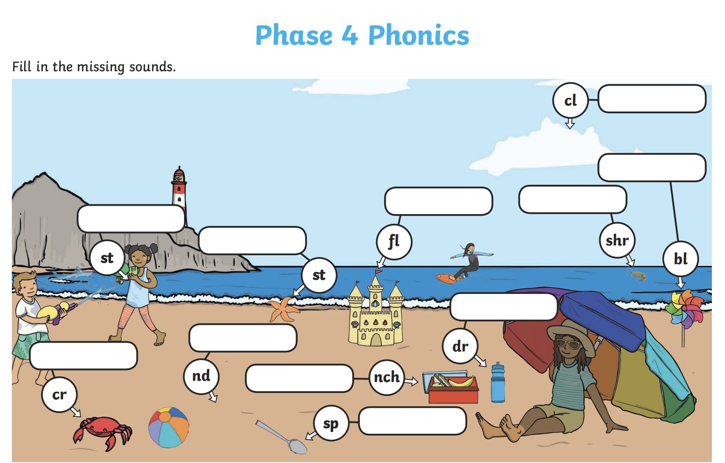

**Tuesday**

**Wednesday**

**Thursday**

Write a sentence to go with the picture using your phonics sounds.

**Friday**

