|  |
| --- |
| **Buttercup/Evergreen Primary**  **Letters and Sounds phonic** |
| **Week 13 Phase 3** |
| **REMEMBER**  Your child will learn to read the words by -  **segmenting** – breaking the word into sounds  **blending** – putting the sounds together to hear the word. |
| **Activities** |
| * Little whiteboards and pens, and magic boards are a fun way for children to try out spellings and practise their handwriting. * Use the letter formation rhyme above to write the graphemes on paper, with chalk outside, in paint, etc. * Go on letter hunts and try to find j-w-v-x sounds around the house. |
| Videos linked to the sounds learnt this week    Letters and Sounds:  <http://www.letters-and-sounds.com/phase-3.html>  Bitesize:  <https://www.bbc.co.uk/bitesize/topics/zvq9bdm>  Phoncis Play:  <https://www.phonicsplay.co.uk/>  Teachitprimary:  <https://www.teachitprimary.co.uk/phonics/phase-3>  You tube:  <https://www.youtube.com/watch?v=vU2vWZKS7rY> |

**Monday**

**Tuesday**

**Wednesday**

Highlight the tricky words you see in each sentence:

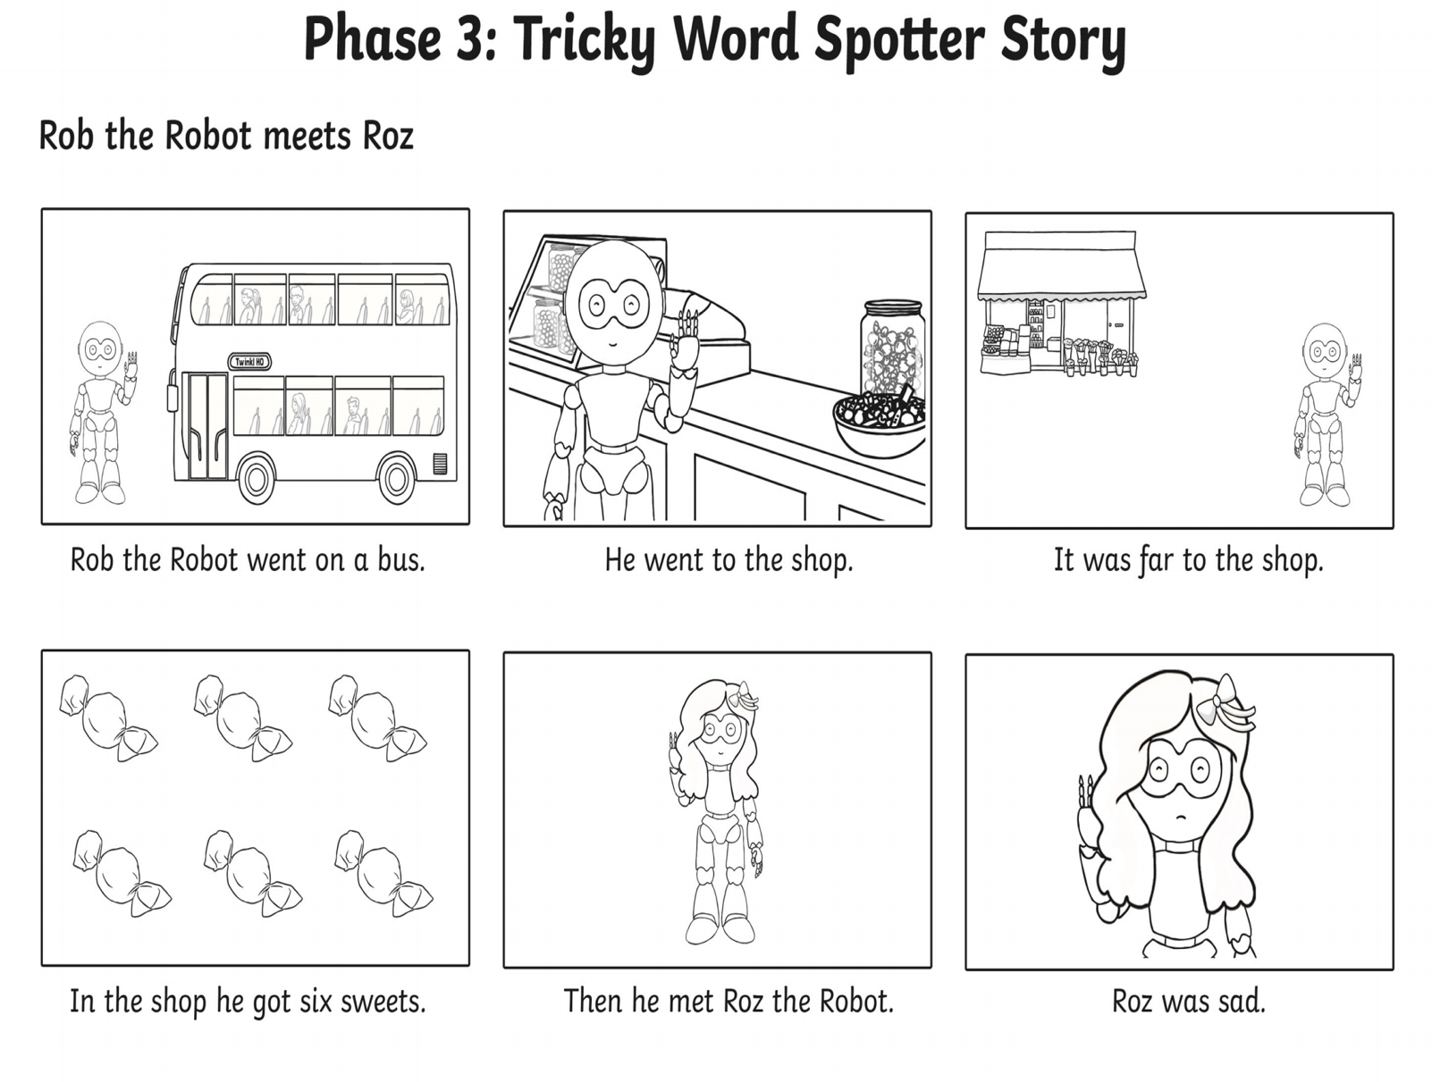

**Thursday**

**Friday**

