**Summer 2**

**Rec Maths- Money**

Notes for parents

(Remember gold prizes from me for neat outstanding work)

If you do not have access to a printer, provide your child with an exercise book to do their work in.

* Write the short date (today's date)
* Write the L.O:
* Miss a line
* Question numbers in the margin and write answers on the line.

(I will be asking your parents if your work looks neat and to send me a picture of your amazing work. I myself will check your work once you come back to school in sha Allah)

**Monday 15th June 2020**

**Tuesday 16th June 2020**

**Wednesday 17th June 2020**

**Thursday 18th June 2020**

**Friday 19th June 2020**

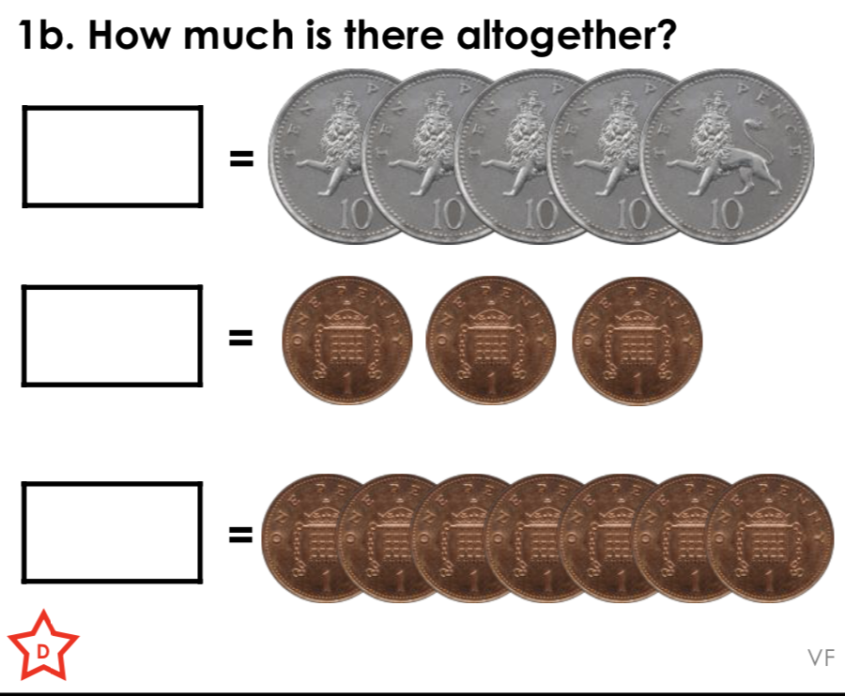

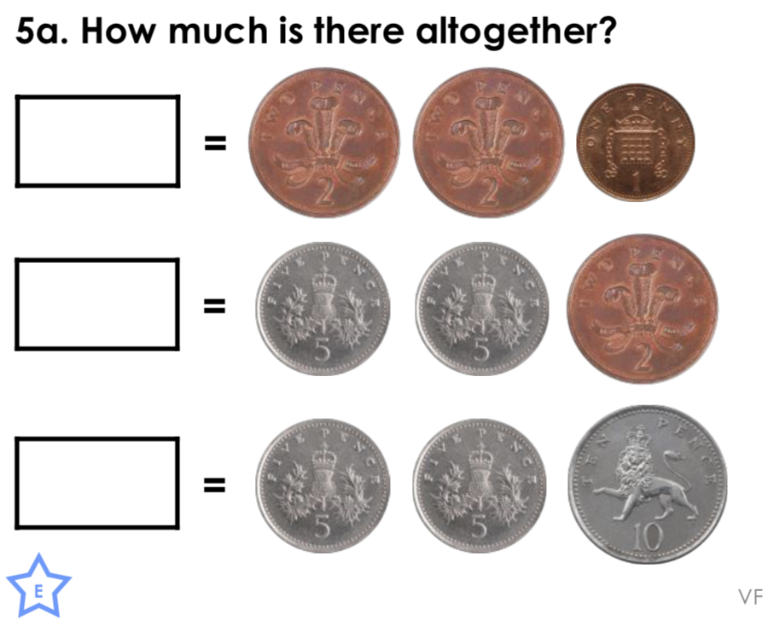

**Challenge:**