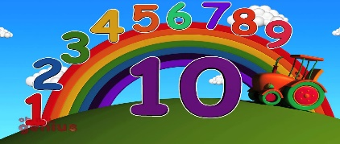**Numbers**

**Monday activity**

For today’s activity I would like the children to go on the internet and play number games.

Here is the website please click…

<https://www.topmarks.co.uk/learning-to-count/teddy-numbers>

<https://www.topmarks.co.uk/learning-to-count/underwater-counting>

<https://www.topmarks.co.uk/learning-to-count/ladybird-spots>

<https://www.topmarks.co.uk/learning-to-count/gingerbread-man-game>

Children are very familiar with these activities

**Tuesday activity**

**Count and circle the correct number**

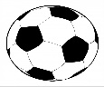

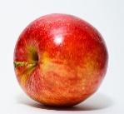

[This Photo](http://commons.wikimedia.org/wiki/File:Red_Apple.jpg) by Unknown Author is licensed under [CC BY-SA](https://creativecommons.org/licenses/by-sa/3.0/)



[This Photo](http://commons.wikimedia.org/wiki/File:Red_Apple.jpg) by Unknown Author is licensed under [CC BY-SA](https://creativecommons.org/licenses/by-sa/3.0/)



[This Photo](http://commons.wikimedia.org/wiki/File:Red_Apple.jpg) by Unknown Author is licensed under [CC BY-SA](https://creativecommons.org/licenses/by-sa/3.0/)

1 2 3 4 5 1 2 3 4 5

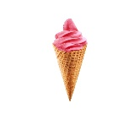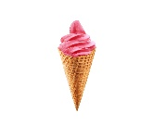

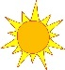

[This Photo](https://commons.wikimedia.org/wiki/File:Sun01.jpg) by Unknown Author is licensed under [CC BY-SA](https://creativecommons.org/licenses/by-sa/3.0/)



[This Photo](https://commons.wikimedia.org/wiki/File:Sun01.jpg) by Unknown Author is licensed under [CC BY-SA](https://creativecommons.org/licenses/by-sa/3.0/)



[This Photo](https://commons.wikimedia.org/wiki/File:Sun01.jpg) by Unknown Author is licensed under [CC BY-SA](https://creativecommons.org/licenses/by-sa/3.0/)



[This Photo](https://commons.wikimedia.org/wiki/File:Sun01.jpg) by Unknown Author is licensed under [CC BY-SA](https://creativecommons.org/licenses/by-sa/3.0/)

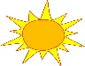

[This Photo](https://commons.wikimedia.org/wiki/File:Sun01.jpg) by Unknown Author is licensed under [CC BY-SA](https://creativecommons.org/licenses/by-sa/3.0/)



[This Photo](https://commons.wikimedia.org/wiki/File:Sun01.jpg) by Unknown Author is licensed under [CC BY-SA](https://creativecommons.org/licenses/by-sa/3.0/)



[This Photo](https://commons.wikimedia.org/wiki/File:Sun01.jpg) by Unknown Author is licensed under [CC BY-SA](https://creativecommons.org/licenses/by-sa/3.0/)



[This Photo](https://commons.wikimedia.org/wiki/File:Sun01.jpg) by Unknown Author is licensed under [CC BY-SA](https://creativecommons.org/licenses/by-sa/3.0/)

6 7 8 9 10 6 7 8 9 10

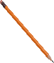

[This Photo](http://www.pngall.com/pencil-png) by Unknown Author is licensed under [CC BY-NC](https://creativecommons.org/licenses/by-nc/3.0/)



[This Photo](http://www.pngall.com/pencil-png) by Unknown Author is licensed under [CC BY-NC](https://creativecommons.org/licenses/by-nc/3.0/)



[This Photo](http://www.pngall.com/pencil-png) by Unknown Author is licensed under [CC BY-NC](https://creativecommons.org/licenses/by-nc/3.0/)



[This Photo](http://www.pngall.com/pencil-png) by Unknown Author is licensed under [CC BY-NC](https://creativecommons.org/licenses/by-nc/3.0/)



[This Photo](http://www.pngall.com/pencil-png) by Unknown Author is licensed under [CC BY-NC](https://creativecommons.org/licenses/by-nc/3.0/)



[This Photo](http://www.pngall.com/pencil-png) by Unknown Author is licensed under [CC BY-NC](https://creativecommons.org/licenses/by-nc/3.0/)



[This Photo](http://www.pngall.com/pencil-png) by Unknown Author is licensed under [CC BY-NC](https://creativecommons.org/licenses/by-nc/3.0/)

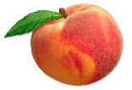

[This Photo](http://www.allwhitebackground.com/peach.html) by Unknown Author is licensed under [CC BY-NC](https://creativecommons.org/licenses/by-nc/3.0/)



[This Photo](http://www.allwhitebackground.com/peach.html) by Unknown Author is licensed under [CC BY-NC](https://creativecommons.org/licenses/by-nc/3.0/)

1 2 3 4 5 6 7 8 9 10



[This Photo](https://commons.wikimedia.org/wiki/File:Golden_key_icon.svg) by Unknown Author is licensed under [CC BY-SA](https://creativecommons.org/licenses/by-sa/3.0/)



[This Photo](https://commons.wikimedia.org/wiki/File:Gold_Star.svg) by Unknown Author is licensed under [CC BY-SA](https://creativecommons.org/licenses/by-sa/3.0/)



[This Photo](https://commons.wikimedia.org/wiki/File:Golden_key_icon.svg) by Unknown Author is licensed under [CC BY-SA](https://creativecommons.org/licenses/by-sa/3.0/)



[This Photo](https://commons.wikimedia.org/wiki/File:Golden_key_icon.svg) by Unknown Author is licensed under [CC BY-SA](https://creativecommons.org/licenses/by-sa/3.0/)



[This Photo](https://commons.wikimedia.org/wiki/File:Golden_key_icon.svg) by Unknown Author is licensed under [CC BY-SA](https://creativecommons.org/licenses/by-sa/3.0/)



[This Photo](https://commons.wikimedia.org/wiki/File:Golden_key_icon.svg) by Unknown Author is licensed under [CC BY-SA](https://creativecommons.org/licenses/by-sa/3.0/)



[This Photo](https://commons.wikimedia.org/wiki/File:Golden_key_icon.svg) by Unknown Author is licensed under [CC BY-SA](https://creativecommons.org/licenses/by-sa/3.0/)



[This Photo](https://commons.wikimedia.org/wiki/File:Golden_key_icon.svg) by Unknown Author is licensed under [CC BY-SA](https://creativecommons.org/licenses/by-sa/3.0/)



[This Photo](https://commons.wikimedia.org/wiki/File:Golden_key_icon.svg) by Unknown Author is licensed under [CC BY-SA](https://creativecommons.org/licenses/by-sa/3.0/)



[This Photo](https://commons.wikimedia.org/wiki/File:Golden_key_icon.svg) by Unknown Author is licensed under [CC BY-SA](https://creativecommons.org/licenses/by-sa/3.0/)



[This Photo](https://commons.wikimedia.org/wiki/File:Gold_Star.svg) by Unknown Author is licensed under [CC BY-SA](https://creativecommons.org/licenses/by-sa/3.0/)



[This Photo](https://commons.wikimedia.org/wiki/File:Gold_Star.svg) by Unknown Author is licensed under [CC BY-SA](https://creativecommons.org/licenses/by-sa/3.0/)



[This Photo](https://commons.wikimedia.org/wiki/File:Gold_Star.svg) by Unknown Author is licensed under [CC BY-SA](https://creativecommons.org/licenses/by-sa/3.0/)



[This Photo](https://commons.wikimedia.org/wiki/File:Gold_Star.svg) by Unknown Author is licensed under [CC BY-SA](https://creativecommons.org/licenses/by-sa/3.0/)

6 7 8 9 10 1 2 3 4 5

**Wednesday activity**

Practise writing the numbers from 1 to 10 please

**1**

**2**

**3**

**4**

**5**

**6**

**7**

**8**

**9**

**10**

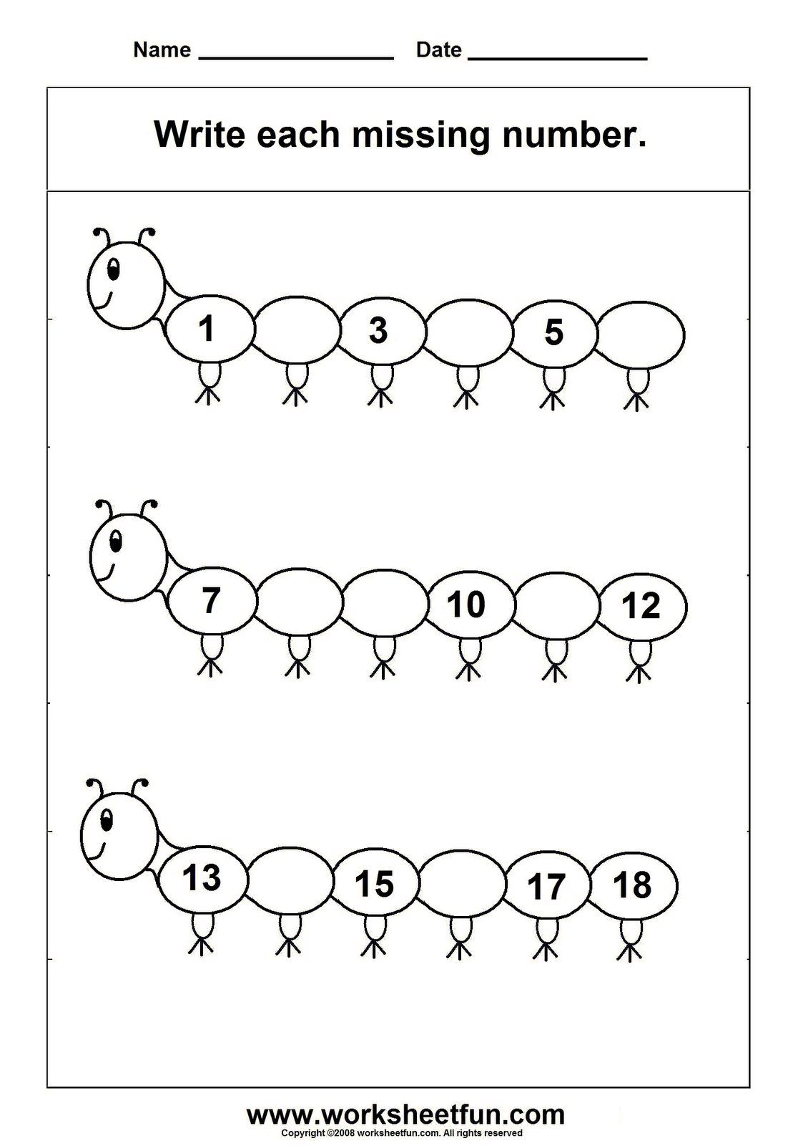

**Thursday activity**

Draw lines to connect the numbers and pictures that go together.

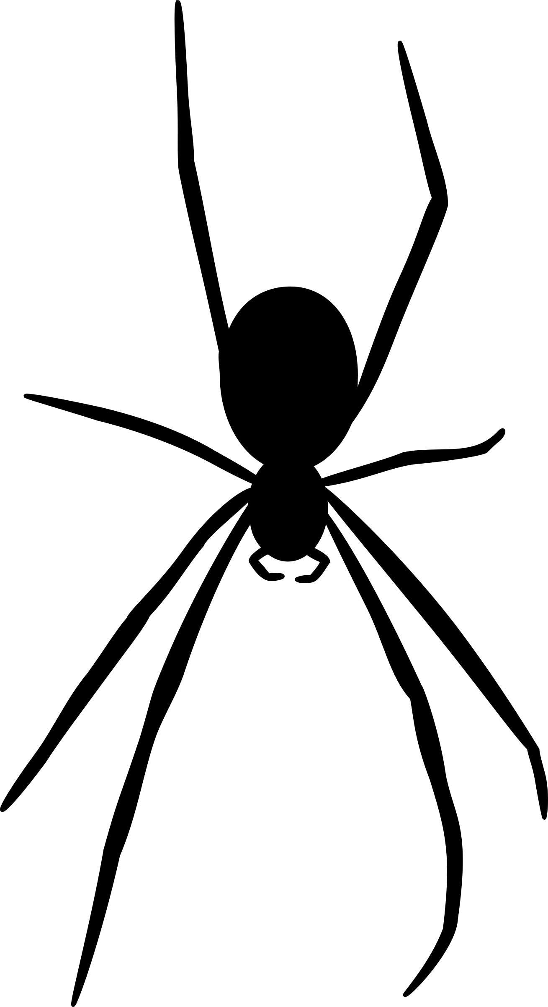**1**

**2**

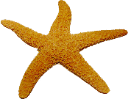

[This Photo](http://www.pngall.com/starfish-png) by Unknown Author is licensed under [CC BY-NC](https://creativecommons.org/licenses/by-nc/3.0/)



[This Photo](http://www.pngall.com/starfish-png) by Unknown Author is licensed under [CC BY-NC](https://creativecommons.org/licenses/by-nc/3.0/)



[This Photo](http://www.pngall.com/starfish-png) by Unknown Author is licensed under [CC BY-NC](https://creativecommons.org/licenses/by-nc/3.0/)



[This Photo](http://www.pngall.com/starfish-png) by Unknown Author is licensed under [CC BY-NC](https://creativecommons.org/licenses/by-nc/3.0/)

**3**

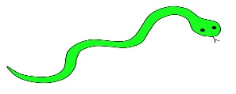

[This Photo](https://www.flickr.com/photos/bycp/5614486981/) by Unknown Author is licensed under [CC BY-NC](https://creativecommons.org/licenses/by-nc/3.0/)

**4**



[This Photo](http://www.dailyclipart.net/clipart/category/animal-clip-art/page/13/) by Unknown Author is licensed under [CC BY-ND](https://creativecommons.org/licenses/by-nd/3.0/)



[This Photo](http://www.dailyclipart.net/clipart/category/animal-clip-art/page/13/) by Unknown Author is licensed under [CC BY-ND](https://creativecommons.org/licenses/by-nd/3.0/)



[This Photo](http://www.dailyclipart.net/clipart/category/animal-clip-art/page/13/) by Unknown Author is licensed under [CC BY-ND](https://creativecommons.org/licenses/by-nd/3.0/)



[This Photo](http://www.dailyclipart.net/clipart/category/animal-clip-art/page/13/) by Unknown Author is licensed under [CC BY-ND](https://creativecommons.org/licenses/by-nd/3.0/)



[This Photo](http://www.dailyclipart.net/clipart/category/animal-clip-art/page/13/) by Unknown Author is licensed under [CC BY-ND](https://creativecommons.org/licenses/by-nd/3.0/)



[This Photo](http://www.dailyclipart.net/clipart/category/animal-clip-art/page/13/) by Unknown Author is licensed under [CC BY-ND](https://creativecommons.org/licenses/by-nd/3.0/)

**5**

**6**

**Friday activity**

**Draw lines to connect the numbers and pictures that go together**



1



2



[This Photo](http://pngimg.com/download/20999) by Unknown Author is licensed under [CC BY-NC](https://creativecommons.org/licenses/by-nc/3.0/)



[This Photo](http://pngimg.com/download/20999) by Unknown Author is licensed under [CC BY-NC](https://creativecommons.org/licenses/by-nc/3.0/)

3



4



5

[This Photo](http://pngimg.com/download/18234) by Unknown Author is licensed under [CC BY-NC](https://creativecommons.org/licenses/by-nc/3.0/)

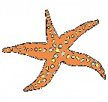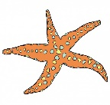6

7



[This Photo](http://solitudesublime.blogspot.com/2012/01/rohu-that-is-me.html) by Unknown Author is licensed under [CC BY-NC-ND](https://creativecommons.org/licenses/by-nc-nd/3.0/)



[This Photo](http://solitudesublime.blogspot.com/2012/01/rohu-that-is-me.html) by Unknown Author is licensed under [CC BY-NC-ND](https://creativecommons.org/licenses/by-nc-nd/3.0/)



[This Photo](http://solitudesublime.blogspot.com/2012/01/rohu-that-is-me.html) by Unknown Author is licensed under [CC BY-NC-ND](https://creativecommons.org/licenses/by-nc-nd/3.0/)



[This Photo](http://solitudesublime.blogspot.com/2012/01/rohu-that-is-me.html) by Unknown Author is licensed under [CC BY-NC-ND](https://creativecommons.org/licenses/by-nc-nd/3.0/)

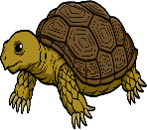

[This Photo](http://www.pngall.com/tortoise-png) by Unknown Author is licensed under [CC BY-NC](https://creativecommons.org/licenses/by-nc/3.0/)



[This Photo](http://www.pngall.com/tortoise-png) by Unknown Author is licensed under [CC BY-NC](https://creativecommons.org/licenses/by-nc/3.0/)



[This Photo](http://www.pngall.com/tortoise-png) by Unknown Author is licensed under [CC BY-NC](https://creativecommons.org/licenses/by-nc/3.0/)



[This Photo](http://www.pngall.com/tortoise-png) by Unknown Author is licensed under [CC BY-NC](https://creativecommons.org/licenses/by-nc/3.0/)



[This Photo](http://www.pngall.com/tortoise-png) by Unknown Author is licensed under [CC BY-NC](https://creativecommons.org/licenses/by-nc/3.0/)

8



[This Photo](http://www.pngall.com/tortoise-png) by Unknown Author is licensed under [CC BY-NC](https://creativecommons.org/licenses/by-nc/3.0/)



[This Photo](http://www.pngall.com/tortoise-png) by Unknown Author is licensed under [CC BY-NC](https://creativecommons.org/licenses/by-nc/3.0/)



[This Photo](http://www.pngall.com/tortoise-png) by Unknown Author is licensed under [CC BY-NC](https://creativecommons.org/licenses/by-nc/3.0/)



[This Photo](http://www.pngall.com/tortoise-png) by Unknown Author is licensed under [CC BY-NC](https://creativecommons.org/licenses/by-nc/3.0/)



9

10

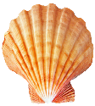

[This Photo](http://pngimg.com/download/37104) by Unknown Author is licensed under [CC BY-NC](https://creativecommons.org/licenses/by-nc/3.0/)



[This Photo](http://pngimg.com/download/37104) by Unknown Author is licensed under [CC BY-NC](https://creativecommons.org/licenses/by-nc/3.0/)



[This Photo](http://pngimg.com/download/37104) by Unknown Author is licensed under [CC BY-NC](https://creativecommons.org/licenses/by-nc/3.0/)



[This Photo](http://pngimg.com/download/37104) by Unknown Author is licensed under [CC BY-NC](https://creativecommons.org/licenses/by-nc/3.0/)



[This Photo](http://pngimg.com/download/37104) by Unknown Author is licensed under [CC BY-NC](https://creativecommons.org/licenses/by-nc/3.0/)



[This Photo](http://pngimg.com/download/37104) by Unknown Author is licensed under [CC BY-NC](https://creativecommons.org/licenses/by-nc/3.0/)



[This Photo](http://pngimg.com/download/37104) by Unknown Author is licensed under [CC BY-NC](https://creativecommons.org/licenses/by-nc/3.0/)



[This Photo](http://pngimg.com/download/37104) by Unknown Author is licensed under [CC BY-NC](https://creativecommons.org/licenses/by-nc/3.0/)