Week 12
Thursday 11thJune 2020
Year 6- Varied fluency
Please click on this link for revision: https://www.bbc.co.uk/bitesize/clips/zc26sbk
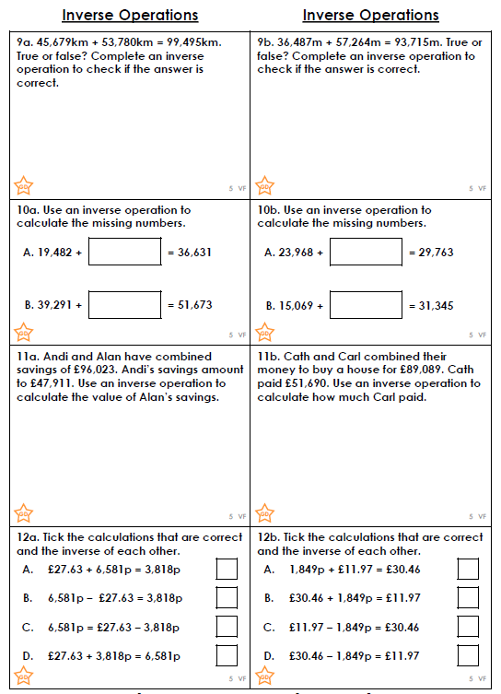

Challenge:
