Week 12
Friday 12thJune 2020
Year 6- Problem solving
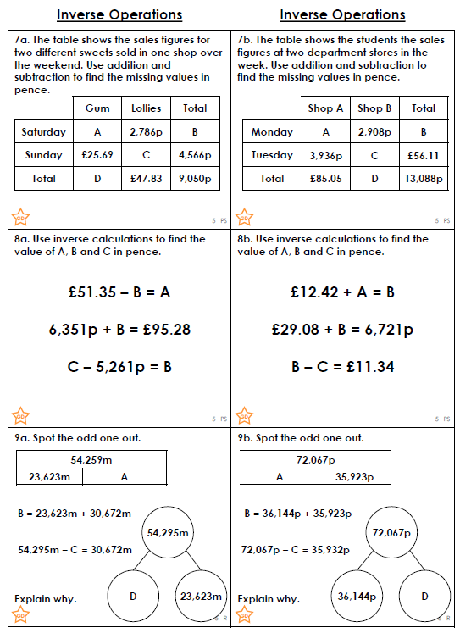

Challenge:
