Week 12
Monday 8th June 2020 - English comprehension – Year 3 & 4
L.O: To answer reading comprehension questions by deducing and inferring information. Read the extract, then read the questions and find evidence from the text to answer the questions.
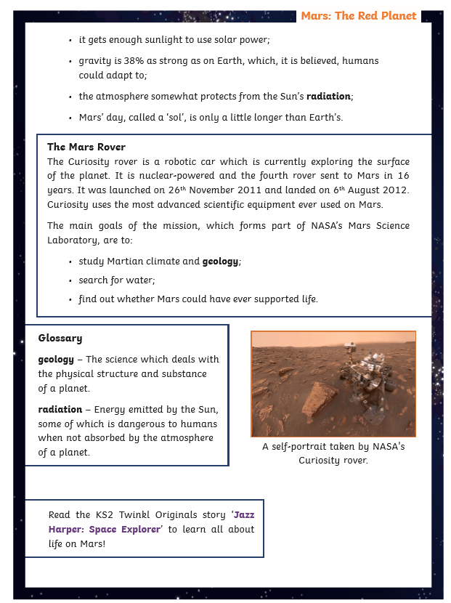
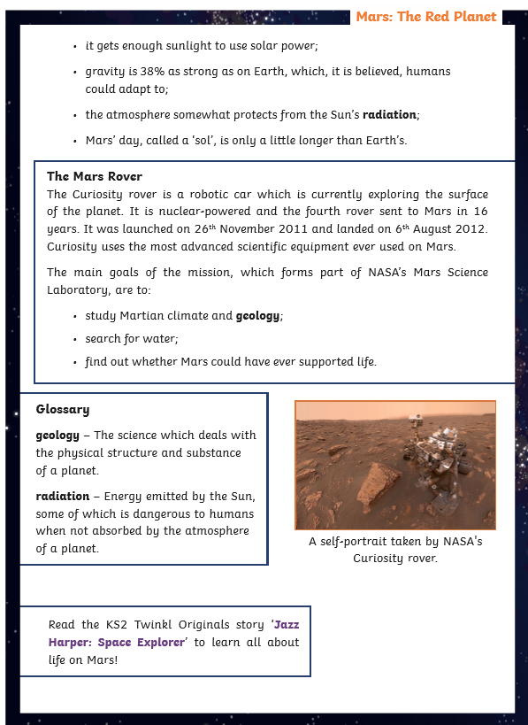

Questions- Year 3 can answer questions 1 to 7
Year 4 should attempt to answer all the questions.
- Please answer in full sentences e.g. What is a day called on Mars and how long is it?
- Answer- The day is called __________ on Mars because_________________
Mars: The Red Planet Questions
- Tick the correct response.
We cannot breathe on Mars because the atmosphere does not have enough:
air
carbon dioxide
atmosphere
oxygen
- Find and copy the correct word to complete the sentence. Mars is named after the god of .
- Which of these are reasons why Mars is a good place to explore? Tick two. Mars gets enough sunlight to use solar power.
A day on Mars is very short. There is no gravity on Mars.
There is a little water in the soil on Mars.
- How many moons does Mars have and what are their names?

- What is a day called on Mars and how long is it?

- Find and copy one caption from the text.

- Why does it seem odd at first that NASA has chosen to explore Mars and not Venus?

- Why do you think the author has put the facts about Mars’ size and atmosphere into a ‘quick facts’ box?

Tuesday 9th June 2020
LO: I can use adverbs to comment on how likely something is to happen.
Examples of Adverbs of possibility
- Certainly
- Definitely
- Maybe
- Possibly
- Surely
- Clearly
- Obviously
- Perhaps
- Probably
- Undoubtedly
What you must do for this task:
- Begin by underlining the adverb of possibility in each sentence.
- Think about which word is giving information about how likely something is.
- Then choose a suitable way to finish the sentence.
- You must write the sentences in your book. Yr 3 complete 1-7. Yr 4 complete ALL.
Example: The sky seemed white and low and it was obviously going to ____.
Answer: The sky seemed white and low and it was obviously going to snow.
- The sky was dark black and it was obviously going to _________.
- Perhaps in the future, students will arrive at school on __________.
- As he had such a big lead in the race, surely, he would _______.
- I haven’t eaten it before but I definitely will __________.
- Clearly the _________ is good because people keep buying it.
- Maybe my ____ will be back soon with tea.
- When I come to your house, I might possibly bring ________.
- Undoubtedly, the best football team is ___________.
- That seems dangerous, I certainly won’t _________.
- Don’t say anything is impossible until you have _________.
Challenge: Now write 3 of your own sentences using expanded nouns. You can include prepositions to improve your sentence further and add more detail.
Example: There was a candle in the room – There was a luminous, golden candle in the spacious, grand room which sat on top of the polished, wooden table.

Tuesday 9th June 2020
Spellings
Write and learn the following words in your book.
Write the words 5 times.
Use each word in a sentence.
Do not forget to use a capital letter and full stop in your sentences.
Challenge- can you use at least 2 of the words from the list in a sentence?
Example- I went to the library to learn about the Islamic history in Europe.
- island
- knowledge
- learn
- length
- library
- material
- medicine

Week 12
Wednesday 10th June 2020
English writing – Year 3 & 4: Task: LO: To create a piece of persuasive writing that argues against having school uniform.

Click on this link for more information: https://www.bbc.co.uk/teach/class-clips-video/english-ks1-ks2-how-to-write-a-persuasive-text/zkcfbdm

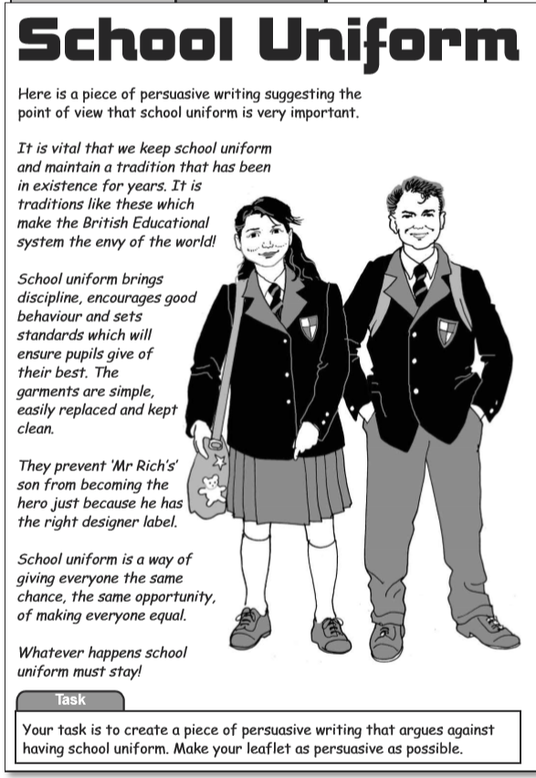

Your task is to create a piece of persuasive writing that argues against having school uniform. Make your leaflet as persuasive as possible.

Do not forget to:
- Use capital letters and full stops.
- Include lots of adjectives (describing words) and adverbs (to describe the verbs)
- Read each sentence to check if it makes sense.
- Use a wide range of punctuation including at least 3 of the following: full stop and capital, question mark, exclamation mark, apostrophe and comma.
- Use more sophisticated connectives, (e.g. although, however, nevertheless, despite, contrary to, as well as etc).

Success Criteria
- I can use facts and evidence to support reasons
- I can use connectives to link ideas (e.g. however, therefore, furthermore)
- I can use emotional language
- I can use powerful adjectives
- I can use rhetorical questions

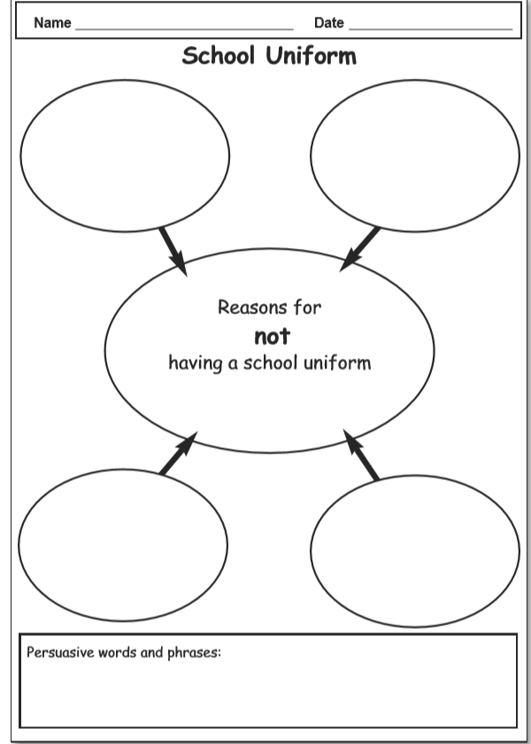

Week 12
Thursday 11th June 2020
Reading and book review – Year 3 & 4
Click on the link and listen to the story of ‘The Birchpark house’. Write A book review about the story.
https://stories.audible.com/pdp/B002UZDSCU?ref=adbl_ent_anon_ds_pdp_pc_pg-1-cntr-0-24
Book review by: ________________________________________________________
Title:_____________________________________________
Author: ___________________________________________
Non-fiction Fiction
What is the book about?
______________________________________________________________________________________
_____________________________________________________________________________________
Who would this book be suitable for? Age/interests

______________________________________________________________________________________
What was your favourite part? (Describe)
______________________________________________________________________________________
Year 4 challenge: Would you/would you not recommend the book to someone else? Why?

Week 12
Friday 12th June 2020
Comprehension: Read the recount and answer the questions in your home learning book. Make sure you date your work and write the title. Remember answers should be written in full sentences.

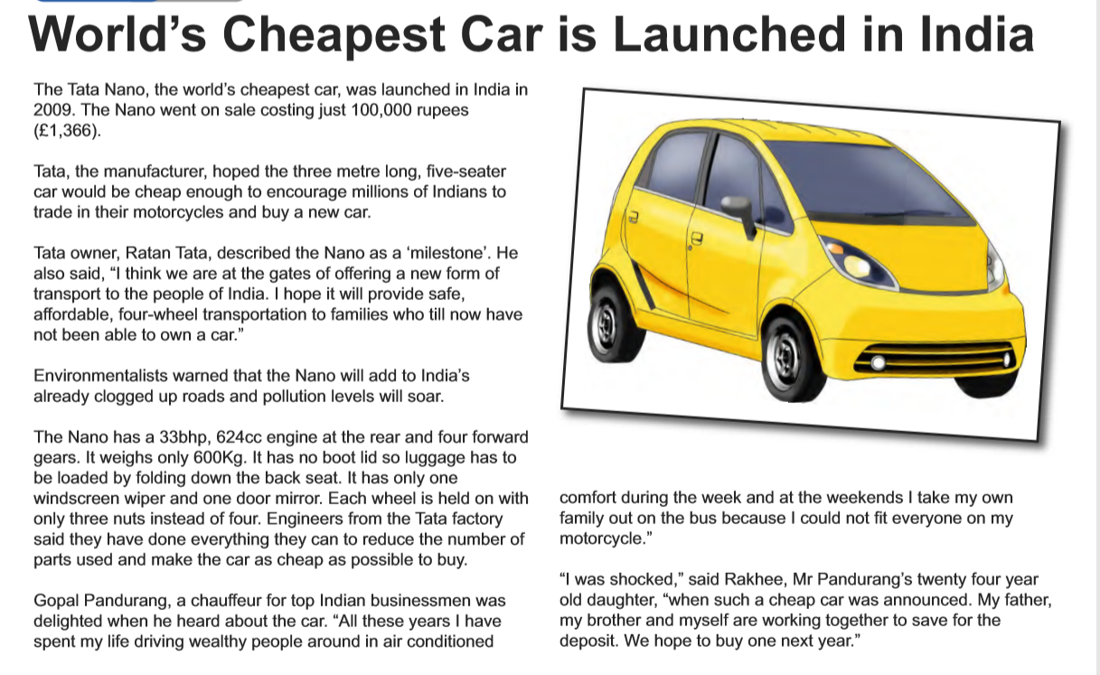

Questions:
Choose the best word or group of words to fit the passage and put a ring around your choice.
- The world’s cheapest car was launched in
- 2007
- 2008
- 2009
- 2010
It cost just 100,000 rupees
- (£3,166) (£1,366) (£6,136) (£1,636)
to buy. The manufacturer hoped
- A) hundreds b) thousands c) millions d) trillions
of Indians would sell their:
- bicycles
- canoes
- rickshaws
- motorcycles
- Who did Tata, the manufacturer, think would buy this car?

- Why is the car company called ‘Tata; motors?

- Why do you think not many Indian people own car?

- Why was Gopal Pandurang delighted when he heard about this care?

- Why do you think Ratan Ta described this car as a ‘milestone’?

Year 4 Challenge: Design an advertisement for this car giving as much information about it as you can.

