Week 9
Tuesday 19th May 2020
Year 6- Varied fluency
Please click on this link for more information: https://www.bbc.co.uk/bitesize/topics/zb6tyrd/articles/zg68k7h

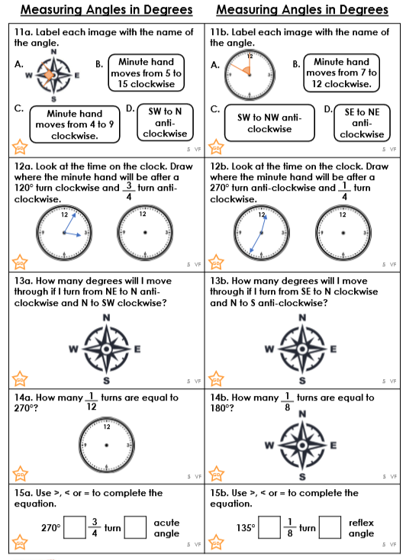

Challenge

