Summer 1
Reception Writing Tasks

Dear Parents/Carers,

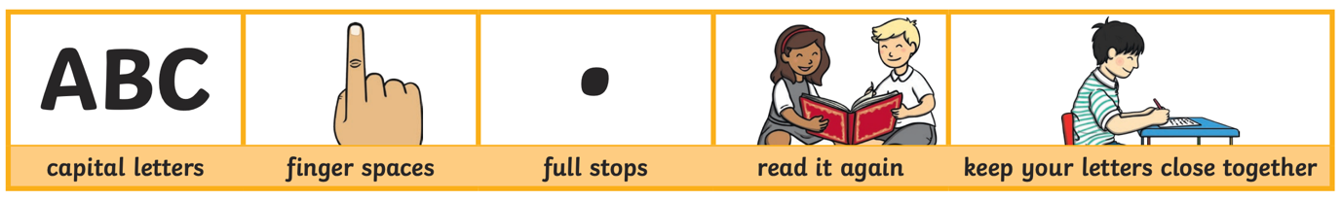
Your child will be expected to complete one writing tasks each day. Please ensure your child is writing in full sentences independently.

Encourage your child to use the above key when writing their sentences.

Success Criteria:
Has your child used capital letters?
Has your child used finger spaces after each word?
Has your child used a full stop at the end of their sentence?
Can your child read what they have written, and does it make sense?
Has your child made sure they have written their letters correctly in a way that can be understood and read by others?

Reception High Frequency Words

By the end of Reception, your child should know all or majority of these high frequency words and should be using them in their writing. How many words does your child know so far?
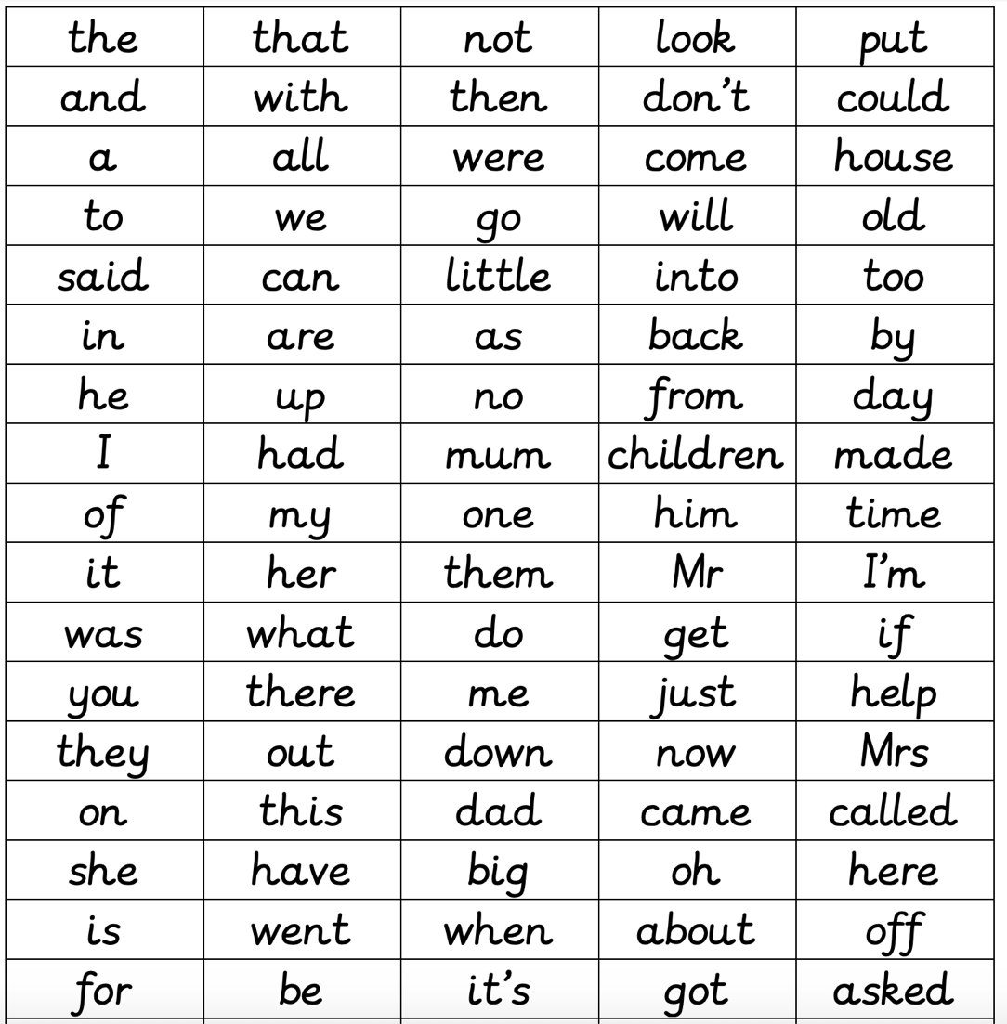

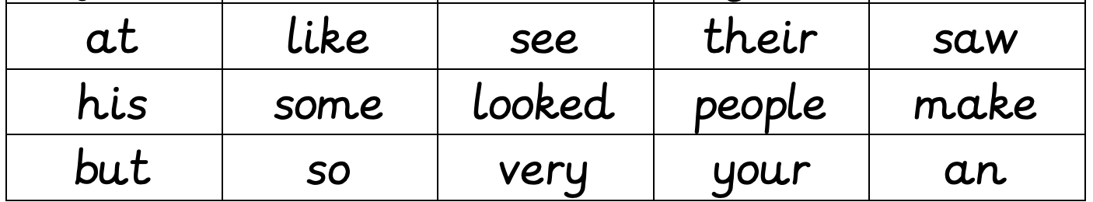

Monday 18th May 2020
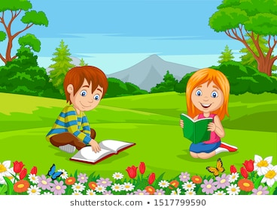

Look at the picture carefully. Write 2-3 sentences to describe what is happening in the picture.

Remember to use lots of adjectives (describing words)

Example: The happy boy is sitting beautifully on the fresh green grass reading his book.

Tuesday 19th May 2020

Read the following words

Catch

Road

Tree

Snail

Brown

Coin

Write a sentence using each word from the list above.
Wednesday 20th May 2020

Get your child to read the above text and then to answer the following questions:

- What was the girls name?

- What colour was the tree?

- Is the tree big or small?

- What can the girl do in the tree?

Thursday 21st May 2020

Write and learn the following words.

Write the words 5 times each. Once your child has written each word, give them a spelling test to check whether your child can spell them correctly.

Going

Look

Went

Now

Grass

Buzz

Shell

What
Friday 22nd May 2020

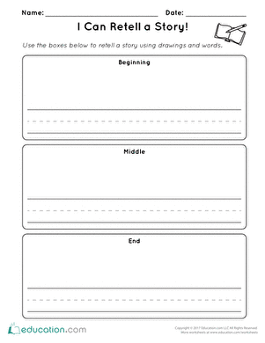
Ask your child to think of their favourite story. This could be their favourite traditional tale such as Goldilocks and The Three Bears, Little Red Riding Hood or The Three Little Pigs or a book that they have read at home.

Get your child to talk about what happened at the beginning of their chosen story. Then to think about what happened in the middle of the story and lastly what happened at the end of the story.

Please encourage your child to work independently and use their phonic sounds to help them write words.

Remember your capital letters, finger spaces and full stop!

