Routine
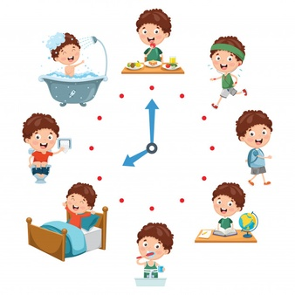
Monday activity
Watch the video
https://www.youtube.com/watch?v=zHWtWOIn3RY

Play a little game with your child, tell them we are going to act out our routine what we do throughout the day and they need to guess what time they do it?

Do actions of waking up, eating breakfast, brushing teeth, dressing, going to school, lunchtime, playing in classroom, tidy up time, home time and bedtime.

Ask your child the following questions:
Do each action and ask children what time is it?
Do I eat breakfast before I go school or after I go school?
Ask the children what time did they wake up?
What time did they go to school?
What time is lunch time?
Ask the children when is it lunch time soon or later?
What do we do after having dinner?
What time do we eat dinner before or after bedtime?

Match the picture with the time
Tuesday activity
Breakfast time 7.30

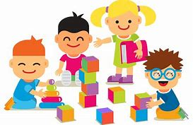
School time 8.25

Play time 10.00

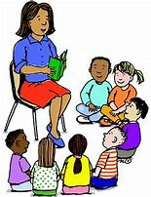
Story time 3.00pm

Dinner time 7.00pm

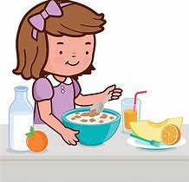
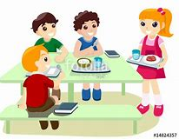
Bed time 8.00pm

Create your own daily routine here’s an example.
Wednesday activity
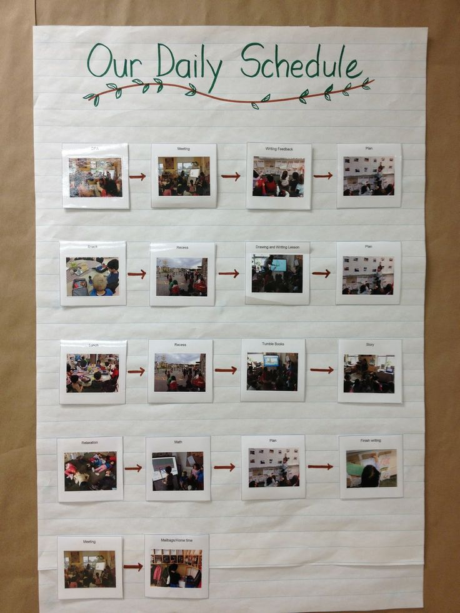

If you can’t take a picture maybe draw it or write it.

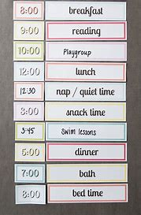

Cut the pictures and put them in order
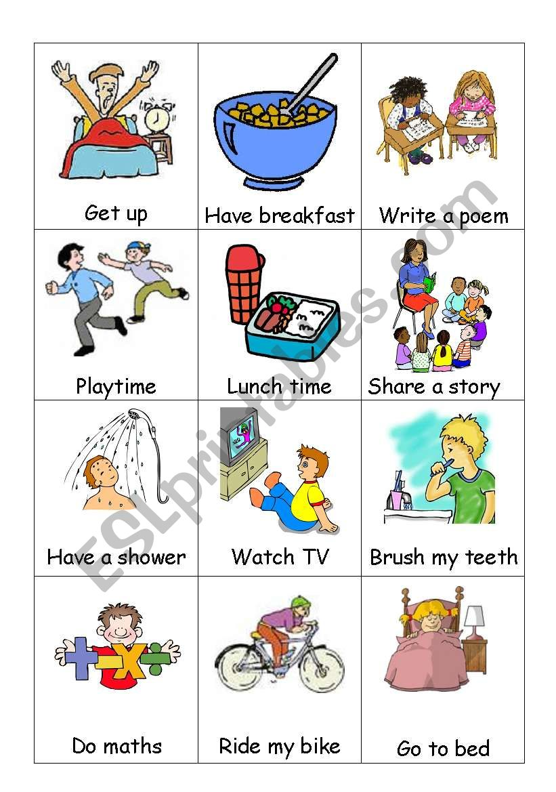
Thursday activity

Match the picture with the time
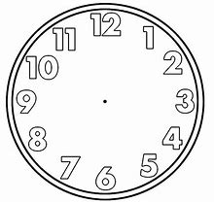

School time 8.25am

Play time 10.00am

Bed time 8.00pm

Story time 3.00pm

Dinner time 7.00pm

Breakfast 7.30

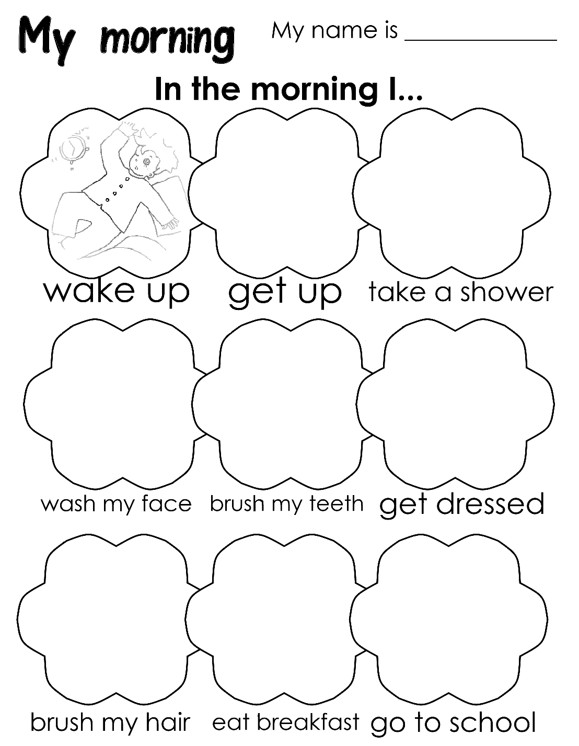
Friday activity

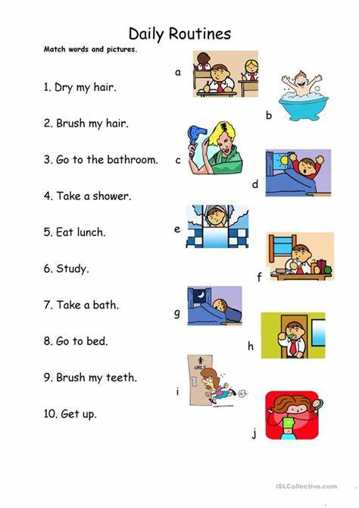
Which number goes with which letter?

