Week 8
Monday 11th May 2020
Year 5- Multiplication task
How fast are you at working out the inverse the 7 times table?
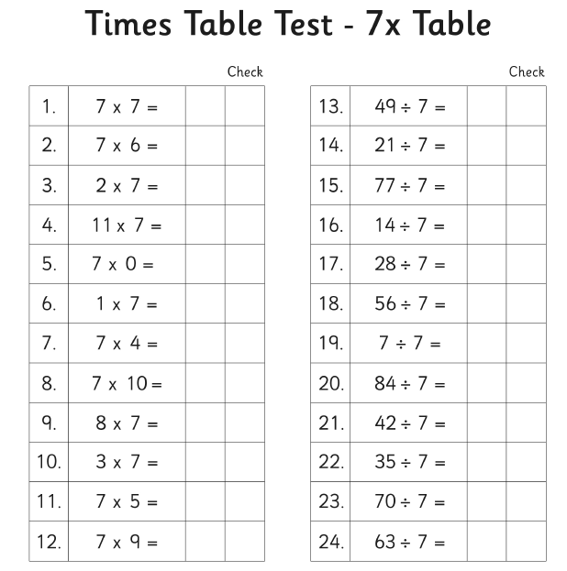

Do the same for the 8 times table
