Week 8
Monday 11th May 2020 - English comprehension – Year 3 & 4
L.O: To answer reading comprehension questions by deducing and inferring information. Read the extract, then read the questions and find evidence from the text to answer the questions.
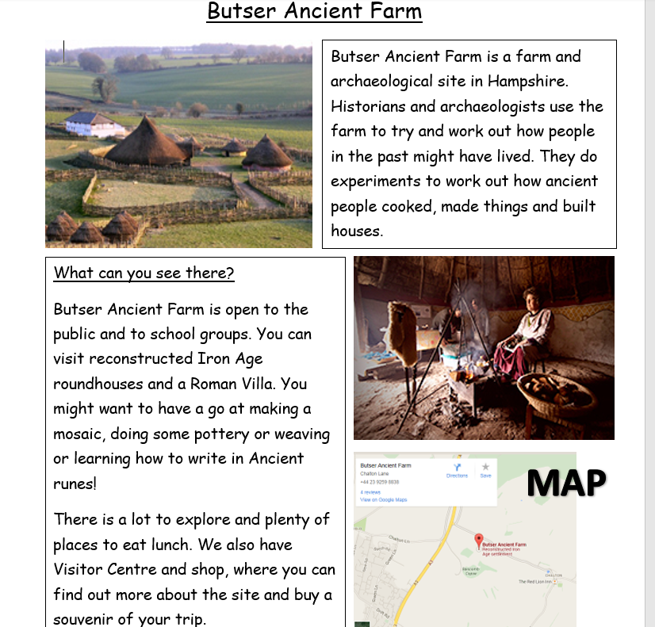
When can you visit?
Butser Ancient Farm is open all year round: Monday - Friday in October to March and 7 days a week in the Spring and Summer months. 10 am – 5pm (4pm in Winter)
We are just outside the village of Chalton, near Waterlooville.

Questions- Year 3 can answer questions 1 to 5
Year 4 should attempt to answer all the questions.
Please answer in full sentences e.g. Why might someone want to visit Butser Ancient Farm?
Answer- Someone want to visit Butser Ancient Farm because……….
- Where is Butser Ancient Farm?
___________________________________________________________
___________________________________________________________
- Why might someone want to visit Butser Ancient Farm?
___________________________________________________________
___________________________________________________________
___________________________________________________________
- List four things you could see or do at Butser.
___________________________________________________________
___________________________________________________________
___________________________________________________________
___________________________________________________________
- Would it be possible to visit Butser Ancient Farm on Saturday 17th February?
____________________________________________________________
____________________________________________________________
- Why do you think the writer has used text boxes?
____________________________________________________________
____________________________________________________________
____________________________________________________________
- Why do you think the author has chosen to include a map?
____________________________________________________________
Week 8
Tuesday 12th May 2020
LO: I am learning and practicing how to use the correct homophones.
They’re, There and Their
Examples:
- “Look at the beautiful rainbow over there!” gasped Lydia.
- The one with the white fence is their house.
- Do you think they’re hiding?

Copy the following sentences neatly into your English book.

Year 3: 1-10 Year 4: 1-15

- Put the book over _________ on the shelf.
- __________ bus was running late.
- The cold wind made __________ teeth shatter.
- Could they be in __________?
- Blue Smarties are the best, _______ my favourite.
- Sawdaa and Madeeha put _________ hands up at the same time.
- Are you sure ___________ not real?
- The new teacher got __________ books ready.
- “I went ___________ last summer too!” Tasneem said cheerfully.
- Is _________ a doctor anywhere near?
- ________ was a jaguar on the forest floor of the Rainforest.
- They washed _________ hands properly using soap and water.
- _______ was a boy whose name was Jim and his friends were very good to him.
- The children always listened to _______ parents.
Challenge: Now write 3 of your own sentences using the homophones
(there, they’re and their) correctly.

Week 8
Tuesday 12th May 2020
Spellings
Write and learn the following words in your book.
Write the words 5 times.
Use each word in a sentence.
Do not forget to use a capital letter and full stop in your sentences.
Challenge- can you use at least 2 of the words from the list in a sentence?
Example- My favourite form of exercise is doing eight sit ups.
- eighth
- enough
- exercise
- experience
- experiment
- extreme
- famous
- favourite

Week 8
Wednesday 13th May 2020
English writing – Year 3 & 4: Task- To write a playscript

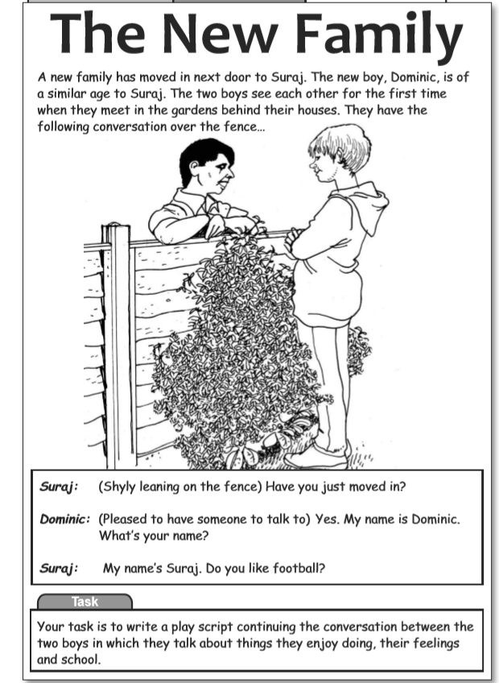

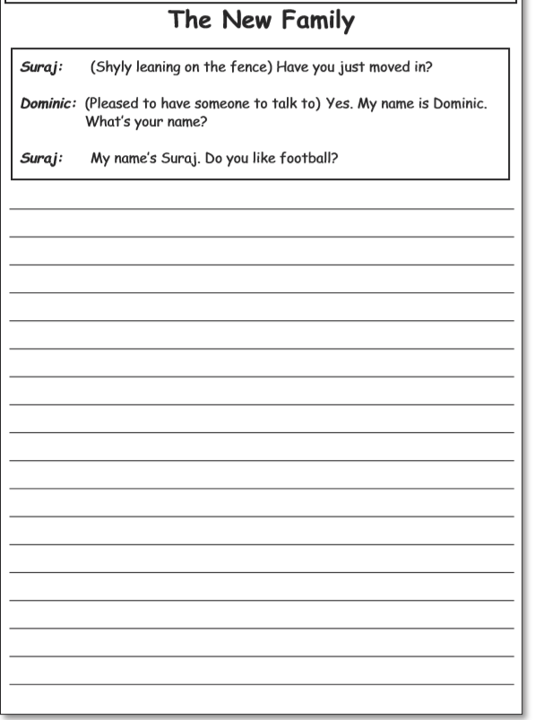

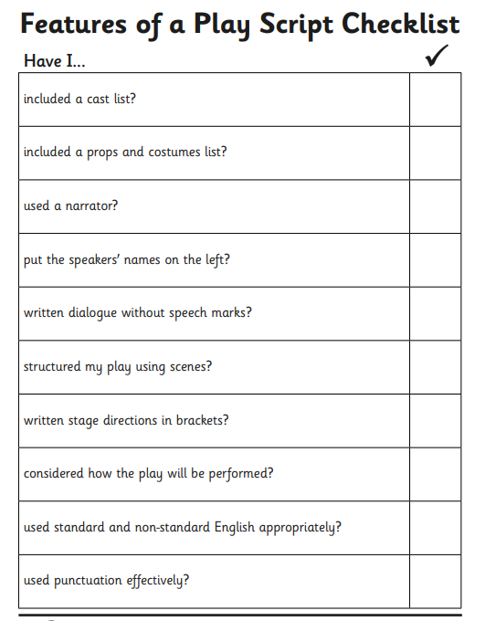
Do not forget to:
- Use capital letters and full stops.
- Include lots of adjectives (describing words) and adverbs (to describe the verbs)
- Read each sentence to check if it makes sense.
- Ensure you write the character names before the speech for example
Dominic: I love football and I play for Arsenal under 15 Club
- Use a wide range of punctuation including at least 3 of the following: full stop and capital, question mark, exclamation mark, apostrophe and comma.
- Use more sophisticated connectives, (e.g. although, however, nevertheless, despite, contrary to, as well as etc).

Week 8
Thursday 14th May 2020
Reading and book review – Year 3 & 4
Choose a book to read and answer the following questions about your book.
Book review by: ________________________________________________________
Title:_____________________________________________
Author: ___________________________________________
Non-fiction Fiction
What is the book about?
______________________________________________________________________________________
_____________________________________________________________________________________
Who would this book be suitable for? Age/interests

______________________________________________________________________________________
What was your favourite part? (Describe)
______________________________________________________________________________________
Year 4 challenge: Would you/would you not recommend the book to someone else? Why?

Week 8
Friday 15th May 2020
Comprehension: Read the playscript and answer the questions in your home learning book. Make sure you date your work and write the title. Remember answers should be written in full sentences.
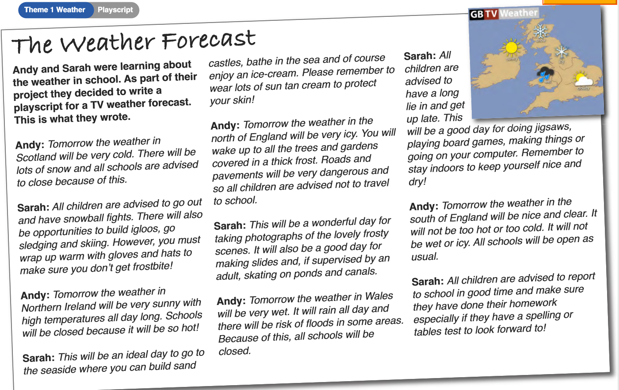
Questions:
Choose the best word or group of words to fit the passage and put a ring around your choice.
  - Andy and Sarah wrote their own script for a weather forecast. They said the weather in

- Scotland
- Northern Ireland
- Northern England
- Wales
Would be very hot and weather in
- Scotland 2) Northern Ireland 3) Northern England 4) Wales
- Who was learning about the weather?
- Why were the schools ‘advised to close’ in Scotland?
- Why were children advised ‘not to travel to school in the north of England?
- Why would children need to be supervised by an adult before ‘skating on ponds and canals’?
- How do you think the children in Wales would feel about being stuck inside all day because of the rain?
- How do you think the children in the south of England would feel if they knew other schools across the country were closed?

Year 4 Challenge: Write your own weather forecast for the next three days in your area with advice to children on what they can do.
Include: the activity the children can do, the type of clothes they can wear and the resources they would need for this type of weather.

