Week 8
Monday 11th May 2020
Year 5/6- English Comprehension
Read the text and answer the following questions.

From ‘World of Warriors – A New Hero’ by Curtis Jobling

Questions
Year 5- Answer questions 1-6
Year 6- Answer questions 1-9
Retrieving Information
- Use a dictionary to find the definitions for
- resonating
- ritual
- terrarium
- Find and copy one word that shows that Trick’s blazer is old.
- Find and copy one word that shows that Trick never forgets to buy his magazines
Making Inferences
- What type of creature lives in the terrarium and how do you know?
- Why do you think Trick kisses his necklace?
- Is Trick’s room tidy? Give 2 pieces of evidence to support your answer.
Writer’s Choices
- Why has the writer chosen to describe the knotted tie as “like a noose”? What does this tell us?
- Why has the author selected words like “shrugged” and “shambled” to describe how Trick moves?
Challenge Question (extended answer)
- Describe what you think Trick might be like at school, using quotes from the text to support your answer.
Week 8
Tuesday 12th May 2020
English SPAG- revision
Please answer the following questions in your book.
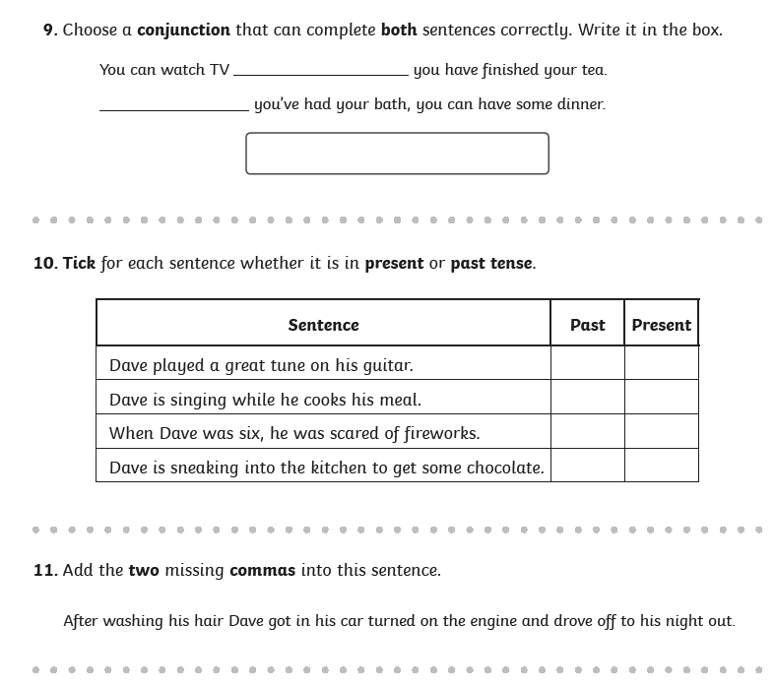

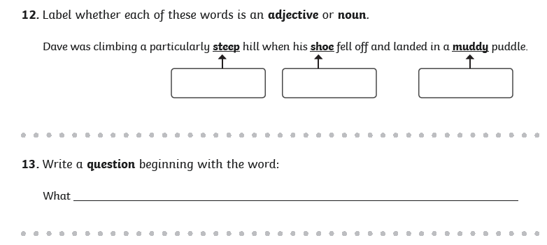
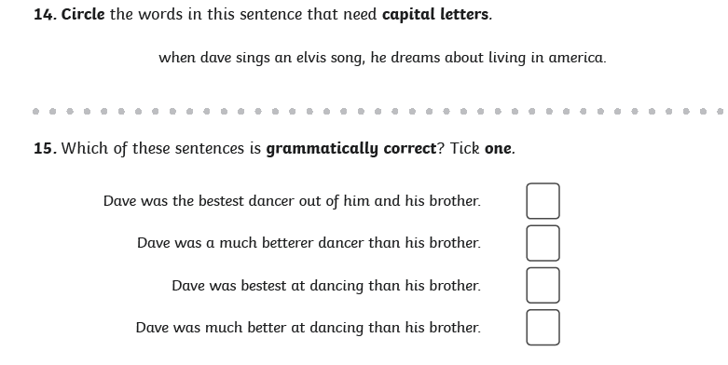
Week 8
Wednesday 13th May 2020
English Writing
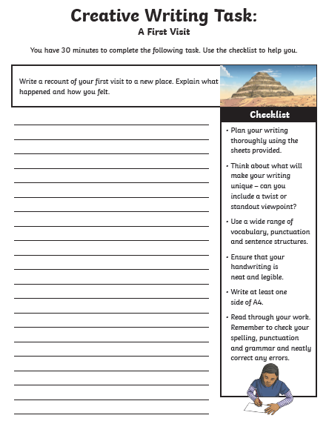
Please click on this link to get more information about how to write a recount:
https://www.bbc.co.uk/bitesize/topics/z2yycdm/articles/zgfhcj6
How to write a recount
- Write your recount in the first person because it happened to you! Eg "I felt excited."
- Use the past tense because it has already happened. Eg "It was the biggest fish I had ever seen!"
- Recounts are written in the order in which they happened. This is called chronological order. Use adverbs such as: firstly, next, then and finally.
- Using descriptive words will make it seem like your reader is there with you. Eg "The fish was shiny and slippery." Focus on the most exciting parts.

Week 8
Thursday 14th May 2020
English - spelling
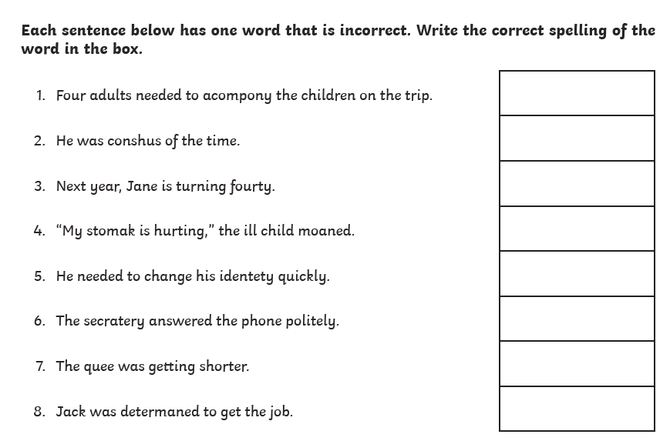

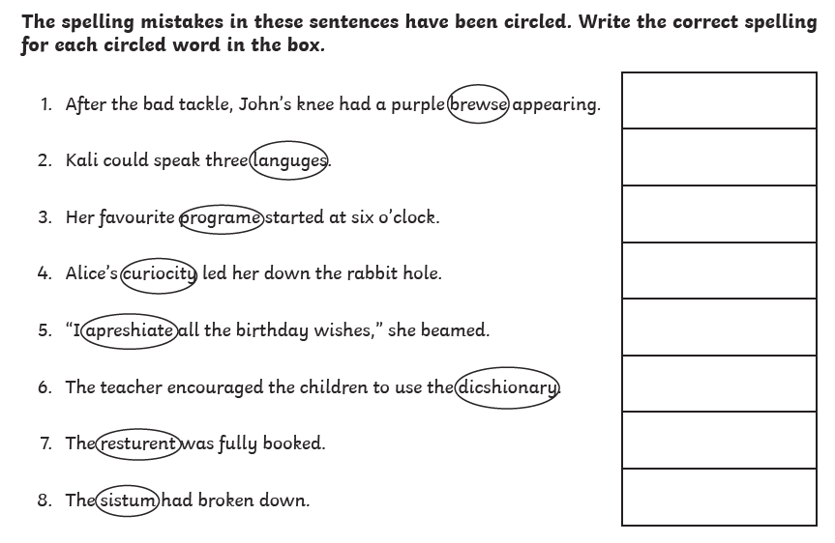
Write your own sentences using the words you have corrected. Make sure they are written in the correct context.

Week 8
Friday 15th May 2020
Year 5/6- Reading Comprehension
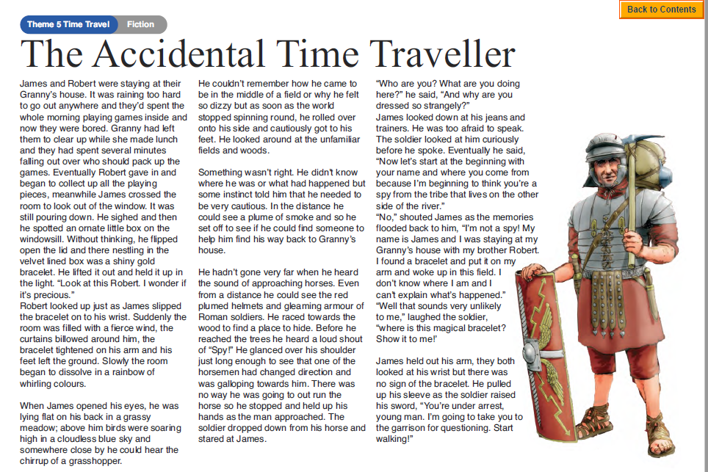

Questions
Year 5- Answer questions 1-6
Year 6- Answer questions 1-8
- What did James and Robert fall out over?

- What does the phrase ‘ornate little box’ suggest about the container the bracelet was found in?

- What happened when James placed the bracelet on his wrist?

- What is a ‘plume of smoke’?

- How do you think James would have felt when he saw the Roman soldiers?

- Why do you think the Roman soldier thought James was a spy?

- Why did the Roman soldier ask James the question, ‘Why are you dressed so strangely?’

- ‘James held out his arm, they both looked at his wrist but there was no sign of the bracelet.’ How do you think James felt when he realised the bracelet was missing from his wrist? Give a reason for your answer.
Challenge: Plan your own ending for ‘The Accidental Time Traveller’.

