Week 7 Monday 4th May 2020
Year 3 & 4
5 Times Table
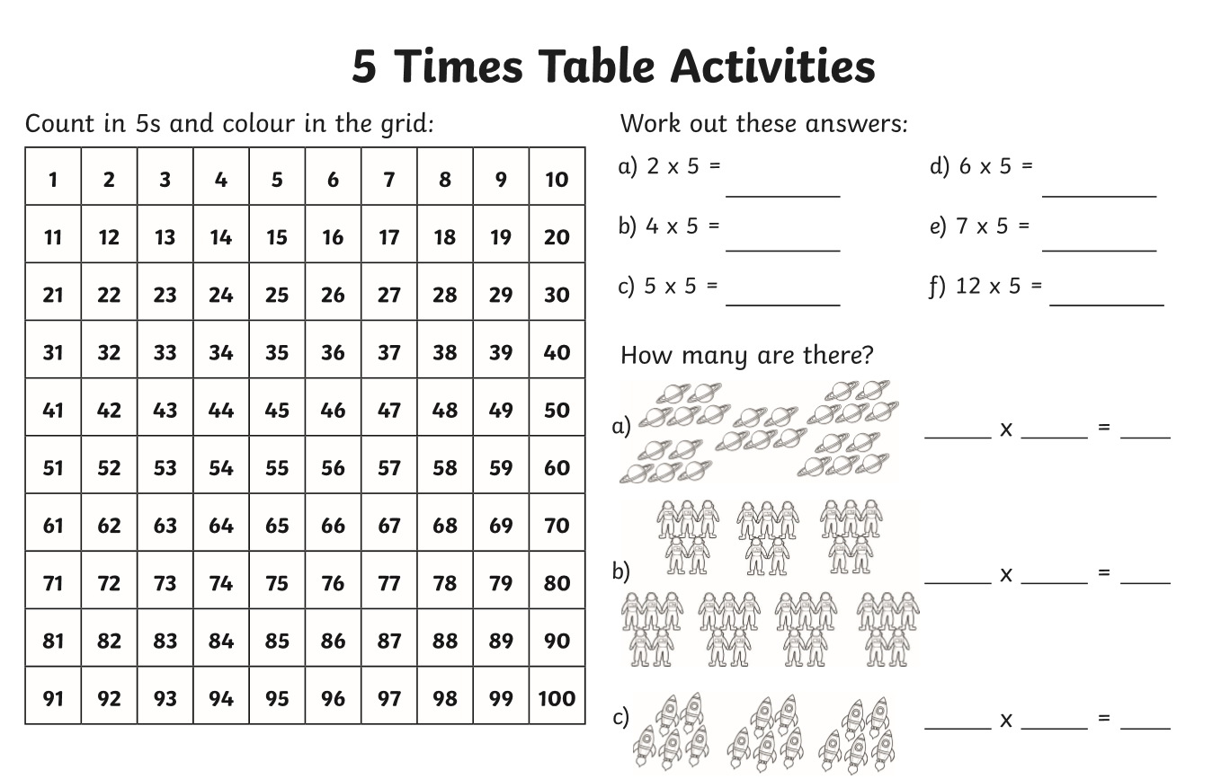
Year 3 – Challenge
40 divide by 5 =
30 divide by 5 =
55 divide by 5 =
20 divide by 5

Now learn and answer the 7 times table questions!

Year 4
Year 4 Challenge

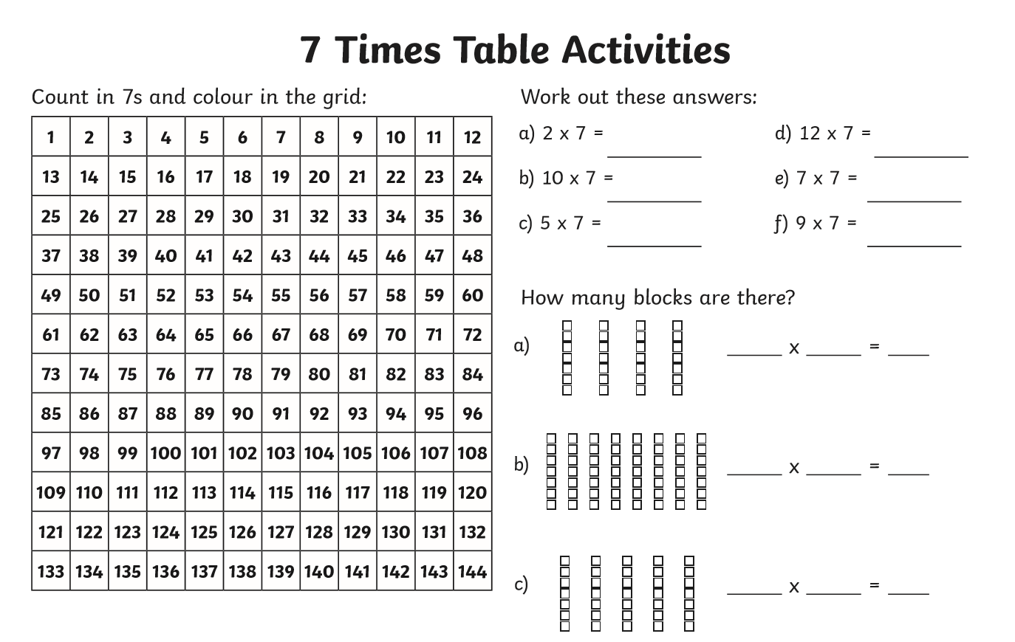
14 divide by 7 =
70 divide by 7 =
63 divide by 7 =
35 divide by 7 =
49 divide by 7 =

