Summer 1
Reception Writing Tasks

Dear Parents/Carers,

Your child will be expected to complete one writing tasks each day. Please ensure your child is writing in full sentences independently.

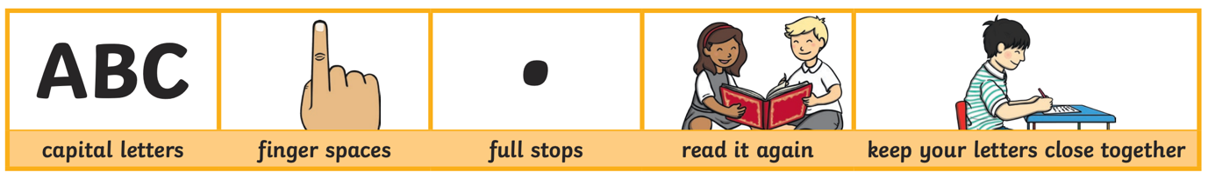

Encourage your child to use the above key when writing their sentences.

Success Criteria:
Has your child used capital letters?
Has your child used finger spaces after each word?
Has your child used a full stop at the end of their sentence?
Can your child read what they have written, and does it make sense?
Has your child made sure they have written their letters correctly in a way that can be understood and read by others?

Reception High Frequency Words
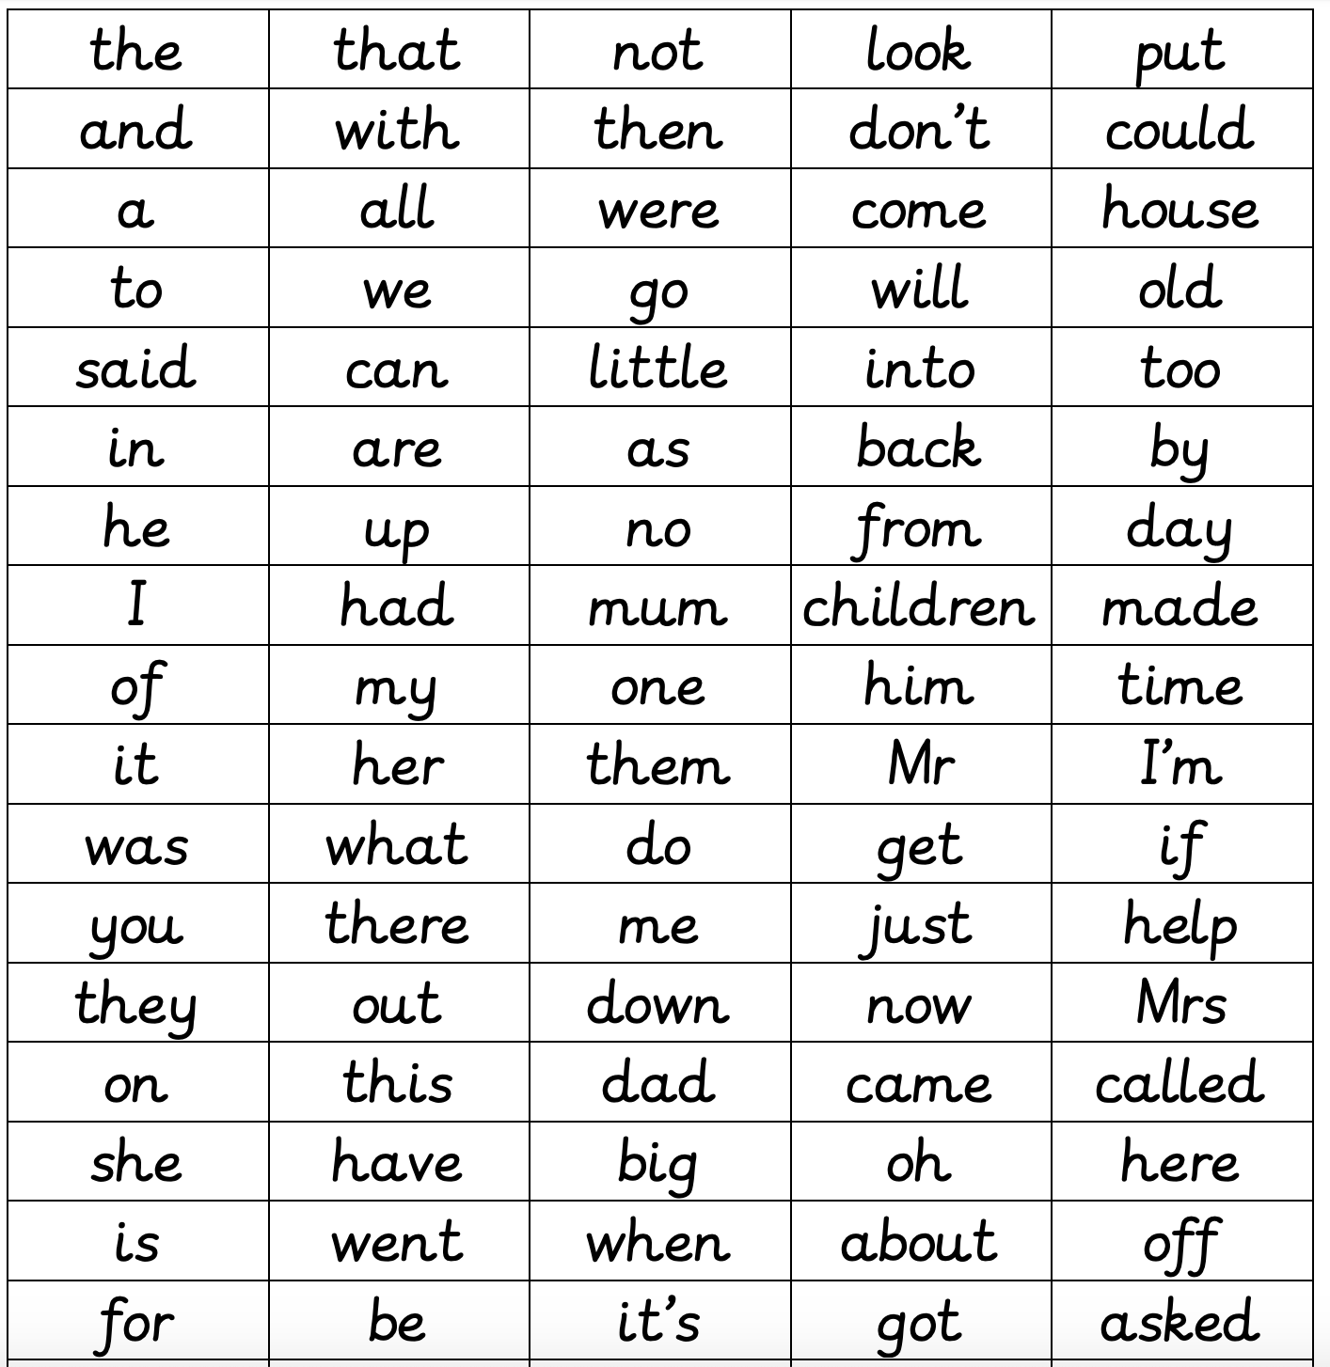
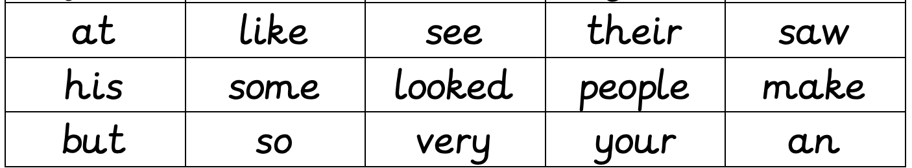

By the end of Reception, your child should know all or majority of these high frequency words and should be using them in their writing.
Monday 4th May 2020

This week we will look at the story ‘Owl Babies’ since you are all familiar with the story.

Read the text below from the story:

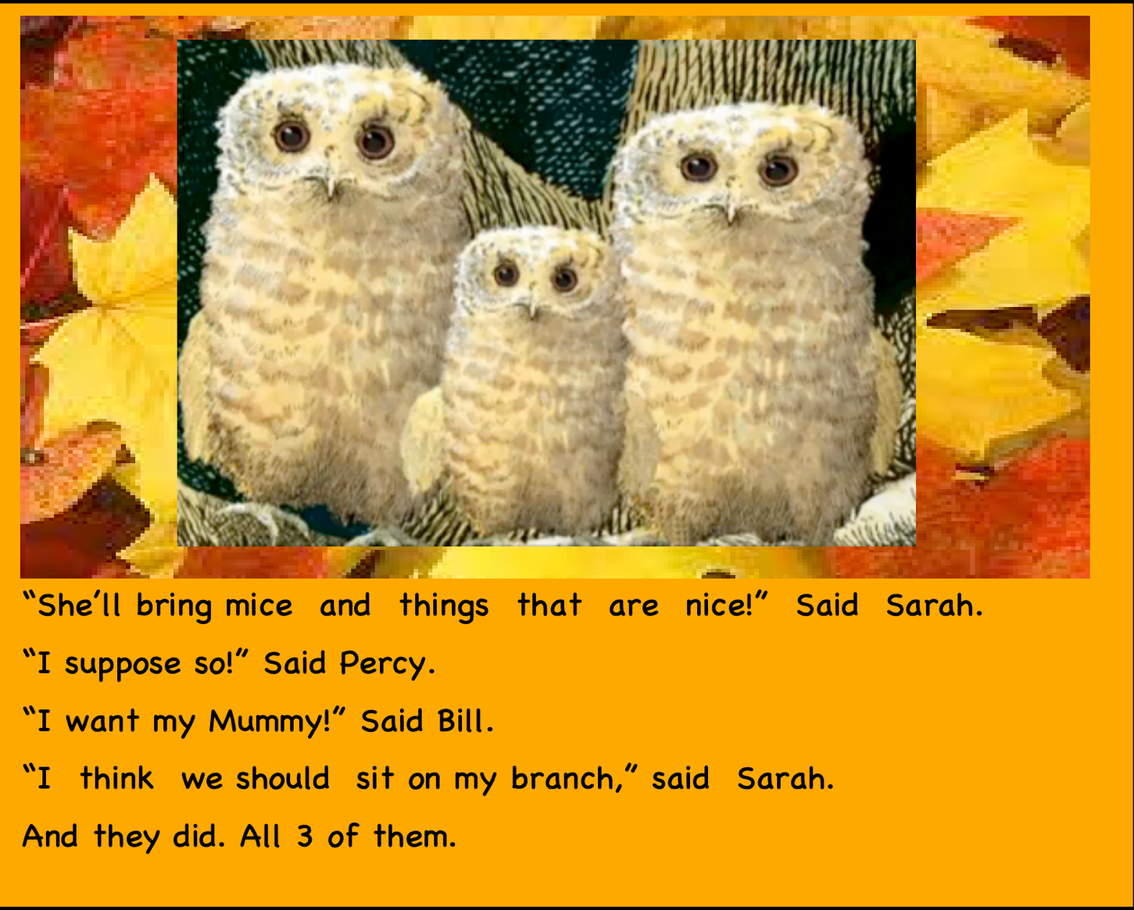

Can you see any high frequency words in the text?

Write a list of the words you can see below in your neatest handwriting below:

Tuesday 5th May 2020
Can you remember who the main characters in the story are?

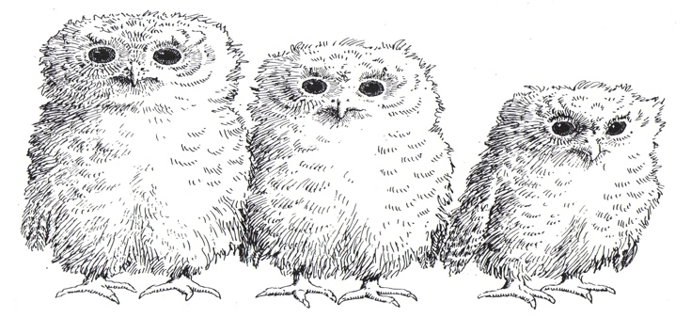

________________ __________________ _______________

Where was the setting of the story?

________________________________________________________________

How do you think the Owls are feeling in the story?

Sarah
Percy
Bill

Use the word bank below

Scared Happy Sad Frightened Brave

Upset Excited Lonely Confused

Wednesday 6th May 2020

Can you use adjectives to describe how the Owl Babies looked?
Can you remember what adjectives are? ‘they are describing words’

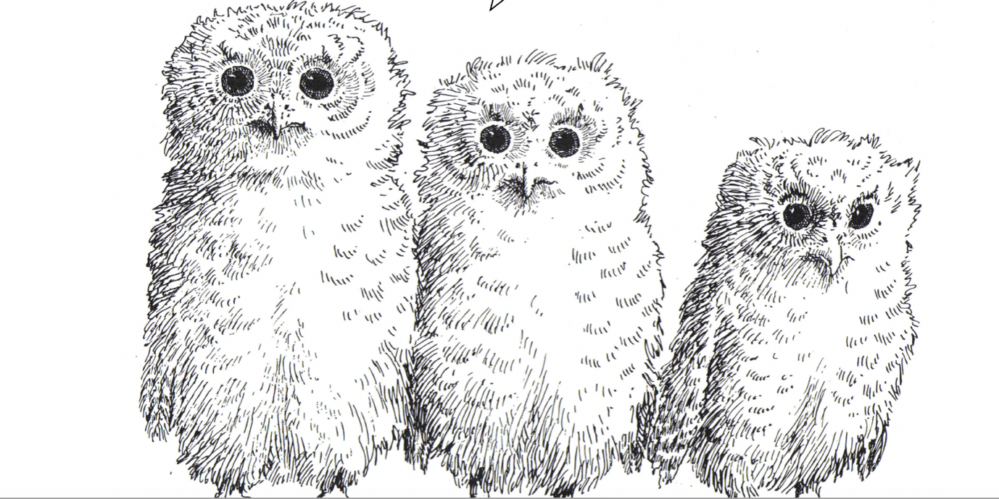

Thursday 7th May 2020

The Owl Babies missed their mommy.

How would you feel if your mummy left you?

What would you do? Would you be brave like the Owl Babies?

Friday 8th May 2020

Can you draw and write about what your favourite part of the story ‘Owl Babies’ was?

To listen to the story clink on the link: https://www.youtube.com/watch?v=TPQRiSTYFHo

Don’t forget to take pictures of the amazing writing you have done and send them to your teachers!!

