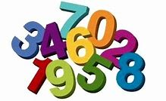
Numbers

Monday activity
Please practise writing numbers with your child.
Write the numbers big with a yellow colouring pencil and then place an arrow showing them where you want them to start from.
Repeat each number 10 times.
Here is an example what I mean…
1 1 1 1 1 1 1 1 1 1
2 2 2 2 2 2 2 2 2 2
3 3 3 3 3 3 3 3 3 3
4 4 4 4 4 4 4 4 4 4
Practise writing up to number 10

Count and match with correct number
Tuesday activity

1
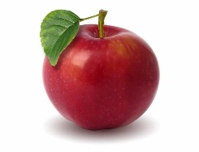

2
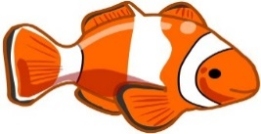
This Photo by Unknown Author is licensed under CC BY-ND
This Photo by Unknown Author is licensed under CC BY-ND
3
4
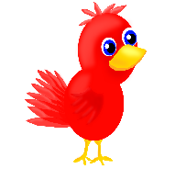
This Photo by Unknown Author is licensed under CC BY
5
This Photo by Unknown Author is licensed under CC BY
This Photo by Unknown Author is licensed under CC BY
This Photo by Unknown Author is licensed under CC BY
This Photo by Unknown Author is licensed under CC BY
This Photo by Unknown Author is licensed under CC BY
This Photo by Unknown Author is licensed under CC BY
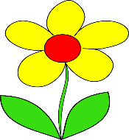
6

7

8

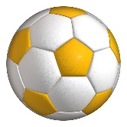
9

10
This Photo by Unknown Author is licensed under CC BY-NC
This Photo by Unknown Author is licensed under CC BY-NC
This Photo by Unknown Author is licensed under CC BY-NC
This Photo by Unknown Author is licensed under CC BY-NC
This Photo by Unknown Author is licensed under CC BY-NC
This Photo by Unknown Author is licensed under CC BY-NC
This Photo by Unknown Author is licensed under CC BY-NC
This Photo by Unknown Author is licensed under CC BY-NC
This Photo by Unknown Author is licensed under CC BY-NC

Wednesday activity
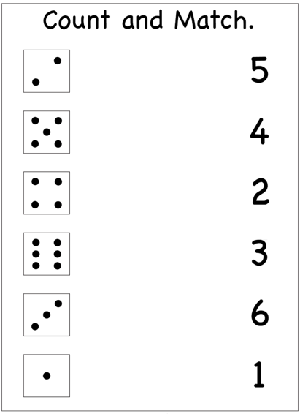

Thursday activity
Have a look in the kitchen
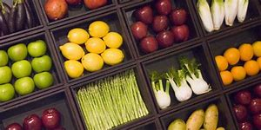
And see if you have any of the items below:
Ketchup slice of bread
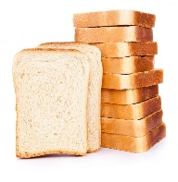
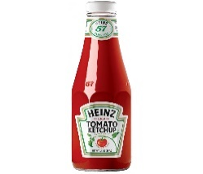
This Photo by Unknown Author is licensed under CC BY-NC-ND
This Photo by Unknown Author is licensed under CC BY-NC-ND

How many did you find? How many did you find?

Apple Chilli
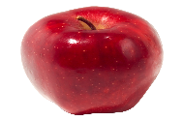
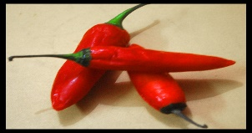
This Photo by Unknown Author is licensed under CC BY-SA
This Photo by Unknown Author is licensed under CC BY-NC-ND

How many did you find?
How many did you find?

Ginger Lemon
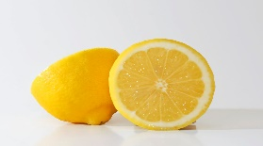
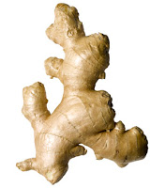
This Photo by Unknown Author is licensed under CC BY-SA

How many did you find? How many did you find?

Have a look around your house
Friday activity
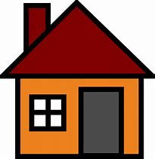

How many chairs do you have?
How many tea tables do you have?
Have many plates do you have?
Have many sofas do you have?
Have many door handles do you have?
Have many toilet tissues do you have?
Have many rugs do you have?
How many toasters do you have?

