Year 5 and 6 Art project

Eid Silhouette Picture
Why not decorate your home with some beautiful art work? Follow the instructions to create your own Eid silhouette!
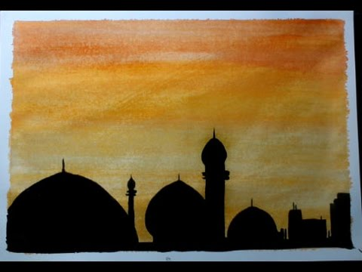

You will need:
2 primary colours of paint (we have used blue and yellow, but red and yellow would look good too)
Card
Black marker pen
Instructions:
Using your darkest colour (blue for us) paint the bottom half of the card.
Mix a small amount of the second paint colour into the first and paint a bit further up the card. Repeat and keep going until the card is covered.
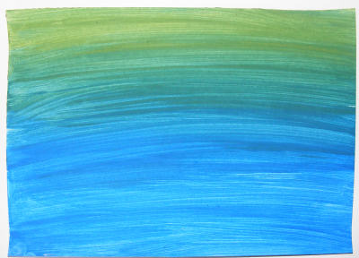
Leave to dry.
With your marker pen, draw an outline of a skyline with mosques (masjids). Colour under the line black.
To finish, add a crescent moon and star.
This technique would make a lovely Eid card, or you could frame your picture for display each year.

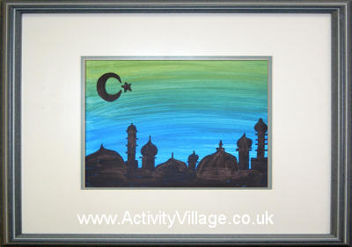

You can email a picture of your art work to your teacher. We would love to see your creations!

