Time to get creative!
Look at the activities below. See if you can follow the instructions and make these beautiful decorations for your home!

Star and Crescent Moon Mobile hanging art
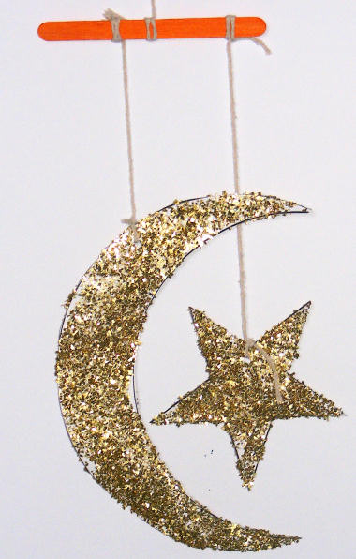
You will need:
Card
Paint or glue and glitter
String
Stick (we used a lolly stick)
Our template (see below)
Instructions:
Print our template onto card or draw your own crescent moon and star. Cut out.
Paint both sides of each or cover with glue and glitter.
Punch a hole in each and tie through a piece of string or yarn.
Tie the other ends of the string to a twig or lolly stick. Tie a piece of string to the middle of the twig to hang the mobile by.

Lolly Stick Star
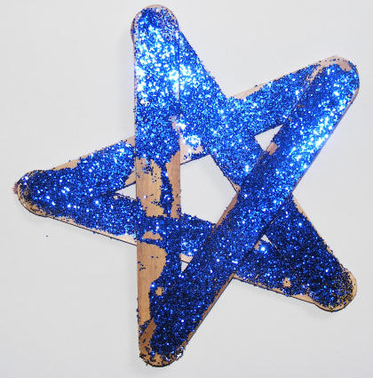
A beautiful, sparkly star!
You will need:
5 lolly or crafts sticks
Glue (high tack is best)
Paint, stickers, glue, glitter ... whatever you want to use to decorate.
Instructions:
Using our picture as a guide, glue the ends of the sticks together to make your star. Leave to dry.
Decorate your star.

Mini Eid Lantern Chain
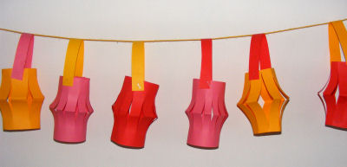
You will need:
A4 sheets of pink, orange and red paper
Glue (or stapler)
String to hang
Instructions:
Fold a sheet of paper in half along the length. Cut a strip about 1 inch (2cm) wide from the edge. You will end up with two strips. Put them on one side for your handles.
Cut along the fold.
Taking one half of the paper, fold in half along the width. Cut snips along the fold to about 1 inch from the paper edge. When you have snipped all the way along the paper edge, unfold the paper and bend it into a cylinder. Glue or staple to secure.
Glue or staple on a handle from one of the strips of paper (use a different colour).
Make the second bit of paper into another lantern.
Repeat with more sheets of paper until you have lots of lanterns!
Thread some string through the handles and hang. You may need to put a small piece of sticky tape to secure each lantern in place, depending on how tight your string is.

You can email your pictures of your decorations around your home to your teachers!

