Week 6
Monday 27th April 2020
Reading comprehension
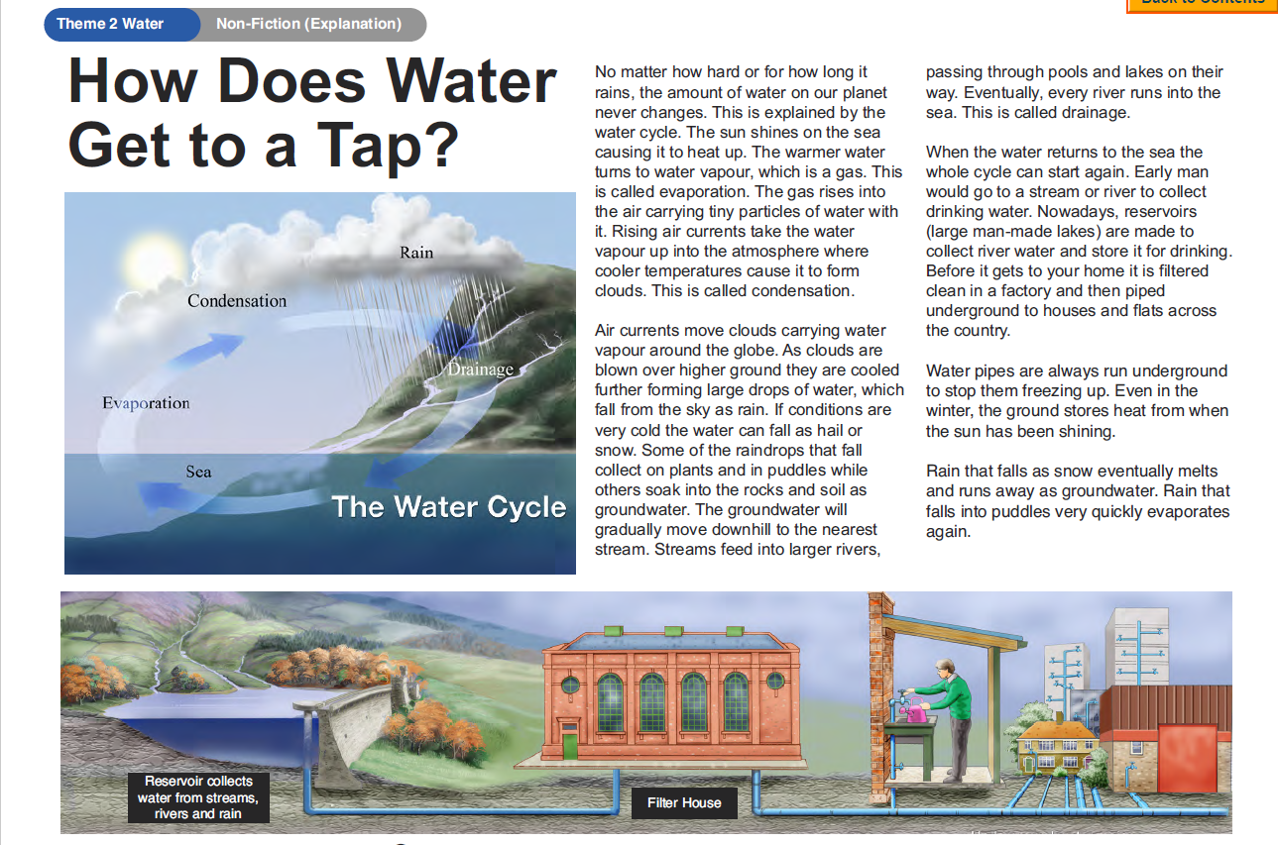
Please answer the following questions in full sentences using evidence from the text.
Year 5- Answer questions 1-6
Year 6-Answer questions 1-8
- Where do raindrops collect when they fall?

- What happens to rain in very cold conditions?

- Where did early man get drinking water?

- Where does our drinking water come from?

- How would you feel about getting your drinking water in the same way as early man?

- Why do you think underground pipes do not freeze up in winter?

- How does a puddle disappear after it has been raining?

- Draw a diagram to explain how the water cycle works.

Week 6
Tuesday 28th April 2020
English grammar – Yr 5 Task-copy the sentences and insert a comma in the correct places.
Click on this link to find more information about using commas:
https://www.bbc.co.uk/bitesize/topics/zvwwxnb/articles/zc773k7

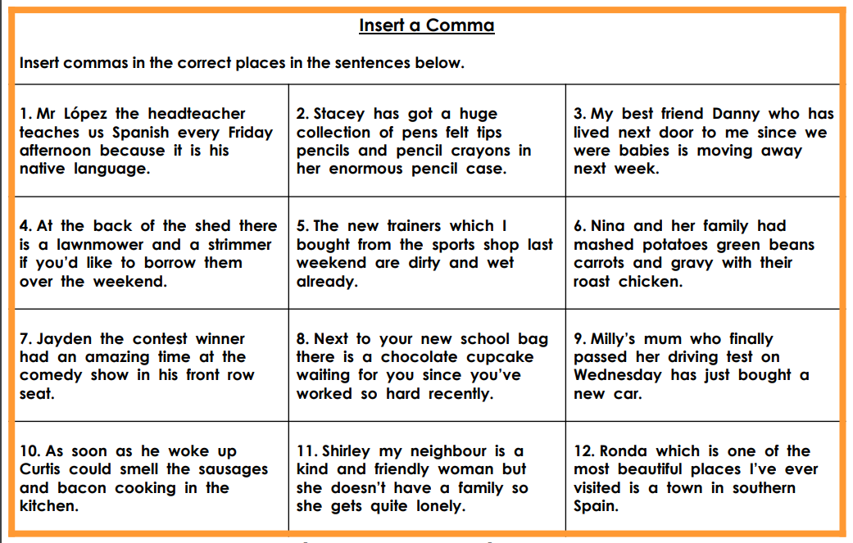

English grammar-Yr 6 Task-copy the sentences and insert a comma in the correct places.
Click on this link to find more information about using commas:
https://www.bbc.co.uk/bitesize/topics/zvwwxnb/articles/zc773k7

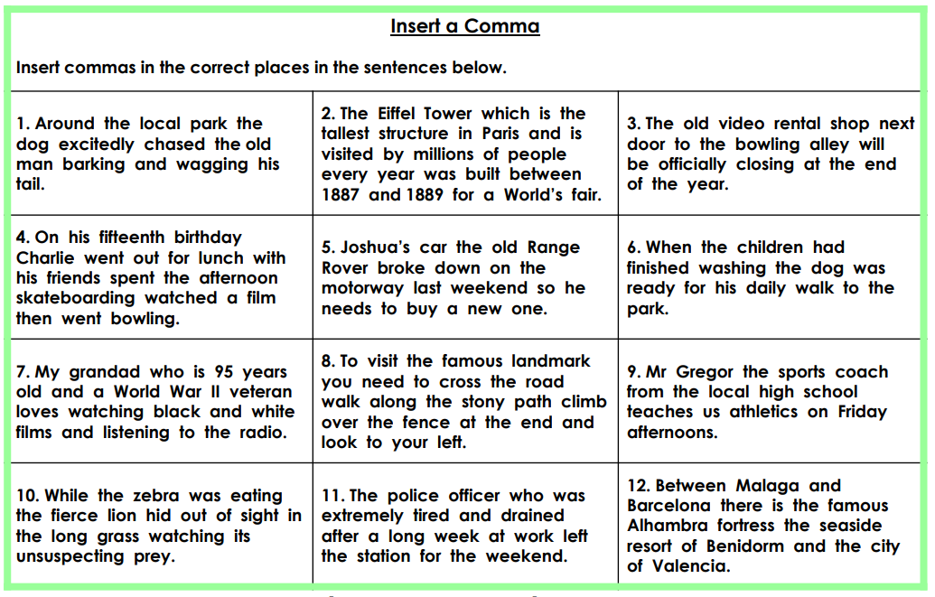
Week 6
Wednesday 29th April 2020
English Writing
Similes and Metaphors
What is a metaphor?
A metaphor is a word or a phrase used to describe something as if it were something else.
For example: A wave of terror washed over him.
The terror is not actually a wave, but a wave is a good way of describing the feeling.
Another example is: Jess is dynamite.
She's not made of dynamite, but it's a way to explain how exciting she is.

What is a simile?
A simile describes something by comparing it to something else, using like or as.
For example:
The snake moved like a ripple on a pond.
It was as slippery as an eel.
Using metaphors and similes can make your writing more descriptive and interesting.

Now watch this clip of Dick and Dom reading and enjoying an extract from George’s Marvellous Medicine by Roald Dahl.
Roald Dahl uses lots of similes and metaphors in his writing. Can you spot any?

Click on this link to access the video:

https://www.bbc.co.uk/bitesize/articles/zkygrj6

Activity 1
Write five sentences to describe yourself using similes and metaphors.
Try to use some exciting vocabulary like Roald Dahl does: fearsome, bewitching and marvellous are great adjectives.
Then, write five sentences to describe a famous person using similes and metaphors.
If you can, ask members of your family to identify the famous person from your description.
Top tip!
Similes can use ‘like’ or ‘as’.

Activity 2
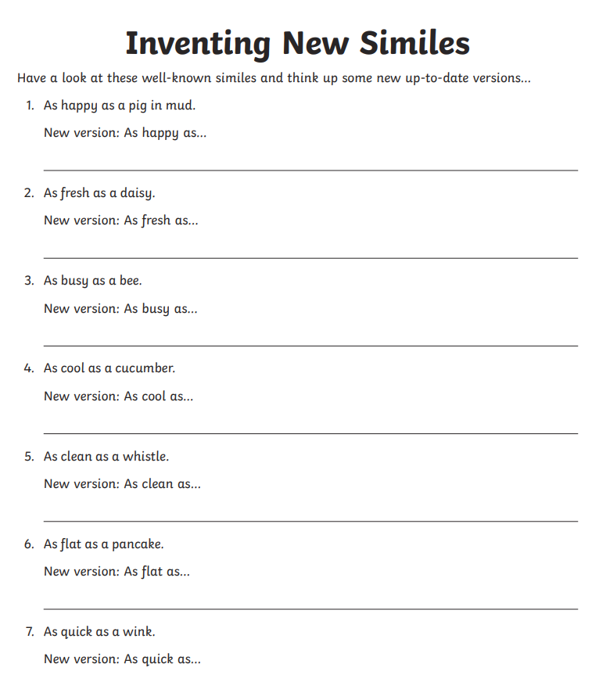
Week 6
Thursday 29th April 2020
English SPAG
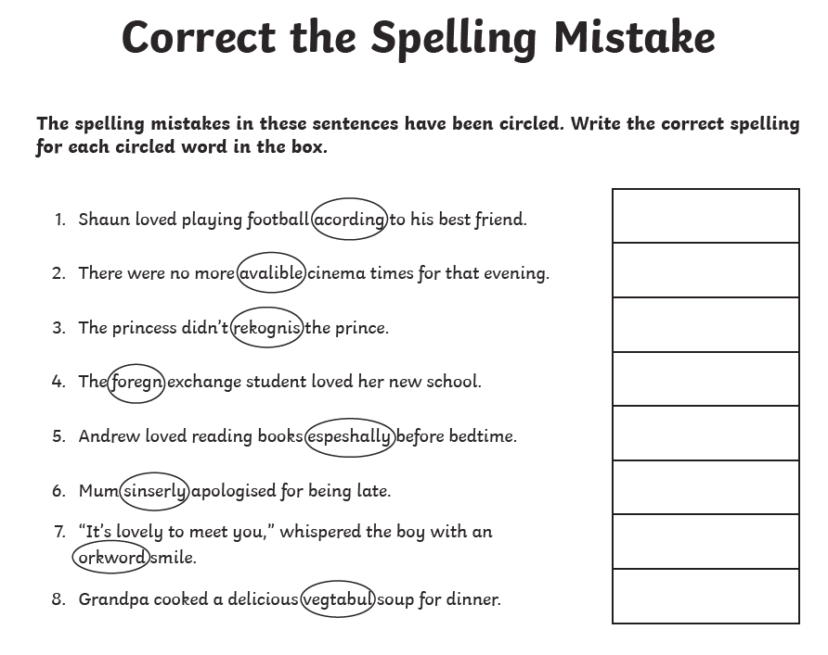
Challenge- Now write your own sentences using the spellings that you corrected.

Week 6
Friday 1st May 2020
Reading comprehension
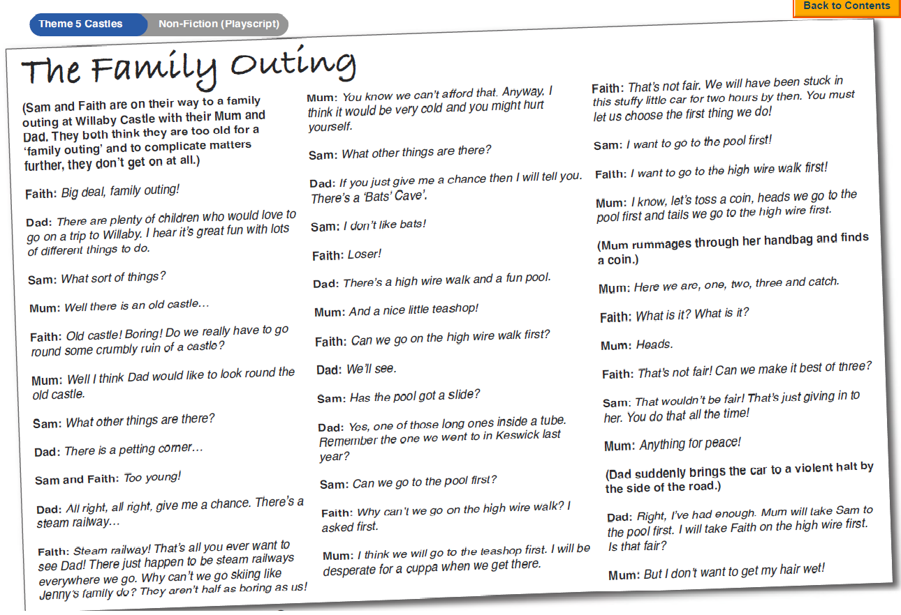
Please answer the following questions in full sentences using evidence from the text.
Year 5-Answer questions 1-6
Year 6-Answer questions 1-8
- ‘Big deal, family outing!’ What do you think Faith is really saying in this sentence?

- What was Faith suggesting when she talked about the steam railway?

- What reasons did mum give for not going skiing?

- Faith called Sam a loser because he did not like bats. Why do you think she did this?

- Mum wanted to go to the teashop first. Why did the children not consider this?

- How would you describe Faiths attitude when the coin landed on ‘heads’?

- How do you think Dad felt when Mum said, ‘But I don’t want to get my hair wet!’

- Imagine you are Dad. Write a short playscript in which Dad resolves the problem of what to do next.

