Comparing weights
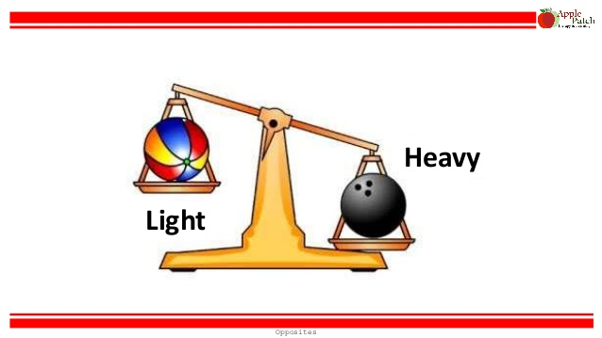

Find an object that you think is heavy and find one that you think is light.
Now think about what would happen if you place the item in a bowl of water.
Do you think it would float or sink? Write down your answers below.
Heavy item….
Light item….

Now let’s see you are right…

Get a bowl of water and place both items in the bowl

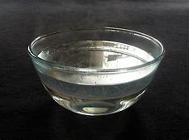

Find items in the kitchen
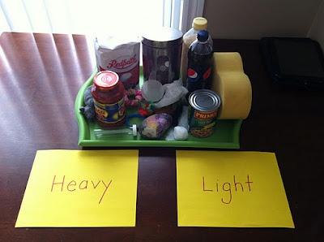

Draw which ones are heavy?

Draw which ones are light?

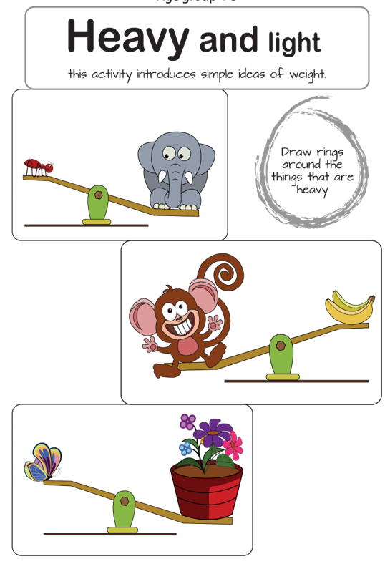

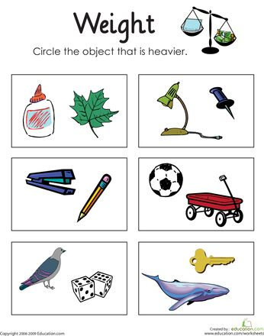

Find 5 different vegetables or fruits in the kitchen.
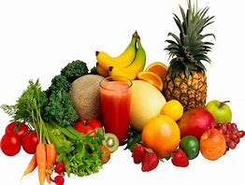

Which one is heavy?

Which one is light?

Which item do you think is the heaviest?

Which items do you think is the lightest?

