Carefully, read and answer the questions using the information pack on micro-organisms.

*There is a challenge at the end, which is to conduct a science experiment!
What Micro-Organisms Are and How they are Grouped
Activity Pack

Micro-Organisms

What are micro-organisms?

What do micro-organisms look like? | How are micro-organisms grouped?
How are micro-organisms grouped? | How can micro-organisms be harmful?

Challenge – Yeast Experiment

This is an experiment to find out which food yeast likes the best.

Make sure you read the Yeast Experiment sheet and have all the necessary equipment listed on the sheet.

Once you have read through the experiment carefully, write a prediction on the Yeast Experiment worksheet.

Make sure you have an adult to help you follow through the steps for the experiment.

Leave the samples for an hour or two.

Come back to the samples and look at what has happened. Which bag has the most gas in? What does this tell you?

Record the results and a conclusion on the Yeast Experiment worksheet.

Yeast Experiment Worksheet

What are you trying to find out?

Which food do you think the yeast will like the most? Why?

Which food do you think the yeast will like the least? Why?

RESULTS
Salt | Sugar | Flour
Rice | Coffee | Oil
Conclusion

ClassifyingOrganisms YeastExperiment

Yeast is a micro-organism that is used in bread to make it rise. When the yeast feeds on the dough, it produces gas which forms air bubbles in the bread. Yeast is put in bread and it eats the dough but what does yeast most like to eat? Is there anything else that yeast loves? Follow the steps in this experiment to find out.

You will need:
- 6 plasticcups
- Water
- Measuring jug

- Weighingscales
- 6 sachets of yeast(7g)
- 6 ziplockbags

- 20gsalt
- 20gsugar
- 20gcoffee

- 20gflour
- 20grice
- 20goil

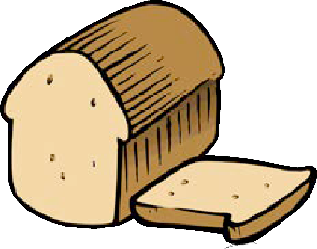

Place 6 plastic cups in a row and measure 200ml of water into each one.

Carefully open each packet of yeast and pour a sachet into each of the cups of water.

Measure out 20g of each of the foods you will be testing: sugar, salt, flour, rice, coffee and oil. Place each one in a separate ziplockbag.

Close the ziplock bag and make sure they are secure so that the water cannot leak.

Carefully pour one of the water and yeast mixtures into each of the ziplock bags until each bag has water, yeast and a food sample in.

Label each of the ziplock bags with the food it has inside.

Gently shake each of the bags to mix the water, yeast and food together, then place flat on a table.
Whichever bag has the most air contains the food that yeast most likes to eat. The bag with the least air contains the food that yeast least likes to eat.

Leave the bags for an hour or two then go back and look at how much air is in each of the bags.

