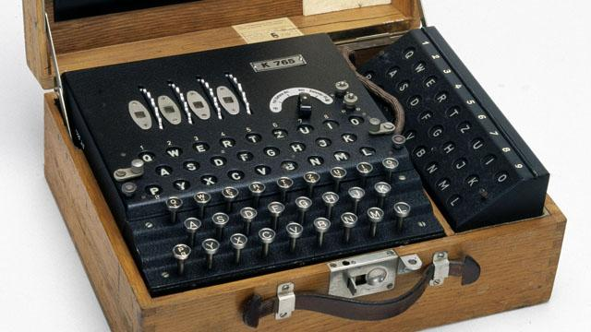
World War II code masters used fractions to code their information.
They would encrypt their messages using decimals and percentages to confuse their enemies. Can you crack the code?

A = 4/5 | B = 5/5 | C = 1/10 | D =2/3 | E = 1/3 | F = 8/10 | G = 7/8
H = 2/4 | I = 3/5 | J = 5/6 | K = 5/9 | L = 4/6 | M = 4/9 | N = 6/10
0 = 5/12 | P = 2/10 | Q = 1/12 | R = 3/4 | S = 9/10 | T = 4/10 | U = 3/10
V = 1/4 | W = 3/7 | X = 8/11 | Y = 7/12 | Z = 6/7
8. 50% + 1/4 =
9. 0.4 + 2/5 =
10. 100% - 3/4 =
11. 60% - 3/10 =
12. 5/10 + 10% =
13. 33% + 1/3 =

1. 7/10 – 0.3 =
2. 3/4 – 0.25 =
3. 66% - 1/3 =
4. 50% - 4/10 =
5. 0.8 – 3/5 =
6. 1 – 2/5 =
7. 4/10 - 30% =

Use this cypher to crack the code
13

3

12

8

11

1

3

3

2

8

3

10

9

2

4

12
9
6

13
9
12
9
7

1

