Monday 30th March 2020
Year 3 & 4
Times Table
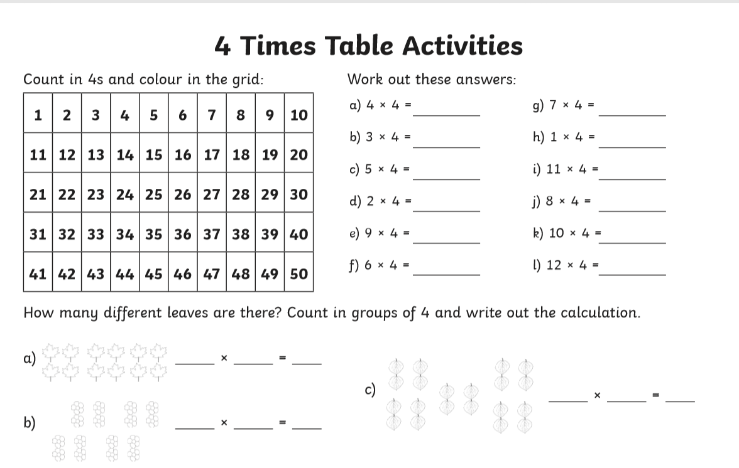
Year 4 Challenge:
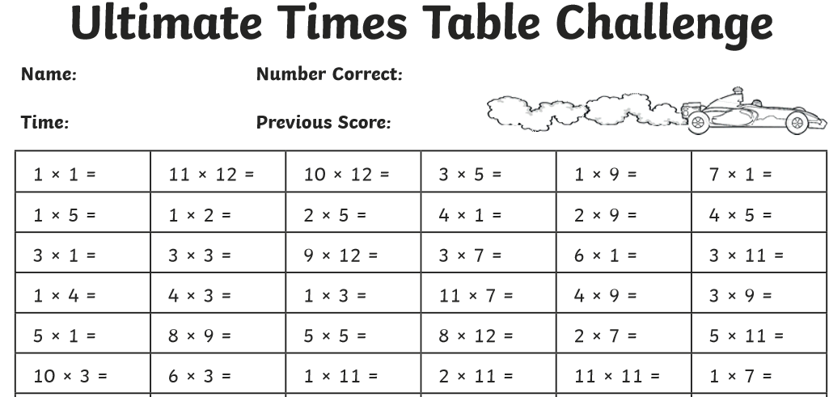
REMEMBER: Spend at least 10 minutes a day memorising your times table!

SPECIAL PRIZE:
If you memorise all of the times tables when you return to school!

