**Week 2**

**Monday 30th March 2020**

**English comprehension – Year 1 & 2**

**A New Pet**

Tom was six. He lived in a flat with his Mum. The flat was on the top floor. It was very high up!

One day, Tom said to his Mum, “Mum, can I have a dog?”

But Mum shook her head and said, “No Tom, you can’t have a dog. There are no dogs allowed in a flat.”

Tom wanted to cry. Then he said, “Mum, can I have a cat?”

But Mum shook her head and said “No Tom, you can’t have a cat. There are no cats allowed in a flat.”

Now Tom did start to cry, “I want my own pet!” he shouted.

Mum patted Tom on the back and gave him a kiss, “Don’t cry Tom, I will see what I can do.”

The next day, when Tom got home from school, there was a small cage on the table. Tom was excited! He ran to look in the cage. In the cage was an orange hamster! Mum put the hamster in Tom’s hands.

Tom smiled and said, “I will call it Rusty. Thank you, Mum!”

**Questions- Year 1 can answer questions 1 to 6**

**Year 2 should attempt to answer all the questions.**

**Please answer in full sentences e.g. What is the boy’s name?**

**Answer- The boy’s name is Tom.**

1. How old is Tom?
2. Where does Tom live?
3. What pets did Tom want?
4. How does Tom feel when Mum says “No?” How do you know this?
5. How does Mum try to make Tom feel better?

1. Why was Tom excited when he saw a cage on the table?
2. What was in the cage?
3. Why did Tom call his pet, ‘Rusty?’
4. How do you know Tom is happy about his new pet?

Challenge- Do you have a pet or would you like one? What kind of pet?

**Week 2**

**Tuesday 31st March 2020**

**English Spag – Year 1 & 2**

**Capital Letters**

**LO: Recognise that proper nouns always have a capital letter**

Proper nouns are names of people. Write down five of your friends in your book.

|  |
| --- |
| My friends names are... |

**Do not forget, they need to start with a capital letter!**

Proper nouns are names of places. Write down five places you have visited.

|  |
| --- |
| Five places I have visited are... |

Proper nouns are days of the week and months of the year. Write down the month you were born and what day it is today.

|  |
| --- |
| I was born in... |

**Challenge: Can you make a list of more proper nouns?**

**Week 2**

**Tuesday 31st March 2020**

**Spellings**

**Write and learn the following words in your book.**

**Write the words 5 times.**

**Use each word in a sentence.**

**Do not forget to use a capital letter and full stop in your sentences.**

**Challenge- can you use at least 2 of the words from the list in a sentence?**

**Example- My sister and I pulled back my dad.**

* **all**
* **big**
* **can**
* **dad**
* **back**
* **and**
* **could**
* **had**

**Week 2**

**Wednesday 1st April 2020**

**English writing – Year 1 & 2**

**Task- Write a short story about a girl who finds herself in a forest as she walks through her bedroom door. Use the questions below to help you describe the setting.**

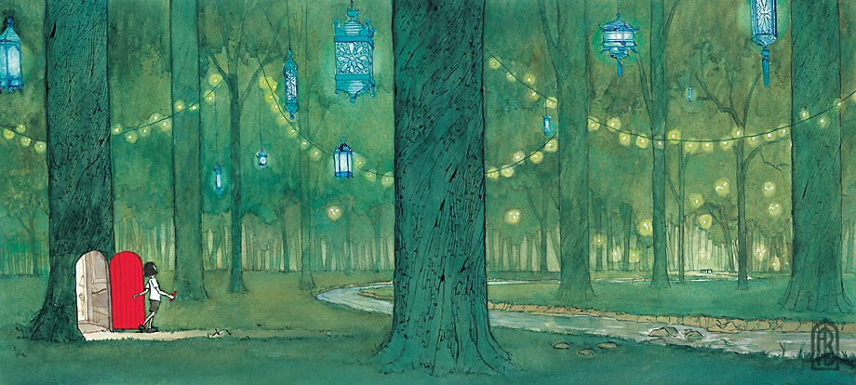

**Do not forget to:**

* **Use capital letters and full stops.**
* **Finger space between each word.**
* **Include lots of adjectives (describing words)**
* **Describe how the girl felt.**
* **Read each sentence to check if it makes sense.**

**Questions to help you:**

* What’s on the other side of the door?
* What is the girl holding in her hand? Why?
* How did she get to the forest?
* Where is this?
* Who hung the lanterns in the trees?
* Where does the stream lead?
* Will the girl go back through the door or stay in the forest? Predict what will happen next.

**Sentence starter for Yr1 children**

Seema opened the door and found herself in a beautiful forest. She was shocked!.....

**Week 2**

**Thursday 2nd April 2020**

**Reading and book review – Year 1 & 2**

**Choose a book to read and answer the following questions**

**about your book.**

**Title:_____________________________________________**

**Author: ___________________________________________**

**What did you like about the book?**

**What was your favourite part? (Describe)**

**Draw a picture of the book cover**

**Yr 2 challenge: Would you recommend this book to your friends and why?**

**Week 2**

**Friday 3rd April 2020**

**English spelling**

**Spelling**

**Write and learn the following words in your book.**

**Write the words 5 times.**

**Use each word in a sentence.**

**Do not forget to use a capital letter and full stop in your sentences.**

**Challenge-can you use an exclamation mark or a question mark in your sentences?**

**Example- Are you feeling better today?**

* **are**
* **called**
* **day**
* **from**
* **down**
* **but**
* **children**

Have a peaceful holiday with your families, keep us all in your duahs. We will see you back online on

Monday 20th April 2020!

